This webquest is intended to reinforce the concepts in Chapter 11 on waves.
Directions - > use Simulation Website http://www.surendranath.org/
When at website use wave motion
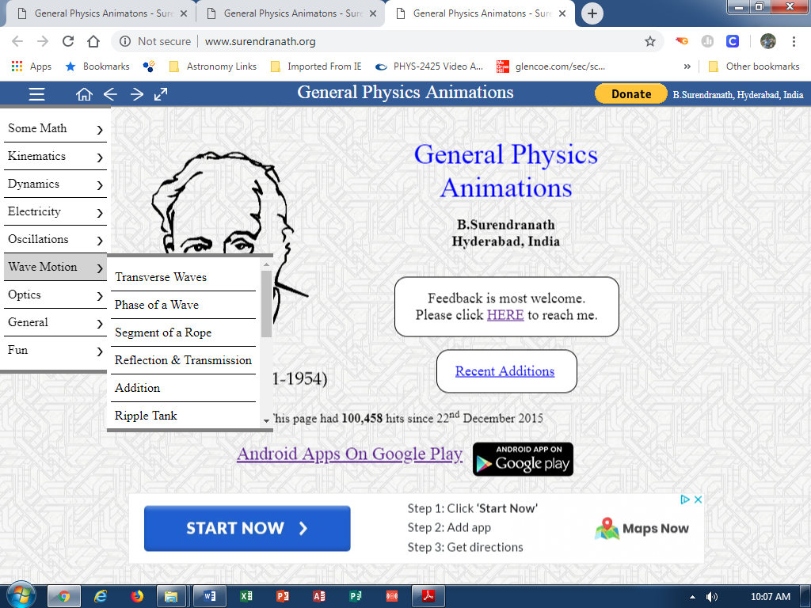
Use wave motion
Use reflection and transmission

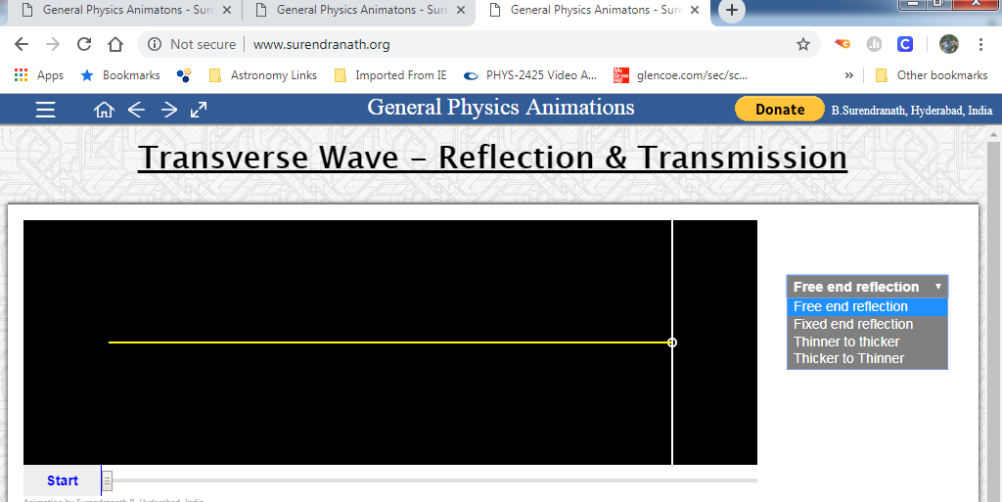
Part 1 use for different cases

Part I. BOUNDARY BEHAVIOR
Case 1. Fixed-End Reflection
Case 2. Free-End Reflection
Case 3. Thinner-to-Thicker
Case 4. Thicker-to-Thinner

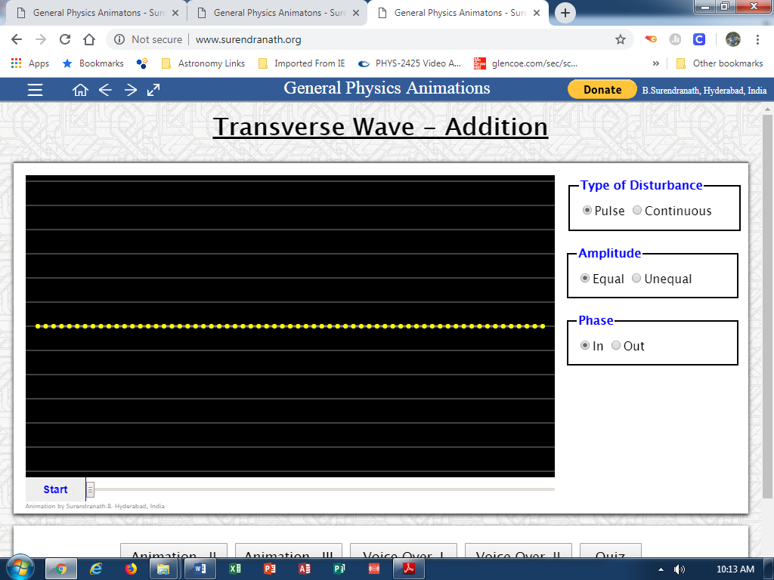
Part II. INTERFERENCE
Part 1. Wave Interference
Part 2. Principle of Superposition

Use Addition

Part III. STANDING WAVES
In phase = cons
Introduction
Part 1. Both Sides Closed
Part 2. One Side Open

Part I BOUNDARY BEHAVIOR

As a wave travels through a medium, it will often reach the end of the medium and encounter an obstacle or perhaps another medium through which it could travel. The behavior of a wave upon reaching the end of a medium is referred to as boundary behavior.

In this activity you will use a computer simulation to investigate the boundary behavior of waves in four cases:

1. Fixed End Reflection
2. Free End Reflection
3. Change of medium: Thinner to Thicker
4. Change of medium: Thicker to Thinner

CASE 1. FIXED END REFLECTION

A pulse is introduced at the left end of a rope. The pulse travels through the rope toward the right end of the medium. This pulse is called the incident pulse. In this case the end of the rope is securely attached to a lab pole.

- Predict what will happen to the pulse as it reaches the fixed end. Sketch your prediction:

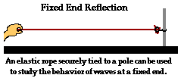

- Click on the SIMULATION and select FIXED END REFLECTION. Describe what you observe:

Does the behavior shown in the simulation agree with your prediction?
- Using Newton’s Third Law explain why the reflected pulse returns inverted.

- How does the speed of the reflected pulse compare to the speed of the incident pulse?

- How does the wavelength of the reflected pulse compare to the wavelength of the incident pulse?

- You have learned that a wave is an energy transport phenomenon. What characteristic of a wave is directly related to the energy of the wave?

- What happens to the energy of the incident pulse as it reaches the boundary? Where does the energy go? Does the energy disappear?

CASE 2. FREE END REFLECTION

What happens if the rope is free to move at its far end? Instead of being securely attached to a lab pole it is now attached to a ring that is loosely fit around the pole. Because the right end of the rope is no longer secured to the pole, the last particle of the rope will be able to move when a disturbance reaches it. This end of the rope is referred to as a free end.

- Predict what will happen to the pulse as it reaches the free end. Sketch your prediction:

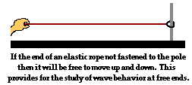

- STOP the SIMULATION and select FREE END REFLECTION. Describe what you observe:

Does the behavior shown in the simulation agree with your prediction?

- What will happen if instead of a crest, a trough is incident upon a free end?

- How does the speed of the reflected pulse compare to the speed of the incident pulse?

CASE 3. THINNER TO THICKER

Let's consider a thin rope attached to a thick rope, with each rope held at opposite ends by students. Suppose that the student holding the end of the thin rope introduces a pulse that will travel from the less dense medium toward the boundary with a denser medium (thick rope).

- Predict what will happen to the pulse as moves from the less dense medium to the denser medium. Sketch your prediction:

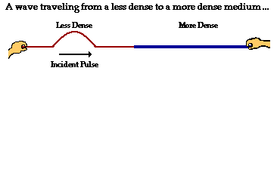
- STOP the SIMULATION and select THINNER TO THICKER. Describe what you observe:

Does the behavior shown in the simulation agree with your prediction?

- How does the speed of the reflected pulse compare to the speed of the transmitted pulse? Explain.

- How does the frequency of the reflected pulse compare to the frequency of the transmitted pulse? Explain.

- How does the wavelength of the reflected pulse compare to the wavelength of the transmitted pulse? Explain.

- How does the amplitude of the reflected pulse compare to the amplitude of the transmitted pulse? Explain.

CASE 4. THICKER TO THINNER

Now let's consider a thick rope attached to a thin rope, with the incident pulse originating in the thick rope.

- Predict what will happen to the pulse as moves from the denser medium to the less dense medium. Sketch your prediction:
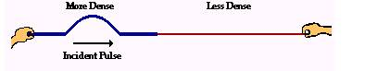

- STOP the SIMULATION and select THICKER TO THINNER. Describe what you observe:

Does the behavior shown in the simulation agree with your prediction?

- How does the speed of the reflected pulse compare to the speed of the transmitted pulse? Explain.

- How does the frequency of the reflected pulse compare to the frequency of the transmitted pulse? Explain.

- How does the wavelength of the reflected pulse compare to the wavelength of the transmitted pulse? Explain.

- How does the amplitude of the reflected pulse compare to the amplitude of the transmitted pulse? Explain.

- How do you explain the fact that transmitted pulses are never inverted?

CONCLUSION PART 1

- Based on your observations of boundary behavior and using complete sentences write your conclusions about the four wave characteristics (speed, wavelength, frequency and amplitude).

- In which case(s) does a pulse reaching the end of a medium become inverted?

- A pulse reaching the end of a medium does not become inverted in which case(s)?

ACTIVITY II. INTERFERENCE

PART 1. Wave Interference
PART 2. Principle of Superposition

PART 1. WAVE INTERFERENCE

What happens when two waves meet while they travel through the same medium? What effect will the meeting of the waves have upon the appearance of the medium? Will the two waves bounce off each other upon meeting or will the two waves pass through each other?

Wave Interference occurs when two waves meet while traveling along the same medium. To begin our exploration of wave interference, consider two pulses of the same amplitude traveling in different directions along the same medium.

- Predict what will happen in the following situation. Sketch your prediction:

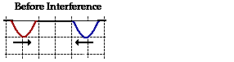

- Click on the SIMULATION. You can advance it slowly by using the cursor. Describe what you observe:

Does the behavior shown in the simulation agree with your prediction?

This type of interference is called Constructive Interference. Constructive Interference occurs when the wave amplitudes reinforce each other, building a wave of even greater amplitude.

- What would happen if the pulses are inverted, i.e. a trough meets a trough? Sketch the resultant wave:

- Another type of interference occurs when the waves are out of phase i.e. a crest meets a trough. Sketch your prediction below:
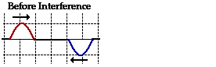

- Click STOP on the SIMULATION and select EQUAL Amplitude and OUT Phase. Describe what you observe:

Does the behavior shown in the simulation agree with your prediction?

This type of interference is called Destructive Interference. Destructive Interference occurs when the wave amplitudes oppose each other, resulting in waves of reduced amplitude.

- Now suppose that the pulses have different amplitudes. Predict what would happen by drawing a sketc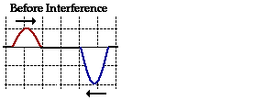h:
- Click STOP on the SIMULATION and select UNEQUAL Amplitude. In this simulation the wave with larger amplitude is the red wave. How does the resultant wave compare to your prediction?

PART 2. PRINCIPLE OF SUPERPOSITION

To determine the resultant wave we can use the Principle of Superposition:

“When two waves interfere, the resulting displacement of the medium at any location is the algebraic sum of the displacements of the individual waves at that same location.”

For each of the cases on questions 29, 32, and 34 find the amplitude of the resultant wave if each square represents one cm.

Q29. _________Q32. _________

Q34. _________

- To determine the precise shape of the medium at a given instant in time, the principle of superposition must be applied to several locations along the medium. In this example several locations have been labeled. Use the principle of superposition for each location and mark the resultant amplitude with a dot. Neatly connect the dots to find the resultant waveform.

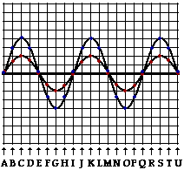

- Several positions along the medium are labeled with a letter. Categorize each labeled position along the medium as being a position where either constructive or destructive interference occurs.

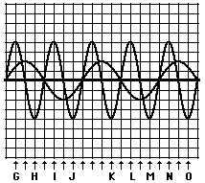

CONCLUSION PART II

- Sound is a pressure wave that consists of compressions and rarefactions. Explain constructive interference of two sound waves in terms of pressure variations.

- . A friend tells you that the word destructive tends to imply that the energy as well as the form of the waves is destroyed. Do you agree with your friend? Explain your answer.

PART III STANDING WAVES
INTRODUCTION

If you shake the end of a stretched rope, waves travel down it to the fixed end and are reflected back. The waves going down and back interfere. In most cases, the combined waveforms have a changing, jumbled appearance. But if the rope is shaken at just the right frequency, a steady waveform, or series of uniform loops, appears to stand in place along the rope.

Appropriately this phenomenon is called a Standing Wave. It arises because of interference with the reflected waves, which have the same wavelength, amplitude and speed. Since the two identical waves travel in opposite directions, the net energy flow down the rope is zero. The energy is “standing” in the loops.

- Some points on the rope remain stationary at all times and are called nodes. At these points, the displacements of the interfering waves are always equal and opposite. If you apply the principle of superposition what kind of interference occurs at these points?

- At other points, the rope oscillates back and forth at the same frequency. The points of maximum amplitude are called antinodes. What kind of interference must occur at these points?

Standing waves can be generated in a rope by more than one driving frequency. The frequencies at which standing waves are produced are called natural frequencies or resonant frequencies. The lowest natural frequency is called the fundamental frequency or first harmonic. All the other frequencies are called harmonic series (the first overtone is the second harmonic and so on.)
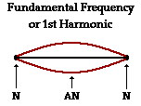
PART I. BOTH SIDES CLOSED

- Open the STANDING LONGITUDINAL WAVES simulation. This simulation shows the formation of standing waves for longitudinal waves.
- Click on BOTH SIDES CLOSED
- Record the wavelength, frequency, number of nodes antinodes, and fraction of a wave that fill the tube.
- To switch to the next harmonic press the HIGHER button.

If you have difficulty visualizing the number of waves take a look at the diagram below.
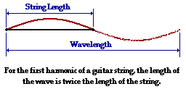

QUESTIONS:

- What pattern do you notice in terms of increasing the harmonic mode and the number of waves to fill the one-meter long tube?

- What pattern is seen in the numerator value of the fraction of waves to fill the tube?

- What pattern is seen regarding the change in frequency as the harmonic mode is increased?

- In general, for a an open tube with both sides closed, the fundamental harmonic wavelength is equal to _________________ the length of the tube.

PART II. ONE SIDE OPEN

- Click on the LOWER button to the fundamental frequency.
- Click on ONE SIDE OPEN
- Record the wavelength, frequency, number of nodes and antinodes, and fraction of a wave that fill the tube.

QUESTIONS:

- What pattern do you notice in terms of increasing the harmonic mode and the number of waves to fill the one-meter long tube?

- What pattern is seen in the numerator value of the fraction of waves to fill the tube?

- What pattern is seen regarding the change in frequency as the harmonic mode is increased?

- In general, for a tube with one side open, the fundamental harmonic wavelength is equal to _________________ the length of the tube

