Name:_________________________
Early Greeks Contributions
It has actually been known that the Earth was round since the time of the ancient Greeks. I believe that it was Pythagoras who first proposed that the Earth was round sometime around 500 B.C. He based his idea on the fact that he showed the Moon must be round by observing the shape of the terminator (the line between the part of the Moon in light and the part of the Moon in the dark) as it moved through its orbital cycle. Pythagoras reasoned that if the Moon was round, then the Earth must be round as well. After that, sometime between 500 B.C. and 430 B.C., a fellow called Anaxagoras determined the true cause of solar and lunar eclipses - and then the shape of the Earth's shadow on the Moon during a lunar eclipse was also used as evidence that the Earth was round.
Around 350 BC, the great Aristotle declared that the Earth was a sphere (based on observations he made about which constellations you could see in the sky as you travelled further and further away from the equator) and during the next hundred years or so, Aristarchus and Eratosthenes actually measured the size of the Earth!

Direction: Go to the follow QR or https://goo.gl/ZUoRrT

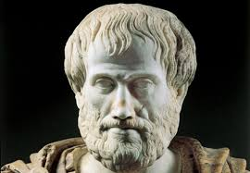

Questions for Whiteboarding – Video I: How Aristotle proved Earth was spherical
1. What was Aristotle’s’ first argument? ______________________________________________________
__________________________________________________________________________________________
2. What was Aristotle’s’ second argument? ___________________________________________________
__________________________________________________________________________________________
3. What was Aristotle’s’ third argument? ______________________________________________________
__________________________________________________________________________________________
4. What was Aristotle’s’ fourth argument? ____________________________________________________
__________________________________________________________________________________________
5. How did Aristotle justify that the Earth was a sphere and not just a flat disc?_____________________
__________________________________________________________________________________________
__________________________________________________________________________________________
6. What was Aristotle’s prediction about every lunar eclipse? ____________________________________
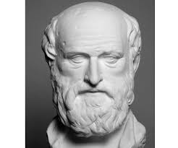
Questions for Whiteboarding – Video II - How Eratosthenes calculated the Earth’s circumference

7. What is significant about the city of Syene on June 21st_____________________________________

8. What happen on June 21st in the City of Alexandria that was different from the city of Syene?_____

_________________________________________________________________________________________

9. What did Eratosthenes concluded regarding the shadow vs no shadow?________________________

10. What is 5000 stadia?___________________________________________________________________

11. How did Eratosthenes calculate the circumference of the Earth?______________________________

__________________________________________________________________________________________
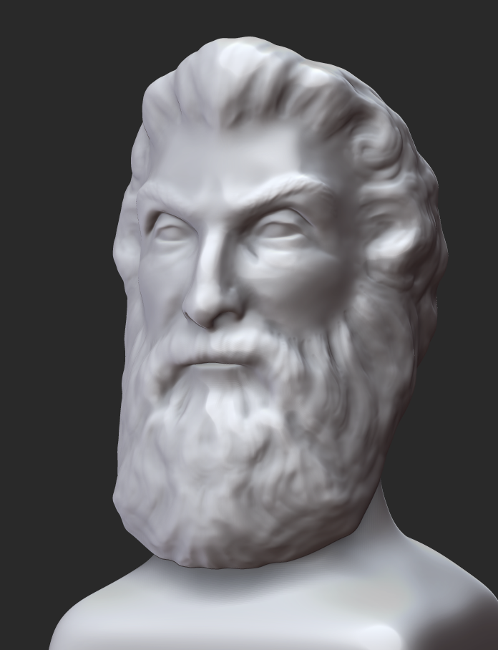
Questions for Whiteboarding – Video III – Aristarchus and his crazy idea

12. Who was the first to come up with a heliocentric model?_____________________________________

13. What did Archimedes’ book the Sand Reckoner tell about Aristarchus theory?________________

__________________________________________________________________________________________

14. What is the one writing that Aristarchus survived?__________________________________________

15. Even though Aristarchus were wrong, why was his ideas so important?_______________________

_________________________________________________________________________________________

16. What is parallax? ______________________________________________________________________

