Vertisium Video Worksheet Name:_____________________________
Date:___________________________
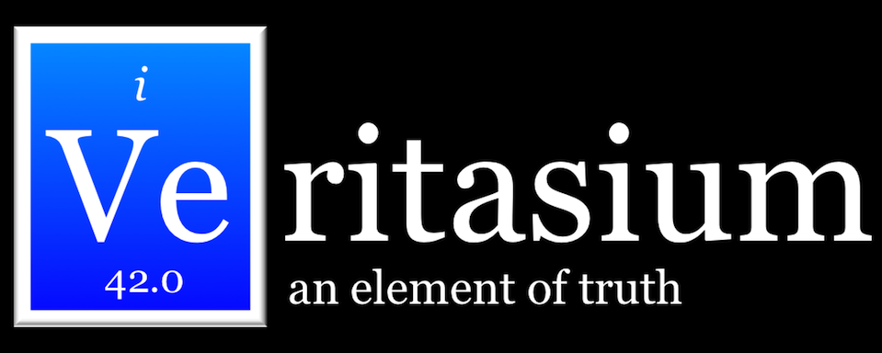
Describe the premise

Science behind

Something I learned
Conclusion
Outcome

