Name:________________________________________

**Introduction to Newton’s Law s C:\Users\Chris\AppData\Local\Microsoft\Windows\Temporary Internet Files\Content.IE5\EUJ0T5FN\MC900413302[1].wmf  
Newton’s First Law.**

* Arguably the greatest scientific genius ever.
* Came up with to explain the observations and analyses of Galileo and Johannes Kepler.
* Discovered that was composed of many colors all mixed together.
* Invented new mathematical techniques such as and theorem in his study of physics.
* Published his Laws in 1687 in the book Mathematical Principles of Natural Philosophy.

**5.1 What is Force?**

j0368408[1]

j0323684[1]

**5**.**2 Newton’s First Law**

**The First Law is Counterintuitive**

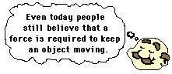

**Implications of Newton’s 1st Law**

* If there is zero net force on a body, it cannot accelerate, and therefore must move at constant velocity, which means

1.

2.

3.

**What is Zero Net Force? (Draw the picture below)**

Even though there are forces on the book, they are balanced. Therefore, there is no net force on the book. ΣF = 0

**Diagrams**

* Draw a force diagram and a free body diagram for a book sitting on a table.

Force Diagram Free Body Diagram

**Sample Problem**

1. A monkey hangs by its tail from a tree branch. Draw a force diagram representing all forces on the monkey
2. Now the monkey hangs by both hands from two vines. Each of the monkey’s arms are at a 45o from the vertical. Draw a force diagram representing all forces on the monkey.

**5.3 - Newton’s Second Law**



**Units of force**



**Working 2nd Law Problems**

1.

2.

3.

4.

5.

**Sample Problem**

In a grocery store, you push a 14.5-kg cart with a force of 12.0 N. If the cart starts at rest, how far does it move in 3.00 seconds?

A catcher stops a 92 mph pitch in his glove, bringing it to rest in 0.15 m. If the force exerted by the catcher is 803 N, what is the mass of the ball?

A 747 jetliner lands and begins to slow to a stop as it moves along the runway. If its mass is 3.50 x 105 kg, its speed is 27.0 m/s, and the net braking force is 4.30 x 105 N

a) what is its speed 7.50 s later?

b) How far has it traveled in this time?

5.4 - Newton’s Third Law

* .
* .



Sample Problem

You rest an empty glass on a table.

a) How many forces act upon the glass?

b) Identify these forces with a free body diagram.

c) Are these forces equal and opposite?

d) Are these forces an action-reaction pair?

Sample Problem

A force of magnitude 7.50 N pushes three boxes with masses m1 = 1.30 kg, m2 = 3.20 kg, and m3 = 4.90 kg as shown. Find the contact force between (a) boxes 1 and 2 and (b) between boxes 2 and 3.

1. m1 = 1.3 kg, m2 = 3.2 kg, m3 = 4.9 kg, SF = 7.5 N Find total ‘a’ for all boxes. mT = 9.4 kg, using ΣF = ma
2. Looking at box 3 only, there are 2 forces acting on it. Box 2 on 3 and the applied force.

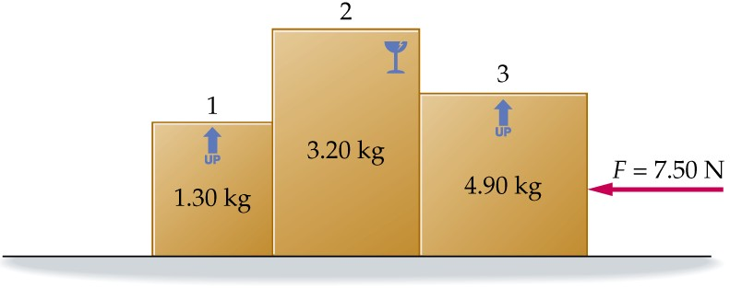

**5.5 - Newton’s 2nd Law in 2-D**



**5.6 – Mass & Weight**



Sample Problem

A man weighs 150 pounds on earth at sea level. Calculate his a) mass in kg b) weight in Newtons.

Apparent weight



Elevator rides

Going Up?

Going Down?

Sample Problem

An 85-kg person is standing on a bathroom scale in an elevator. What is the person’s apparent weight

1. when the elevator accelerates upward at 2.0 m/s2?
2. when the elevator is moving at constant velocity between floors?

Sample Problem

A 5-kg salmon is hanging from a fish scale in an elevator. What is the salmon’s apparent weight when the elevator is

1. at rest?
2. moving upward and slowing at 3.2 m/s2? a = -3.2 m/s2

**5.7 Normal Force**

Normal force on flat surface

Drawing

Normal force on ramp – **HUGE!!!!!!! UNDERSTAND CONCEPT.**

Drawing

Normal force not associated with weight

More on the Normal Force

Draw a free body diagram for the skier.



Sample problem

1. Find the normal force exerted on a 2.5-kg book resting on a surface inclined at 28o above the horizontal.
2. If the angle of the incline is reduced, do you expect the normal force to increase, decrease, or stay the same?