Electromagnetic Induction
Concept Review
Electromagnetic Waves
Use the figure below to answer the following questions.
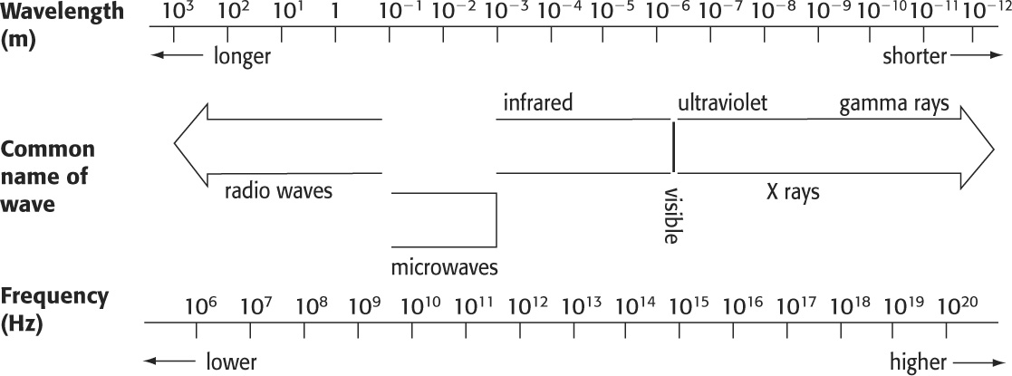
1. What does the figure above represent?

2. Place the terms “high energy” and “low energy” on the correct sides of the figure above.
3. Identify the type of relationship between wavelength and frequency, between wavelength and energy, and between frequency and energy.

4. Give a practical application of each form of electromagnetic radiation.
a. infrared e. visible light
b. X rays f. radio waves
c. ultraviolet g. gamma rays
d. microwaves

