Name:_________________________________________Date:___________________Period:______
Practice Work Problems -Section 7.1
- A 63.4 g facial tissue box is lifted at constant speed from the ground to height 1.08 m. Find work the lifter does on box.

- Student carries 63.4 g tissue box 3.2 m at constant height of 1.08 m above floor. How much work does gravity do on box?

- 25 kg mass is pulled 3.4 m across horiz. surface by 170 N horiz. force. Coefficient of friction is 0.33. Find work done by applied force.

Find work done by friction

Find work done by gravity.

Find net work done on mass.

- An intern pushes a 72 kg patient on a 15 kg gurney, producing an acceleration of 0.60 m/s². How much work does the intern do by pushing the patient and gurney through a distance of 2.5 m? Assume the gurney moves without friction.
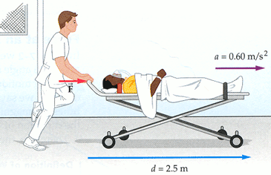

- A 75.0 kg person slides a distance of 5.00 m on a straight water slide, dropping through a vertical height of 2.50 m. How much work does gravity do on the person?

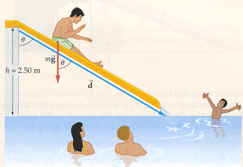
- You want to load a box into the back of a truck. One way is to lift it straight up through a height h, as shown, doing a work W₁. Alternatively, you can slide the box up a loading ramp a distance L, doing a work W₂. Assuming the box slides on the ramp without friction, which of the following is correct: (a) W₁ < W₂ , (b) , W₁ = W₂
(c) W₁ > W₂?
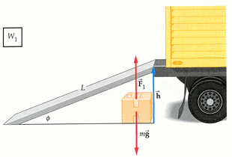

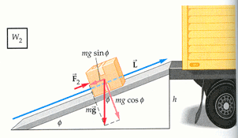

- A car of mass m coasts down a hill inclined at an angle below the horizontal. The car is acted on by three forces: (i) the normal force N exerted by the road, (ii) a force due to air resistance, F_{air}, and (iii) the force of gravity, mg. Find the total work done on the car as it travels a distance d along the road.
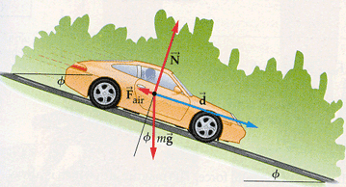

- The figure shows an overhead view of a puck on a frictionless horizontal surface. Three constant horizontal forces act on the puck in the directions indicated. The magnitude of F₁ is 10.0 N, that of F₂ is 15.0 N, and that of F₃ is 12.0 N. The puck starts from rest. What is the net work W done on the puck by the three forces when the puck has gone through a displacement of magnitude d = 0.400 m?

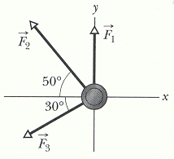

Practice Work-Energy Theorem Problems -Section 7.2
- A 4.1 kg box of books is lifted vertically from rest a distance of 1.6 m by an upward applied force of 60.0 N. Find (a) the work done by the applied force, (b) the work done by gravity, and (c) the final speed of the box.
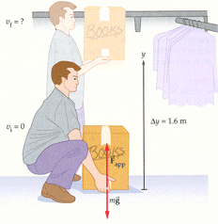

- From rest, a 72 kg object is pulled on a level surface by a horiz. 238 N force. If coeff. of kinetic friction is 0.28, how far will object have traveled by the time its speed reaches 5.0 m/s?

- The figure shows two industrial spies sliding an initially stationary 225 kg floor safe a displacement d of magnitude 8.50 m, straight toward their truck. The push F₁ of Spy 001 is 12.0 N, directed at an angle of 30⁰ downward from the horizontal: the pull F₂ of Spy 002 is 10.0 N, directed at 40⁰ above the horizontal. The magnitudes and directions of these forces do not change as the safe moves, and the floor and safe make frictionless contact. (a) What is the net work done on the safe by forces F₁ and F₂ during the displacement d? (b) During the displacement, what is the work W_{g} done on the safe by the gravitational force F_{g} and what is the work W_{N} done on the safe by the normal force N from the floor? (c) The safe is initially stationary. What is its speed V_{f} at the end of the 8.50 m displacement?

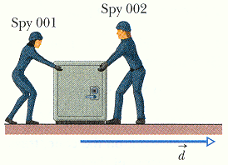

- A boy exerts a force of 11.0 N at 29⁰ above the horizontal on a 6.40 kg sled. a) Find the work done by the boy and b) the final speed of the sled after it moves 2.00 m, assuming the sled starts with an initial speed of 0.500 m/s and slides horizontally without friction.
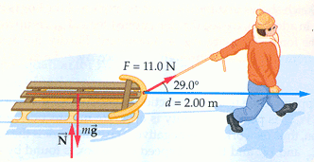

- During a storm, a crate of crepe is sliding across a slick, oily parking lot through a displacement while a steady wind pushes against the crate with a force as shown in the figure. (a) How much work does this force from the wind do on the crate during displacement? (b) If the crate has a kinetic energy of 10 J at the beginning of displacement d, what is its kinetic energy at the end of d?

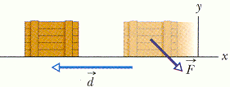

- An initially stationary 15.0 kg crate of cheese wheels is pulled, via a cable, a distance L = 5.70 m up a frictionless ramp, to a height h of 2.50 m, where it stops. See the figure. (a) How much work W_{g} is done on the crate by the gravitational force F_{g} during the lift? (b) How much work W_{T} is done on the crate by the force T from the cable during the lift?

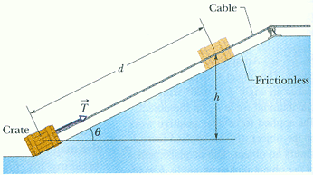

- An elevator cab of mass m = 500 kg is descending with speed v_{i} = 4.0 m/s when its supporting cable begins to slip, allowing it to fall with constant acceleration a= g/5. See the figure. (a) During the fall through a distance d = 12 m, what is the work W_{g} done on the cab by the gravitational force F_{g}? (b) During the 12 m fall, what is the work W_{T} done on the cab by the upward pull T of the elevator cable? (c) What is the net work W done on the cab during the fall? (d) What is the cab's kinetic energy at the end of the 12 m fall?

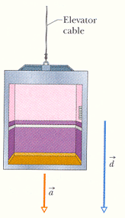
Practice – Work done by a variable force – Section 7.3
- A 1.2 block is held against a spring of force constant 1.0 x 10⁴ N/m, compressing it a distance of 0.15 m. How fast is the block moving after it is released and the spring pushes it away?

- Initially sliding with a speed of 2.2 m/s, a 1.8 kg block collides with a spring and compresses it 0.31 m before coming to a rest. What is the force constant of the spring?

Practice Power – Section 7.4
- To pass a slow-moving truck, you want your fancy 1.30 x 10³ kg , car to accelerate from 13.4 m/s to 17.9 m/s in 3.00 s. What is the minimum power required for this pass?
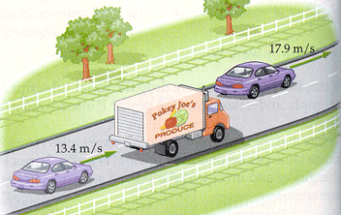
- It takes a force of 1280 N to keep a 1500 kg car moving with a constant speed up a slope of 5.0⁰. If the engine delivers 50.0 hp to the drive wheels, what is the maximum speed of the car?
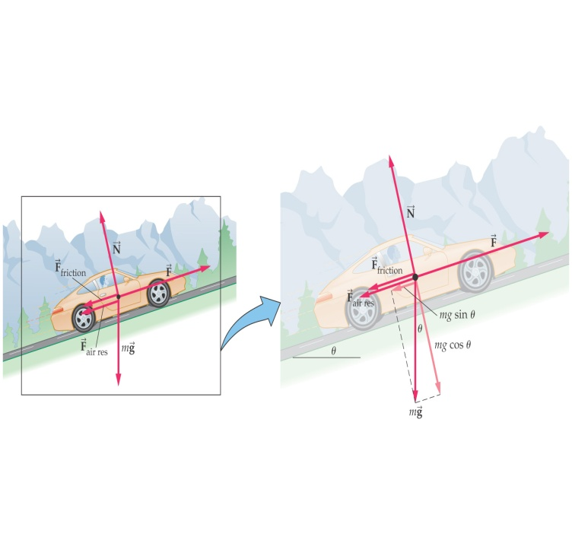

Practice Potential Energy Problems -Section 8.1
- Find the gravitational potential energy of a 65 kg person on a 3.0 m high diving board. Let U = 0 be at water level.

- An 82 kg mountain climber is in the final stage of the ascent of 4301 m high Pikes Peak. What is the change in gravitational potential energy as the climber gains the last 100 m of altitude? Let PE_{g} = 0 be (a) at sea level or (b) at the top of the peak.

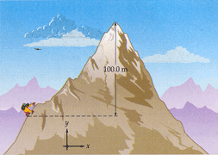
- A candy bar called the Mountain Bar has a calorie content of 210.0 Cal = 210.0 kcal, which is equivalent to an energy of 8.791 x 10⁵ J. If an 82 kg mountain climber eats a Mountain Bar and magically converts it all to potential energy, what gain of altitude would be possible?

- The figure shows a 2.0 kg block of slippery cheese that slides along a frictionless track from point a to point b. The cheese travels through a total distance of 2.0 m along the track, and a net vertical distance of 0.80 m. How much work is done on the cheese by the gravitational force during the slide?
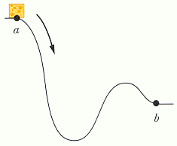

- A 2.0 kg sloth hangs 5.0 m above the ground. See figure. (a) What is the gravitational potential energy U of the sloth-Earth system if we take the reference point y = 0 to be (1) at the ground, (2) at a balcony floor that is 3.0 m above the ground, (3) at the limb, and (4) 1.0 m above the limb? Take the gravitational potential energy to be zero at y = 0. (b) The sloth drops to the ground. For each choice of reference point, what is the change ∆ U in the potential energy of the sloth-Earth system due to the fall?
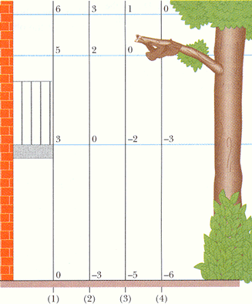

- A 40.0 kg child is in a swing that is attached to ropes 2.00 m long. Find the gravitational potential energy associated with the child relative to the child’s lowest position under the following conditions:
- When the ropes are horizontal

- When the ropes makes a 30.0° angle with the vertical

- At the bottom of the circular arc

Practice Conservation of Energy -Section 8.3
- In the figure a child of mass m is released from rest at the top of a water slide, at height h = 8.5 m above the bottom of the slide. Assuming that the slide is frictionless because of the water on it, find the child's speed at the bottom of the slide.
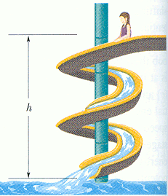
- A food shipper pushes a wood crate of cabbage heads (total mass m= 14 kg) across a concrete floor with a constant horizontal force F of magnitude 40 N. In a straight-line displacement of magnitude d = 0.50 m, the speed of the crate decreases from V_{i} =0 .60 m/s to V_{f} = 0.20 m/s. (a) How much work is done by force F? (b) What is the increase in the thermal energy of the crate and floor?

- At the end of a graduation ceremony, graduates fling their caps into the air. Suppose a 0.120 kg cap is thrown straight upward with an initial speed of 7.85 m/s, and that frictional force can be ignored. (a)Use kinematics to find the speed of the cap when it is 1.18 m above the release point. (b) Show that the mechanical energy at the release point is the same as the mechanical energy 1.18 m above the release point.
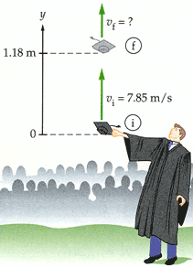
- In the bottom of the ninth inning, a player hits a 0.15 kg baseball over the outfield fence. The ball leaves the bat with a speed of 36 m/s, and a fan in the bleachers catches it 7.2 m above the where it was hit. Assuming frictional forces can be ignored, find (a) the kinetic energy of the ball when it is caught and (b) its speed when caught.

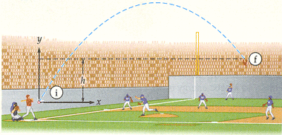

- Swimmers at a water park can enter a pool using one of two frictionless slides of equal height. Slide 1 approaches the water with a uniform slope; slide 2 dips rapidly at first, then levels out. Is the speed V₂ at the bottom of slide 2 (a) greater than, (b) less than, or(c) the same as the speed V₁ at the bottom of slide 1?
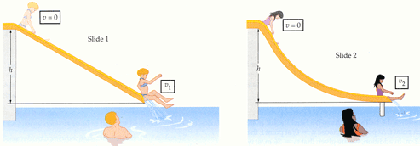

- A 55 kg skateboarder enters a ramp moving horizontally with a speed of 6.5 m/s, and leaves the ramp moving vertically with a speed of 4.1 m/s. Find the height of the ramp, assuming no energy loss to frictional forces.
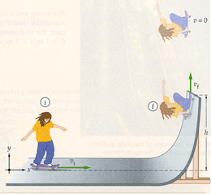
- A snowboarder coasts on a smooth track that rises from one level to another. If the snowboarder's initial speed is 4 m/s, the snowboarder just makes it to the upper level and comes to rest. With a slightly greater initial speed of 5 m/s, the snowboarder is still moving to the right on the upper level. Is the snowboarder's final speed in this case(a) 1 m/s, (b) 2 m/s, or (c) 3 m/s?
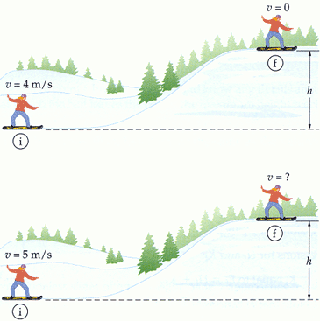
- A block of mass m₁ = 2.40 kg is connected to a second block of mass, m₂ = 1.80 kg as shown in the figure. When the blocks are released from rest they move through a distance d = 0.500 m, at which point m₂ hits the floor. Given that the coefficient of kinetic between m1 and the horizontal surface is μ_{k} = 0.450 , find the speed of the blocks just before m₂ lands.
