Chapter 21 – Practice Problems
Section 21.1-21.2

- The disk drive in a portable CD player is connected to a battery that supplies it with a current of 0.22 A. How many electrons pass through the drive in 4.5 s?

- A battery with an emf of 1.5 V delivers a current of 0.44 A to a flashlight bulb for 64 s. Find (a) the charge that passes through the circuit and (b) the work done by the battery.

- A small cell has an emf of 0.80 V and can supply 10.0 mA under normal operating conditions. How should a battery be constructed if it is to have an emf of 12.0 V and an operating current of 30.0 mA? How many cells will be needed?

Section 21.4

- A potential difference of 24 V is applied to a 150 Ω resistor. How much current flows through the resistor?

- Wire 1 has a length and a circular cross section of diameter D. Wire 2 is constructed from the same material as wire 1 and has the same shape, but its length is 2L, and its diameter is 2D. Is the resistance of wire 2 (a) the same as that of wire 1, (b) twice that of wire 1, or (c) half that of wire 1?

- A current of 1.82 A flows through a copper wire 1.75 m long and 1.10 mm in diameter. Find the potential difference between the ends of the wire.

- A handheld electric fan operates on a 3.00 V battery. If the power generated by the fan is 2.24 W, what is the current supplied by the battery?

- A battery that produces a potential difference V is connected to a 5 W light bulb. Later, the 5 W light bulb is replaced with a 10 W light bulb. (a) In which case does the battery supply the greatest current? (b) Which light bulb has the greatest resistance?

- A battery with an emf of 12 V is connected to a 545 Ω resistor. How much energy is dissipated in the resistor is 65 s?

- A holiday goose is cooked in the kitchen oven for 4.00 h. Assume that the stove draws a current of 20.0 A, operates at a voltage of 220.0 V, and uses electrical energy that costs $0.048 per kWh. How much does it cost to cook your goose?

Section 21.4
- A circuit of three resistors connected in series to a 24.0 V battery. The current in the circuit is 0.0320 A. Given that R₁ = 250.0 Ω and R₂ = 150.0 Ω , find (a)the value of R₃ and (b) the potential difference across each resistor.

- Two identical light bulbs are connected to a battery, either in series or in parallel. Are the bulbs in series(a) brighter, (b) dimmer, or (c) the same brightness as the bulbs in parallel?

- In the circuit shown in the diagram, the emf of the battery is 12.0 V, and all the resistors have a resistance of 200.0 Ω . Find the current supplied by the battery to this circuit.

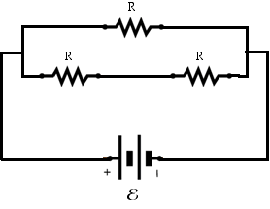
Section 21.5
- Find the currents I₁, I₂, and I₃ in the circuit shown in the figure.
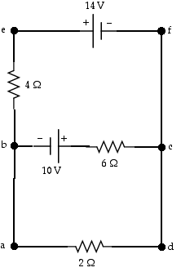
- (a) Under steady-state conditions, find the unkown currents I₁, I₂, and I₃ in the multiloop circuit shown in the figure.(b) What is the charge on the capacitor?
