Linear Webquest
Part I.- Constant Velocity versus Acceleration
1. Which car or cars (red, green, and/or blue) are undergoing an acceleration? How can you tell the difference in motion?

2. Look at the Position-Time graphs of each of the cars.
Sketch and label the graphs of each of the cars

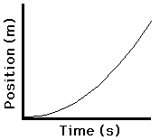

3. Write the mathematical relationship of the position and time described by each of the car's graphs. Right below each of them substitute the appropriate variables.

4. Sketch a qualitative Velocity-Time graph for each car and label each line.

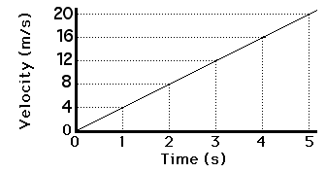

5. What quantity (i.e. variable not a numerical value) is obtained by calculating the area under the curve of a velocity-time graph?

6. What quantity (i.e. variable not a numerical value) is obtained by calculating the slope of the velocity-time graph?

Part II. - Direction of Velocity and Acceleration
7. Accelerating objects have a changing velocity - either due to a speed change or a direction change. Considering east as a positive direction and west as a negative. Complete the table below by writing the direction of each vector as (+) or (-)
SituationVelocity Acceleration
Car speeding up going East
Car speeding up going West
Car slowing down going East
Car slowing down going West
8. What is the Rule of Thumb to determine the direction of acceleration?

Part III. Watch The Stoplight
A blue car moving at a constant speed of 10 m/s passes a red car that is at rest. This occurs at a stoplight the moment that the light turns green. The red car accelerates from rest at 4 m/s/s for 3 s and then maintains a constant speed.
9. Calculate at what speed does the red car travel after 3 s. Show all your work.

10. Use your ruler to plot a velocity-time graph for both cars for an interval of 12 seconds.
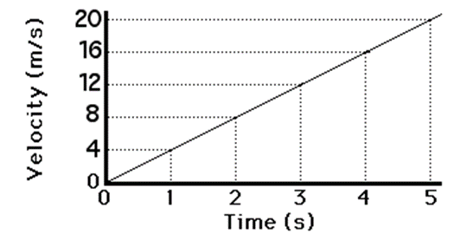
11. Calculate the slope of the line for the red car for the first three seconds. Show all your work!

12. Use the graph to find the displacement of each individual car after 9 seconds. Mark your work clearly on the graph.

13. Does the red car pass the blue car at three seconds? If not, then when does the red car pass the blue car?

14. When lines on a velocity-time graph intersect, does this mean that the two cars are passing by each other? If not, what does it mean?

Part IV. Motion Virtual Lab
- Constant Positive Velocity:

Write the letter that completes the description below using the following words. You may use the words more than once.
a) acceleration
b) position
c) zero
d) constant velocity
e) positive velocity

15. _____ The "dot-trail" shows that the object has equal _______ intervals.
16. _____ Therefore we can say that the dot moves at _______________.
17. _____The upward slope of the position-time graph shows that the object is traveling with a constant________
18. _____The velocity-time graph shows a horizontal line with a _____ slope.
19. _____ This means that there is no ________.
20._____The line in the v-t graph is located in the positive region of the graph corresponding to a _______.
21. _____The acceleration-time graph shows a horizontal line at the _____ mark.
B. Find the slope of the position-time line. SHOW ALL YOUR WORK.

- Constant Negative Velocity
A. Write the letter that completes the description below using the following words. You may use the words more than once.
a) acceleration
b) zero
c) negative velocity
22. _____ The downward slope of the position-time graph shows that the object is traveling with a constant ________ .
23. _____The velocity-time graph shows a horizontal line with a _____ slope.
24. _____ This means that there is no ________.
25. _____The line in the v-t graph is located in the negative region of the graph corresponding to a ____________.
26. _____The acceleration-time graph shows a horizontal line at the _____ mark.
B. Find the slope of the position-time line. SHOW ALL YOUR WORK.

- Rightward Velocity and Positive Acceleration
Write the letter that completes the description below using the following words. You may use the words more than once.
a) velocity
b) positive velocity
c) positive
d) positive acceleration
27. _____ An object that moves in the positive direction has a _____velocity.
28. _____ If the object is speeding up, then its acceleration is directed in the same direction as its motion, this means that the object has ______ ______.
29. _____ The "dot trail" shows that each consecutive dot is not the same distance apart. Therefore, the _________ is changing.
30. _____ The position-time graph shows that the slope is changing meaning that the ______ is changing.
31. _____ The velocity-time graph is located in the positive region of the graph indicating a _________ _____________.
32. _____ The v-t line has a positive slope meaning that there is a _________ acceleration.
33. _____ The acceleration-time graph shows a horizontal line in the_____ region of the graph.
34. _____ This means that the object has a ______________ ____________.

- Rightward Velocity and Negative Acceleration
A. Write the letter that completes the description below using the following words. You may use the words more than once.
a) positive velocity
b) negative
c) negative acceleration

35. _____ If the object is slowing down, then its acceleration is directed in the opposite direction as its motion, this means that the object has ______ ________.
36. ______The velocity-time graph is located in the positive region of the graph indicating a ________ _________.
37. _____ The v-t line has a negative slope meaning that there is a _________ acceleration.
38. _____ The acceleration-time graph shows a horizontal line in the_____ region of the graph.
39. _____ This means that the object has a ______________ ____________.
B. Find the slope of the velocity-time line. SHOW ALL YOUR WORK

- Leftward Velocity and Negative Acceleration
A. Write the letter that completes the description below using the following words. You may use the words more than once.
a) negative
b) negative acceleration

40. _____If the object is speeding up, then its acceleration is directed in the same direction as its motion, this means that the object has ______ ______.
41. _____ The position-time graph shows a __________ slope.
42. _____ This means that the velocity is ___________.
43. _____ The v-t line has a negative slope meaning that there is a _________acceleration.
44. _____ The acceleration-time graph shows a horizontal line in the_____ region of the graph.
45. _____ This means that the object has a ______________ ____________.

B. Find the slope of the velocity-time graph. SHOW ALL YOUR WORK

- Negative Velocity and Positive Acceleration
A. Write the letter that completes the description below using the following words. You may use the words more than once.
a) negative velocity
b) positive
c) positive acceleration

46. _____ An object that moves in the negative direction has a _____ _________.
47 _____ If the object is slowing down, then its acceleration is directed in the opposite direction as its motion, this means that the object has ______ ________.
48 _____ The v-t line has a positive slope meaning that there is a _________ acceleration.

B. Find the slope of the velocity-time graph. SHOW ALL YOUR WORK

