Dynamics Experiment How Does A Spring Scale Work?
Hooke's Law

Purpose:
- To investigate Hooke's Law (The relation between force and stretch for a spring)
- To investigate Newton's Laws and the operation of a spring scale.

Discussion:
Everybody knows that when you apply a force to a spring or a rubber band, it stretches. A scientist would ask, "How is the force that you apply related to the amount of stretch?" This question was answered by Robert Hooke, a contemporary of Newton, and the answer has come to be called Hooke's Law.
Hooke's Law, believe it or not, is a very important and widely-used law in physics and engineering. Its applications go far beyond springs and rubber bands.
You can investigate Hooke's Law by measuring how much known forces stretch a spring. A convenient way to apply a precisely-known force is to let the weight of a known mass be the force used to stretch the spring. The force can be calculated from W = mg. The stretch of the spring can be measured by noting the position of the end of the spring before and during the application of the force.

Equipment:
Spring | rubber band | ring stand
ring-stand clamps | c-clamp | spring scale | ruler or meter stick
set of known masses

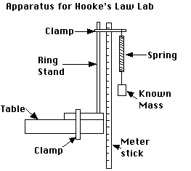
Safety Notes:
- Be sure to keep your feet out of the area in which the masses will fall if the spring or rubber band breaks!
- Be sure to clamp the ring stand to the lab table, or weight it with several books so that the mass does not pull it off the table.
- You need to hang enough mass to the end of the spring to get a measurable stretch, but too much force will permanently damage the spring. (An engineer would say that it has exceeded its "elastic limit"). "You break it, you bought it."

Procedure:
- Assemble the apparatus as shown in the diagram above. Be sure to clamp the ring stand to the lab table, or weight it with several books.
- Construct a data table. You will need to record the mass that you hang from the spring and the position of the end of the spring before and after the mass is added. From this, you will calculate the force applied to the spring and the resulting stretch of the spring. You should allow for at least 8-10 trials. (A sample data table is shown below.)
- For each trial, record the mass, the starting position of the spring (before hanging the mass) and the ending position of the spring (while it is being stretched).
- Repeat the process for a rubber band.
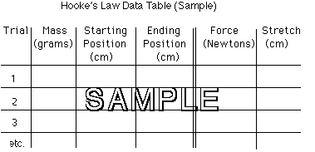
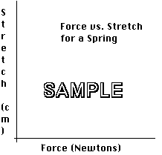

Results:
- Calculate the force applied to the spring/rubber band in each trial (W = mg) Use g = 9.81 m/s².
- Calculate the stretch of the spring/rubber band in each trial (the difference in the starting and ending positions).
- Draw graphs of force versus stretch for the spring and the rubber band. You may be able to put both graphs on the same sheet of graph paper, depending on the data.

Conclusions:
Hooke's Law says that the stretch of a spring is directly proportional to the applied force. (Engineers say "Stress is proportional to strain".) In symbols, F =1/2kx², where F is the force, x is the stretch, and k is a constant of proportionality. If Hooke's Law is correct, then, the graph of force versus stretch will be a straight line.
Do your results confirm or contradict Hooke's Law? Please elaborate.

Discussion Questions:
Examine a spring scale. It is a simple device that measures force by measuring the amount that the force stretches a spring.
- Hang an object (at rest) from the spring scale. Draw a set of diagrams that shows all of the forces that act:
  - on the object
  - on the spring scale
- What is the net force on:
  - the object?
  - the spring scale?
- Are the forces that act on the object equal and opposite? Are they a Newton's Third Law force pair?
- Are the forces that act on the spring scale equal and opposite? Are they a Newton's Third Law force pair?
- For each force in your diagrams (question 1), indicate its Newton's Third Law "partner". Be sure to indicate (a) what the force pushes or pulls on, and (b) its direction

