Name:__________________________________Date:_________________Period:____
Chapter 4 – Guided Practice Problems - Projectile Launched Horizontally
- A baseball rolls off a 0.70 m high desk and strikes the floor 0.25 m away from the base of the desk. How fast was the ball rolling?

- In a scene in an action movie, a stuntman jumps from the top of one building to the top of another building 4.0 m away. After a running start, he leaps at a velocity of 5.0 m/s at an angle of 15° with respect to the flat roof. Will he make it to the other roof, which is 2.5 m shorter than the building he jumps from?

- A baseball is thrown at an angle of 25° relative to the ground at a speed of 23.0 m/s. If the ball was caught 42.0 m from the thrower, how long was it in the air? How high did the ball travel before being caught?

- A cat chases a mouse across a 1.0 m high table. The mouse steps out of the way and the cat slides off the table and strikes the floor 2.2 m from the edge of the table. When the cat slid off the table, what was its speed?

- An eagle perched on a tree limb 19.5 m above the water spots a fish swimming near the surface. The eagle pushes off from the branch and descends toward the water. By adjusting its body in flight, the eagle maintains a constant speed of 3.10 m/s at an angle of 20.0 deg below the horizontal. (a) How long does it take for the eagle to reach the water? (b) how far has the eagle traveled in the horizontal direction when it reaches the water?
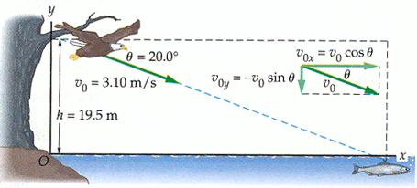

- A mountain climber encounters a crevasse in an ice field. The opposite side of the crevasse is 2.75 m lower, and is separated horizontally by a distance of 4.10 m. To cross the crevasse, the climber gets a running start and jumps in the horizontal direction. (a) What is the minimum speed needed by the climber to safely cross the crevasse? If, instead the climber's speed is 6.00 m/s, (b) where does the climber land, and (c) what is the climber's speed on landing

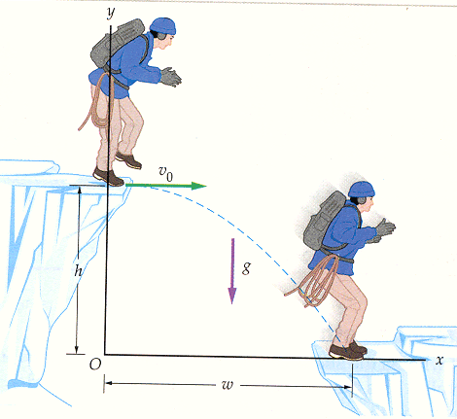

- Chipping from the rough, a golfer sends the ball over a 3.00 m high tree that is 14.0 m away. The ball lands at the same level from which if was struck after traveling a horizontal distance of 17.8 m on the green, of course. (a) If the ball left the club 54.0 deg above the horizontal and landed on the green 2.24 s later, what was its initial speed? (b) How high was the ball when it passed over the tree?
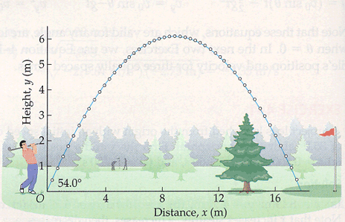
- A golfer hits a ball with an initial speed of 30.0 m/s at an angle of 50.0 deg above the horizontal. The ball lands on a green that is 5.00 m above the level where the ball was struck. (a) How long is the ball in the air? (b) How far has the ball traveled in the horizontal direction when it lands? (c) What is the speed and direction of motion of the ball just before it lands?

- A trained dolphin leaps from the water with an initial speed of 12.0 m/s. It jumps directly toward a ball held by the trainer a horizontal distance of 5.50 m away and a vertical distance of 4.10 m above the water. In the absence of gravity the dolphin would move in a straight line to the ball and catch it, but because of gravity the dolphin follows a parabolic path well below the ball's initial position. If the trainer releases the ball the instant the dolphin leaves the water, show that the dolphin and the falling ball meet.
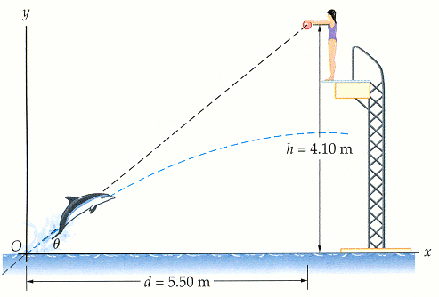
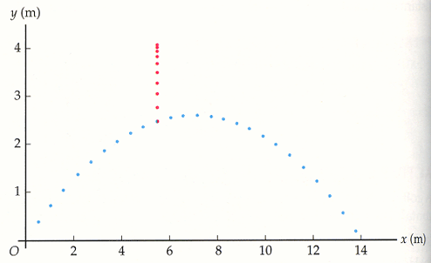
- The archerfish hunts by dislodging an unsuspecting insect from its resting place with a stream of water expelled from the fish's mouth. Suppose the archerfish squirts water with an initial speed of 2.30 m/s at an angle of 19.5 deg above the horizontal. When the stream of water reaches a beetle on a leaf a height h above the water's surface it is moving horizontally. (a) How much time does the beetle have to react? (b) What is the height h of the beetle? (c) What is the horizontal distance d between the fish and the beetle when the water is launched?
