Name:__________________________________________________________Date:________________________

Phases of the Moon Webquest
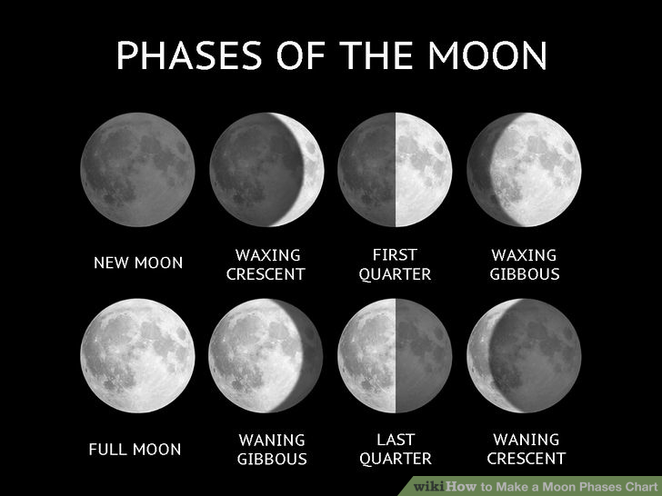
Fun Fact:
The Moon (or Luna) is the Earth’s only natural satellite and was formed 4.6 billion years ago around some 30–50 million years after the formation of the solar system. The Moon is in synchronous rotation with Earth meaning the same side is always facing the Earth. The first unmanned mission to the Moon was in 1959 by the Soviet Lunar Program with the first manned landing being Apollo 11 in 1969.

Go To: http://www.astrosociety.org/education/publications/tnl/12/12.html
- Describe The Moon’s orbit:
a. Shape:_________________________________________________________________

b. Direction of Revolution (as view from the Northern Hemisphere)_____________________

c. It is exactly in line with the equator, or is it slightly tilted_________________________
d. Fill in the blank:
The point on earth directly under the moon is never more than__________________north or south of the_________________________

Go To: http://starchild.gsfc.nasa.gov/docs/StarChild/solar_system_level2/moonlight.html
- How many days are there in the cycle of the moon phases? __________________

- Read about each phase

- Test yourself with the phases chart

Go to: http://www.moonconnection.com/moon_phases_calendar.phtml
Select: August, 2017, Northern Hemisphere
2. On the blank lines write a phase name and the dates when that 8 phase will occur this month.
a. New Moon __________ e.
b. f.
c. g.
d. f.

