Fluid Mechanics

Section 8.1 - Fluids and the buoyant force
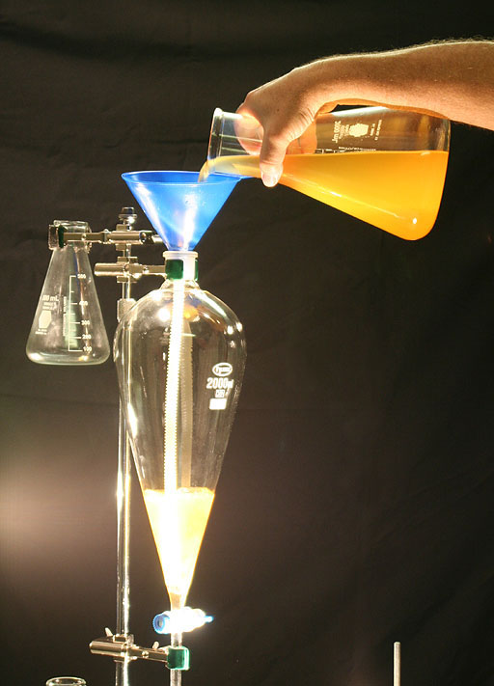

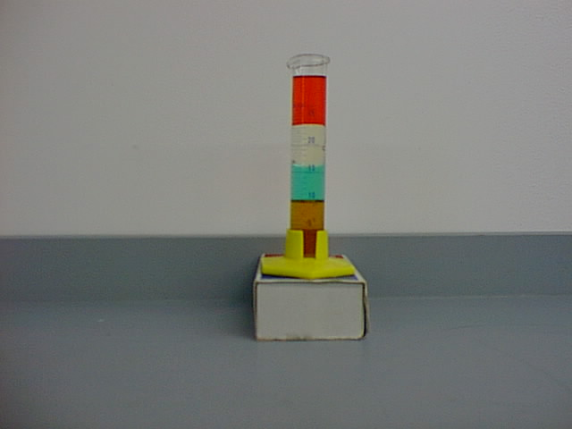
Section 8.1 Fluid Density
Density is
Mass density

Section 8.1 Buoyant Forces
Buoyant Force

Act in a direction
When the object net force

Buoyant Force:

Buoyant Force on a floating object

Section 8.1 Relationships between weight of object and buoyant force
Can balloons lift a little girl of the ground?

Section 8.2 Fluid Pressure
Pressure.

SI unit

Pascal's principle :

Hydraulic Lift

Absolute Pressure
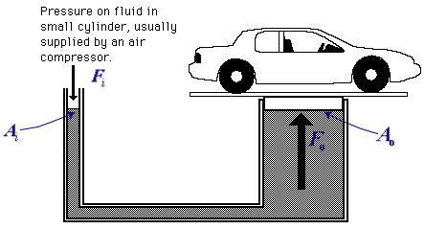
Absolute pressure

Fluid Pressure

This is the expression for Archimedes Principle
Section 8.3 – Fluids in Motion
- Ideal fluid is a fluid that _________________________ and is incompressible.
- _____________ refers to the amount of _______________ within a fluid.
- ______ viscosity flows more _______ (caused by the friction of the fluid particles sliding past each other) – this is those intermolecular forces from chemistry
- Ideal fluids are “______________________” loses no kinetic energy due to friction as they flow. (_______________)
- ___________________________________
- Area and the speed of the flow in one area must equal the area and the speed in a another area = this is from conservation of mass.
- _______________________________

Bernoulli’s Principle

