Name: ___________________________________ Period: __________________ Date: _________________

Exploring Gravity
Learning Goals

- Students will investigate the variables that affect gravity.

QUESTION: How does gravity affect objects?

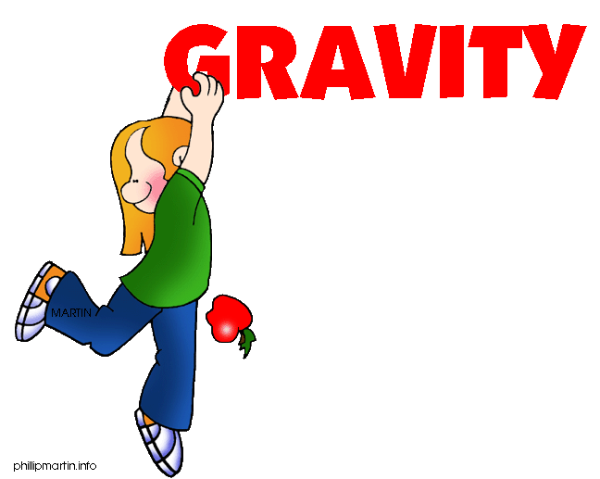

Jasmine and Emily were learning about forces in class. They learned that a force was either a push or a pull. Emily wondered if gravity was a force. She knew that when she dropped her book it was pulled down to the ground. Jasmine knew that the moon had less gravity than the earth, but she wasn’t sure why.

Check the circle containing the statement you agree with:

- Gravity depends on the material of the objects.
- Gravity is not a force because it can’t move objects.
- Gravity is a force because a force is a push or a pull.
- The moon has less gravity than the Earth because it has less mass than the Earth.
- The moon has less gravity than the Earth because it has no atmosphere.

Background information:

Variable-A variable is any factor that can be changed or controlled

Independent Variable – something that is changed by the scientist
- What is tested
- What is manipulated

Dependent Variable – something that might be affected by the change in the independent variable
- What is observed
- What is measured
- The data collected during the investigation

INSTRUCTIONS: Open up the Gravity simulation on the PhET website. http://tinyurl.com/ma8rw9x

- Get familiar with the simulation by moving the figures back and forth as well as changing the mass of the spheres.

- Circle the different variables that can be found in this simulation.

Distance between figures Mass of the spheres
Force Size of the figures
Strength of the figures Size of the meter stick

- What do you think the size of the arrows on top of each sphere represent?

- Pick a variable to manipulate (the independent variable). Summarize what you changed and what happened in the table below:

Manipulated (Independent) Variable | Dependent Variable

- Change a different variable and summarize what happens in the table below:

Manipulated (Independent) Variable | Dependent Variable

True or False
Circle the correct answer.

1. Gravity is a force that can be changed. T/F

2. The bigger an object is, the smaller the force of gravity. T/F

3. As one object gets closer to another object, the force of gravity will increase. T/F

4. The Sun has a greater gravitational force than Jupiter. T/F

Circle the Correct Answer

Circle the pair with the greater gravitational force.

- 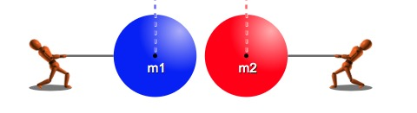

Explain why you chose the diagram you did.

2. 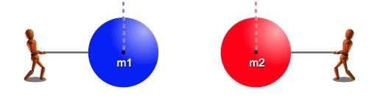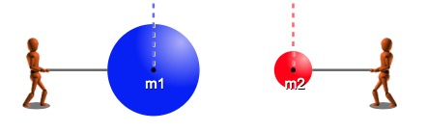

Explain why you chose the diagram you did.

Analysis Question: Why do you think Saturn and Jupiter have more moons than the other planets in our solar system?

Name____________________________________________________________________________________

Exit Slip

Question | Answer
Can gravity be considered a force? Why or why not?
What variable(s) affect gravity?
Questions I still have, things I am confused about

OPTIONAL CLAIM-EVIDENCE-REASONING/ANALYSIS

QUESTIONS:
1. Can gravity be considered a force?
CLAIM:

EVIDENCE:

SCIENTIFIC REASONING:

2. What variables affect gravity?
CLAIM:

EVIDENCE:

SCIENTIFIC REASONING:

