Science 9
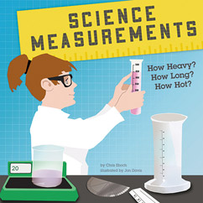
Student Learning Objectives
Unit 2: NEWTON LAWS (Chapter 4)
For each of the following objectives rate yourself according to the following scale:
4 I’m an EXPERT. I understand the topic well enough that I could teach it to a classmate.
3 I’m a PRACTITIONER. I understand the topic fairly well but occasionally need some help.
2 I’m an APPRENTICE. I have some understanding, but still need additional help.
1 I’m a NOVICE. I sort of know what the topic is about but need a lot of help.
Your goal is to reach or pass practitioner level by the day of the test.
Book Section | Objectives | Instructional Sources | My Self Rating
1.1 What is Science?  pgs 1-6 | I can distinguish between the difference branches of science and understand how they overlap. | PPT Notes
 |  | Vocabulary 7
 |  | WS Nature of Science
1.2 Using a Scientific Approach  Pgs 7-11 | I can use the scientific method in science and related fields. | PPT Notes
 |  | Vocabulary 9
 |  | Observation Lab
 |  | WS Simpson
1.3 Measurements  Pgs 12-21 |  | PPT Notes
 | I can use the vocabulary of measurement in science 9 | Vocabulary 10
 | I can convert scientific notation correctly. | WS Scientific Notion
 | I can use the metric prefixes and convert between them | WS Metric Prefixes
 | I can convert between the different temperature scales | WS Temperature
1.4 Presenting Scientific Data  Pgs 22-27 | I can present my scientific data using variety of methods | PPT Notes
 | I can organize and analyze a data table and graphs | Paper Towel Lab
 | I can identify the relationship between the manipulated and responding variables | WS Graph Analysis

