Conservation of Energy: Potential into Kinetic Energy Lab

Background:
In this lab you will investigate how potential energy is changed into kinetic energy. A mass falling towards the floor will pull a cart along a horizontal track. The change in potential energy (PE_{g} = mgh) of the falling mass shows up as kinetic energy (KE = 1/2mv²) if frictional forces are small.

Materials:
Cart pulley
Small masses meter stick
Balance timer
String

Procedures:
Case 1:
- Find the mass of the cart and the mass of the object which will fall to the fall with a balance.
- Attach a light string between the mass and cart and place the string over the pulley. The string should be long enough so that the mass can be next to the pulley then fall to the floor without having the cart hit the pulley (see figure 7)
- With a meter stick, measure the distance which the mass falls as it goes from next to the pulley to the fall.
- Measure the time for the mass to go from the pulley to the floor. Start the clock when someone release the cart and stop it when the mass hits the floor. Run a few trails and use the average time. The time will be used to calculate the velocity at which the cart and the mass are moving.
Case 2:
- Find the time for the mass to drop when the falling mass is doubled.
Case 3:
- Use the cart with twice the mass of the original and the same mass you used in case 2.
Caution: make sure the mass drops the same height each time.

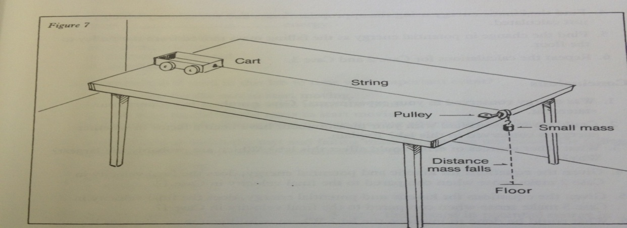
Analysis:
- For the date you obtained in each case, find the average time for the mass to hit the ground.
- Find the average velocity of the cart as it moves down the track.
- Given that the cart starts from rest, the final velocity is twice the average velocity. (What equations shows this?). Therefore, find the final velocity that the cart and the falling mass were going just before hitting the floor.
- Find the kinetic energy using the appropriate mass the velocity which you just calculated.
- Find the potential energy as the falling mass moved from the pulley to the floor.
- Repeat the calculations for case 2 and case 3.
Conclusions:
- Was energy conserved in your experiment?, Give numbers to support your statement.
- Could errors associated with you measurements have been a factor in whether energy is conserved in this lab? Explain.
- What others sources of error could affect this lab?. Which are probably the largest and why?
- Given the equations for kinetic energy and potential energy, does the final velocity in case 2 makes sense when compared to the final velocity in case 1?
- Given the equations for kinetic energy and potential energy, does the final velocity in case 3 makes sense when compared to the final velocity in case 1?
- What could have been done to improve this lab? Where would you make changes if you could make them?

