Chapter 9 Practice Problems
Momentum
- A 1180 kg car drives along a city street at 30.0 mph (13.4 m/s). What is the magnitude of the car's momentum?

- A major league pitcher can give a 0.142 kg baseball a speed of 101 mph (45.1 m/s). Find the magnitude of the baseball's momentum?

- The figure shows a 2.0 kg toy race car before and after taking a turn on a track. Its speed is 0.50 m/s before the turn and 0.40 m/s after the turn. What is the change in the linear momentum of the car due to the turn?
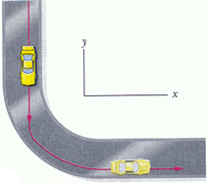

- At a city park, a person throws some bread into a duck pond. Two 4.00 kg ducks and a 9.00 kg goose paddle rapidly toward the bread, as in the figure. If the ducks swim at 1.10 m/s, and the goose swims with a speed of 1.30 m/s, find the magnitude and direction of the total momentum of the three birds.

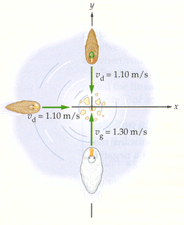

Impulse
- A 0.144 kg baseball is moving toward home plate with a speed of 43.0 m/s when it is bunted (hit softly). The bat exerts an average force of 6.5 x 10³ N on the ball for 1.30 ms. The average force is directed toward the pitcher, which we take to be positive x direction. What is the final speed of the ball?

- A person stands under an umbrella during a rain shower. A few minutes later the rain drops turn to hail–though the number of "drops" hitting the umbrella per time and the speed remains the same. Is the force required to hold the umbrella in the hail (a) the same as(b) more than, or (c) less than the force required in the rain?
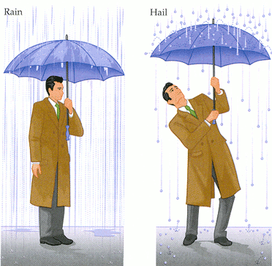
- After winning a prize on a game show, a 72 kg contestant jumps for joy. (a) If the jump results in an upward speed of 2.1 m/s, what is the impulse experienced by the contestant? (b) Before the jump, the floor exerts an upward force of mg on the contestant. What additional average upward force does the floor exert if the contestant pushes down on it for 0.36 sec during the jump?
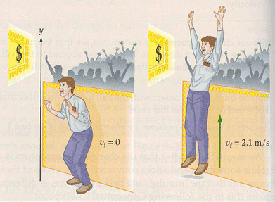

Conservation of Energy
- Two groups of canoeists meet in the middle of a lake. After a brief visit, a person in canoe 1 pushes on canoe 2 with a force of 46 N to separate the canoes. If the mass of canoe 1 and its occupants is 130 kg, and the mass of canoe 2 and its occupants is 250 kg, find the momentum of each canoe after 1.20 s of pushing.
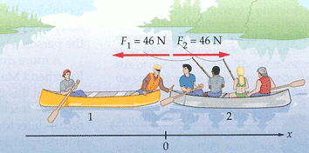

- In example 8, the final momentum of the system (consisting of the two canoes and their occupants) is equal to the initial momentum of the system. Is the final kinetic energy (a) equal to, (b) less than, or(c) greater than the initial kinetic energy?

- A honeybee with a mass of 0.150 g lands on one end of a floating 4.75 g Popsicle stick. After sitting at rest for a moment, it runs toward the other end with a velocity v_{b} relative to the still water. The stick moves in the opposite direction with a speed of 0.120 cm/s. What is the velocity of the bee? (Let the direction of the bee's motion be the positive x direction.)
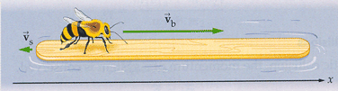

- A ballot box with mass m = 6.0 kg slides with speed v = 4.0 m/s across a frictionless floor in the positive x direction on an x axis. It suddenly explodes into two pieces. One piece, with mass m₁ = 2.0 kg, moves in the positive direction of the x axis with speed v₁ = 8.0 m/s. What is the velocity of the second piece, with mass m₂?

- A firecracker placed inside a coconut of mass M, initially at rest on a frictionless floor, blows the coconut into three pieces that slide across the floor. See the figure below. Piece C, with mass 0.30M, has final speed . V_{fc} = 5.0 m/s.
(a) What is the speed of piece B, with mass 0.20M?
(b) What is the speed of piece A?
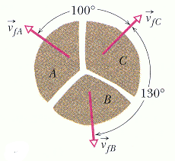
Collisions
- A 1200 kg car moving at 2.5 m/s is struck in the rear by a 2600 kg truck moving at 6.2 m/s. If the vehicles stick together after the collision, what is their speed immediately after colliding?

- A railroad car of mass m and speed v collides and sticks to an identical railroad car that is initially at rest. After the collision, is the kinetic energy of the system (a) 1/2, (b) 1/3, or (c) 1/4 of its initial kinetic energy?

- On a touchdown attempt, a 95.0 kg running back runs toward the end zone at 3.75 m/s. A 111 kg linebacker moving at 4.10 m/s meets the runner in a head-on collision. If the two players stick together, (a) what is their velocity immediately after the collision? (b) What are the initial and final kinetic energies of the system?
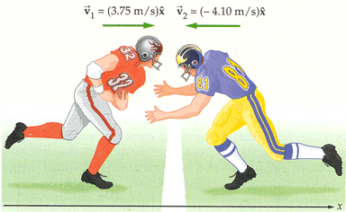
- A pitched 140 g baseball, in horizontal flight with a speed v_{i} of 39.0 m/s, is struck by a bat. After leaving the bat, the ball travels in the opposite direction with speed v_{f}, also 39.0 m/s.
(a) What impulse acts on the ball while it is in contact with the bat during the collision?
(b) The impact time ∆t for the baseball-bat collision is 1.20 ms. What average force acts on the baseball?
(c) Now suppose the collision is not head-on, and the ball leaves the bat with a speed v_{f} of 45.0 m/s at an upward angle of 30.0⁰ . What now is the impulse on the ball?
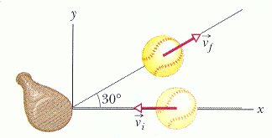
- In a ballistic pendulum, an object of mass m is fired with an initial speed v₀ at the bob of a pendulum. The bob has a mass M, and is suspended by a rod of negligible mass. After the collision, the object and the bob stick together and swing through an arc, eventually gaining a height h. Find the height h in terms of m, M, v₀, and g.
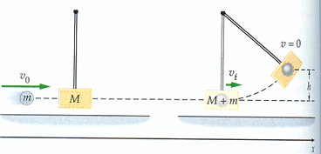

- The ballistic pendulum was used to measure the speeds of bullets before electronic timing devises were developed. The version shown in the figure consists of a large block of wood of mass M = 5.4 kg, hanging from two long cords. A bullet of mass m = 9.5 g is fired into the block, coming quickly to rest. The block +bullet then swing upward, their center of mass rising a vertical distance h = 6.3 cm before the pendulum comes momentarily to rest at the end of its arc. What is the speed of the bullet just prior to the collision?
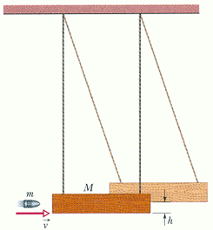
- Two metal spheres, suspended by vertical cords, initially just touch, as in the figure. Sphere 1, with mass m₁ = 30g, is pulled to the left to height h₁= 8.0 cm, and then released from rest. After swinging down, it undergoes an elastic collision with sphere 2, whose mass m₂ = 75 g. What is the velocity v_{1f} of sphere 1 just after the collision?
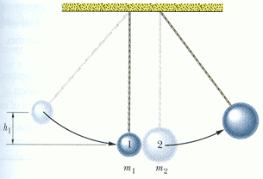
Collisions in 2 –D
- A car with a mass of 950 kg and a speed of 16 m/s approaches an intersection, as shown. A 1300 kg minivan traveling at 21 m/s is heading for the same intersection. The car and minivan collide and stick together. Find the speed and direction of the wrecked vehicles just after the collision, assuming external forces can be ignored.
