Name:___________________________________________Date:_____________Period:__________
Ch 6.1 Friction Practice Problems– Coefficients of Friction
- Once the crate with a mass of 25 kg is in motion, a horizontal force of 53 N keeps the crate moving with a constant velocity. Find the µ_{k,} the coefficient of kinetic friction, between the crate and the floor.

- A 25 kg chair initially at rest on a horizontal floor requires a 165 N horizontal force to set it in motion. Once the chair is in motion, a 127 horizontal force keeps it moving at a constant velocity.
- Find the coefficient of static friction between the chair and floor.

- Find the coefficient of kinetic friction between the chair and floor.

- A museum curator moves artifacts into place on various different display surfaces. Using the values in below in the table to find the F_{smax} and F_{k} for the following situations:
- Moving a 145 kg aluminum sculpture across a horizontal steel platform.

- Pulling a 15 kg steel sword across a horizontal steel shield.

- Pushing a 250 kg wood bed on a horizontal wood floor.

- Sliding a 0.55 kg glass amulet on a horizontal glass display case.

- A student pulls on a rose attached to a box of books and moves the box down a hall. The student pulls with a force of 185 N at an angle of 25° above the horizontal. The box has a mass of 35.0 kg of and µ_{k} between the box and floor is 0.27. Find the acceleration of the box.

- A student in item 4 moves the box up a ramp incline at 12° with the horizontal. If the box starts from rest at the bottom of the ramp aid is pulled at an angle of 25.0° with respect to the incline with the same 185 N force, what is the acceleration up the ramp? Assume that µ_{k} = 0.27.

- A 75 kg box slides down a 25.0° ramp with an acceleration of 3.60 m/s².
- Find the µ_{k} between the box and the ramp.

- What acceleration would a 175 kg box have on this ramp?

- A box of books weighing 325 N moves at a constant velocity across the floor when the box is pushed with a force of 425 N exerted downward at an angle of 35.2° below the horizontal. Find the µ_{k} between the box and floor.

6.2 Static Equilibrium
8. A traction device employing three pulleys is applied to a broken leg, as shown in the figure. The middle pulley is attached to the sole of the foot, and a mass m supplies the tension in the ropes. Find the value of the mass m if the force exerted on the sole of the foot by the middle pulley is to be 165 N.

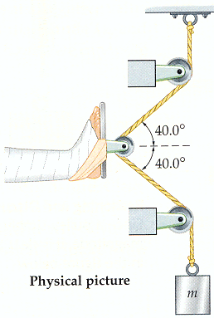

  - Translational Equilibrium
- A 1.84 kg bag of clothespins hangs in the middle of a clothesline, causing it to sag by an angle of 3.50 degree. Find the tension T, in the clothesline?

6.4 Coupled Motion – (Connected Objects)
- A block of mass m₁ slides on a frictionless tabletop. It is connected to a string that passes over a pulley and suspends a mass m₂. Find the acceleration of the masses and the tension in the string.
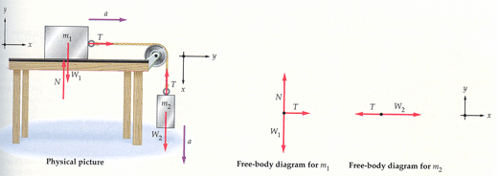

- The figure shows two blocks connected by a cord that passes over a massless, frictionless pulley. The lighter block m₁ has a mass m₁ = 1.3 kg and the heavier block m₂ has a m₂ = 2.8 kg. Find the magnitudes of the accelerations of the two blocks and the magnitude T of the force on each block from the cord.
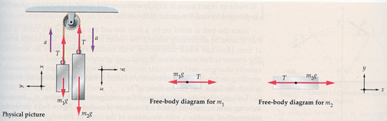

6.5 Circular Motion
- If a roadway is banked at the proper angle, a car can round a corner without any assistance from friction between the tires and the road. Find the appropriate angle for a 900 kg car traveling at 20.5 m/s in a turn of radius 85.0 m.
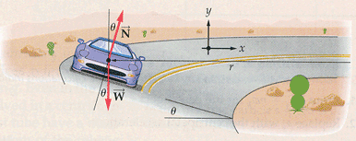

- A 1200 kg car rounds a corner of radius r = 45 m. If the coefficient of static friction between the tires and the road is μ_{s} = 0.82, what is the greatest speed the car can have in the corner without skidding?

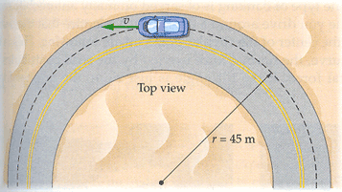
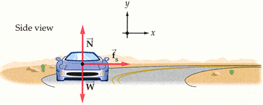

- While driving along a country lane with a constant speed of 17.0 m/s, you encounter a dip in the road. The dip can be approximated as a circular arc, with radius of 65.0 m. What is the normal force exerted by a car seat on a 80.0 kg passenger when the car is at the bottom of the dip?

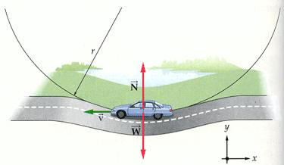

- The centrifuge in the figure rotates at a rate that gives the bottom of the test tube a linear speed of 89.3 m/s. If the bottom of the test tube is 8.50 cm from the axis of rotation, what is the centripetal acceleration experienced there?

- In a 1901 circus performance, Allo "Dare Devil" Diavolo introduced the stunt of riding a bicycle in a loop-the-loop. Assuming that the loop is a circle with radius R = 2.7 m, what is the least speed v Diavolo could have at the top of the loop to remain in contact with it there?

