Introduction to Friction
Friction

Microscopic View
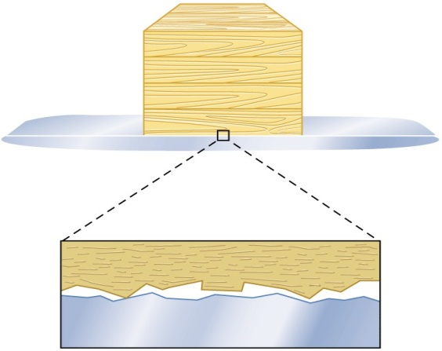
Friction depends on the normal force.
- The friction that exists between two surfaces is ____________________ to the normal force.
- Increasing the normal force i_______________friction; _____________the normal force decreases friction.
- This has several implications, such as…

Static Friction
- This type of friction occurs between ______________ that are not slipping relative to each other.

f_{s} < m_{s}N is an inequality!
- The fact that the static friction equation is an inequality has important implications.
- Static friction between two surfaces is _______________________________ trying to make the surfaces slide on one another.
- Static friction _____________________ as the force trying to push an object increases ________
_______________________________________________________
- Once the maximum value of static friction has been exceeded by an applied force, the surfaces begin to slide and the friction is no longer static friction
Static friction and applied horizontal force
(Drawing)

Static friction on a ramp
(Drawings)

Kinetic Friction
- This type of friction occurs between surfaces that are _______________ past each other.

- Kinetic friction (sliding friction) is generally _______________than static friction (motionless friction) for most surfaces.
Sample Problem
A 10-kg box rests on a ramp that is laying flat. The coefficient of static friction is 0.50, and the coefficient of kinetic friction is 0.30.
- What is the maximum horizontal force that can be applied to the box before it begins to slide?
- What force is necessary to keep the box sliding at constant velocity?

Sample Problem
A 10-kg wooden box rests on a ramp that is lying flat. The coefficient of static friction is 0.50, and the coefficient of kinetic friction is 0.30. What is the friction force between the box and ramp if
- no force horizontal force is applied to the box?
- a 20 N horizontal force is applied to the box?
- a 60 N horizontal force is applied to the box?

Sample Problem
A 1500 N crate is being pushed across a level floor at a constant speed by a force F of 600 N at an angle of 20° below the horizontal as shown in the figure.

Sample Problem
A 10-kg wooden box rests on a wooden ramp. The coefficient of static friction is 0.50, and the coefficient of kinetic friction is 0.30. What is the friction force between the box and ramp if
- the ramp is at a 25º angle?
- the ramp is at a 45º angle?
- what is the acceleration of the box when the ramp is at 45º?

Strings and Springs
A physical picture of tension
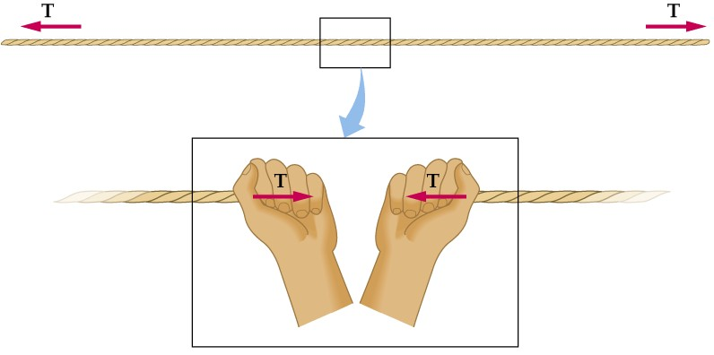

Tension examples
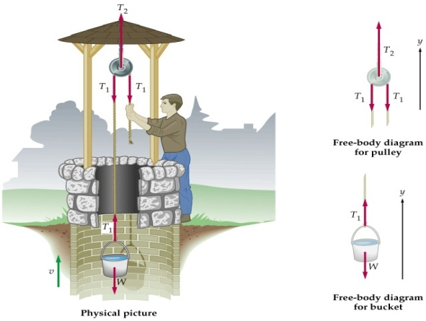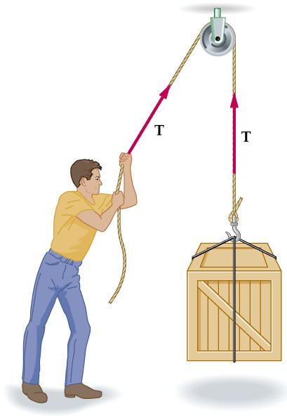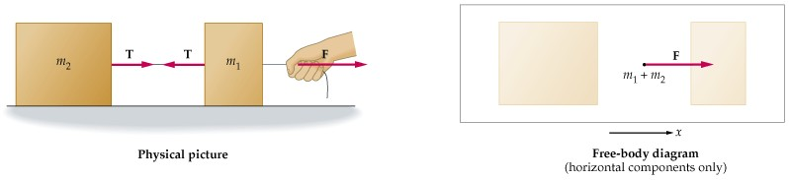
Sample problem
- A 1,500 kg crate hangs motionless from a crane cable. What is the tension in the cable? Ignore the mass of the cable.
- Suppose the crane accelerates the crate upward at 1.2 m/s₂. What is the tension in the cable now?

Sample problem
A 1.80 kg object is connected to a spring of force constant 120 N/m. How far is the spring stretched if it is used to drag the object across a floor at constant velocity? Assume the coefficient of kinetic friction is 0.60.

Connected Objects
A 5.0 kg object (m₁) is connected to a 10.0 kg object (m₂) by a string. If a pulling force F of 20 N is applied to the 5.0 kg object as shown,
A) what is the acceleration of the system?
B) what is the tension in the string connecting the objects?
(Assume a frictionless surface.)

Gravity 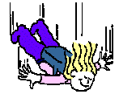

Slowing gravity down

Magic pulleys on a flat table

Sample problem
Mass 1 (10 kg) rests on a frictionless table connected by a string to Mass 2 (5 kg). Find
- the acceleration of each block.
- the tension in the connecting string.

Sample Problem
Mass 1 (10 kg) rests on a table connected by a string to Mass 2 (5 kg). Find the minimum coefficient of static friction for which the blocks remain stationary.

Pulleys and Ramps - together

Sample Problem
Two blocks are connected by a string as shown in the figure. What is the acceleration, assuming there is no friction?

Uniform Circular Motion
- An object that moves at _______________ in a circle of constant radius is said to be in uniform circular motion.
- Question: Why is uniform circular motion accelerated motion?
- Answer:

Centrifugal Force
- Question: What is centrifugal force?
- Answer:

There is no outward directed force in circular motion. To explain why this is the case, let’s review Newton’s 1st Law
Newton’s 1st Law and cars

- When a car accelerates forward suddenly, you as a passenger feel as if you are flung backward.
- You are in fact NOT flung backward

When a car turns
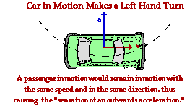
- You feel as if you are flung to the outside. You call this apparent, but nonexistent, force “_______________________________”.
- You are NOT flung to the outside. Your_____________________________ the inward acceleration and your body simply wants to keep moving in straight line motion!
- As with all other types of acceleration, your body feels as if it is being flung in the opposite direction of the actual acceleration. The force on your body, and the resulting acceleration, _________________________________________

Centripetal Acceleration
- Centripetal (or center-seeking) acceleration ___________________________ circle and keeps an object moving in circular motion.
- This type of acceleration is at ___________________ to the velocity.
- This type of acceleration doesn’t speed up an object, or slow it down, it ___________________.
Centripetal Acceleration

  - a_{c}:
  - v:
  - r:

Centripetal Force
- A force responsible for centripetal acceleration is referred to as a ____________________
- Centripetal force is simply _____________ times ____________________.
- F_{c} =
- F_{c} =
  - F_{c}:
  - v:
  - r:
Any force can be centripetal
- The name “centripetal” can be applied to any force in situations when that force is causing an object to move in a circle.
- You can identify the real force or combination of forces which are causing the centripetal acceleration.
- Any kind of force can act as a centripetal force.
Sample Problem
A 1200-kg car rounds a corner of radius r = 45 m. If the coefficient of static friction between tires and the road is 0.93 and the coefficient of kinetic friction between tires and the road is 0.75, what is the maximum velocity the car can have without skidding?

Sample Problem
You whirl a 2.0 kg stone in a horizontal circle about your head. The rope attached to the stone is 1.5 m long.
a) What is the tension in the rope? (The rope makes a 10º angle with the horizontal).
b) How fast is the stone moving?

