Chapter 5 – Practice Problems
Section 5.3
- A truck pulls a trailer on a flat stretch of road. The forces acting on the trailer are the forces due to gravity (250,000 N downward), the force exerted by the road (250,000 N upward), and the force exerted by the cable connecting the trailer to the truck (20,000 N to the right). The forces acting on the truck are the force due to gravity (80,000 N to the downward), the force exerted on the cable (20,000 N to the left) and the force causing the truck to move forward (26,400 to the right).

- Draw and label a free- body diagram on the trailer.

- Draw and label a free-body diagram on the truck.

- A physics book is at rest on a desk. Gravitational force pulls the book down. The desk exerts an upward force on the book that is equal in magnitude to the gravitational force. Draw a free body diagram of the book.

Section 5.3 – 2nd Law
- Moe, Larry, and Curly push on a 752 kg boat that floats next to a dock. They each exert an 80.5 N force parallel to the dock. (a) What is the acceleration of the boat if they all push in the same direction? (b) What is the magnitude and direction of the boat's acceleration if Larry and Curly push in the opposite direction to Moe's push?
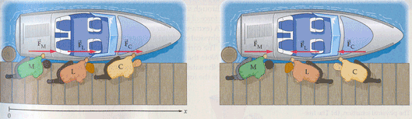

- A man is pulling on his dog with a force of 70.0 N directed at an angle of +30.0° to the horizontal. Find the x and y components of this force.

- Foamcrete is a substance designed to stop an airplane that has run off the end of a runway, without causing injury to passengers. It is solid enough to support a car, but crumbles under the weight of a large airplane. By crumbling, it slows he plane to a safe stop. For example, suppose a 747 jetliner with a mass of 1.75 x 10⁵ kg and an initial speed of 26.8 m/s is slowed down to a stop in 122 m. What is the magnitude of the retarding force Fexerted by the Foamcrete on the plane?
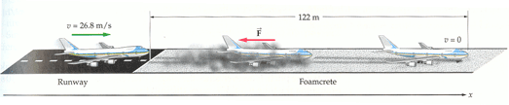

- A pitcher throws a 0.15 kg baseball, accelerating it from rest to a speed of about 90 mi/h. Estimate the force exerted by the pitcher on the ball.
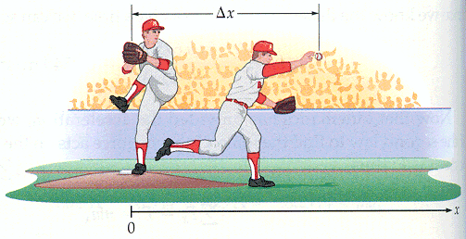
- The net force on the propeller of a 3.2 kg model airplane is 7.0 N forward. What is the acceleration of the airplane?

- The net force on a golf cart is 390 N north. If the cart has a total mass of 270 kg, what are the magnitude and direction of the cart’s acceleration?

- A soccer ball is kicked with a force of 13.5 N accelerates at 6.5 m/s² to the right. What is the mass of the ball?

- A 2.0 kg otter starts from rest at the top of the muddy incline 85 cm long and slides down to the bottom in 0.50 s. What net force acts on the otter along the incline?

- A 4.6 kg sled is pulled across a smooth ice surface. The force acting on the sled is of magnitude 6.20 N and points in a direction of 35.0⁰ above the horizontal. If the sled starts at rest, how fast is it going after being pulled for 1.15 s?

Newton’s Third Law
- Two groups of canoeists meet in the middle of a lake. After a brief visit, a person in canoe 1 pushes on canoe 2 with a force of 46 N to separate the canoes. If the mass of canoe 1 and its occupants is m₁ = 150 kg , and the mass of canoe 2 and its occupants is m₂ = 250 kg, (a) find the acceleration the push gives to each canoe. (b) What is the separation of the canoes after 1.2 s of pushing?
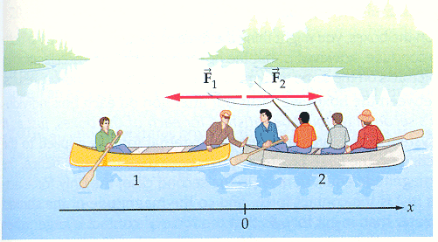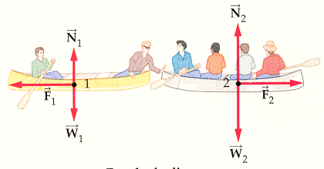

- A box of mass m₁= 10.0 kg rests on a smooth, horizontal floor next to a box of mass m₂= 5.00 kg . If you push on box 1 with a horizontal force of magnitude F = 20.0 N, (a) what is the acceleration of the boxes? (b) What is the force of contact between the boxes?
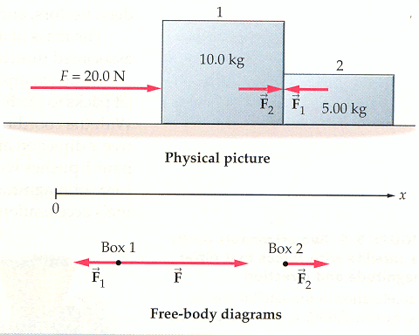
Section 5.5 – Vectors – The Nature of Force
- Jack and Jill lift upward on a 1.3 kg pail of water, with Jack exerting a F₁ of magnitude 7.0 N and Jill exerting a F₂ of magnitude 11 N. Jill’s force is exerted at an angle of 28⁰ with the vertical. At what angle θ with respect to the vertical should Jack exert his force if the pail is to accelerate straight upward?

- A 4.60 kg sled is pulled across a smooth ice surface. The force acting on the sled is of magnitude 6.20 N and points in a direction 35.0⁰ above the horizontal. If the sled starts from rest, how fast is it gong after being pulled for 1.15s?

5.6 - Weight
- The fire alarm goes off and a 97- kg fireman slides 3.0 m down a pole to the ground floor. Suppose the fireman starts from rest, slides with constant acceleration, and reaches the ground floor in 1.2 s. What was the upward force F exerted by the pole on the fireman?
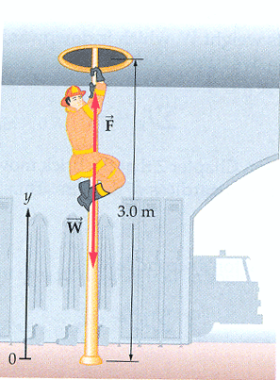
- A passenger of mass m= 72.2 kg stands on a bathroom scale in an elevator. We are concerned with the scale readings when the cab is stationary, and when it is moving up or down.
(a) Find the general solution for the scale reading, whatever the vertical motion of the cab.
(b) What does the scale read if the cab is stationary or moving upward at a constant 0.50 m/s?
(c) What does the scale read if the cab accelerates upward at 3.20 m/s² and downward at3.20 m/s²?
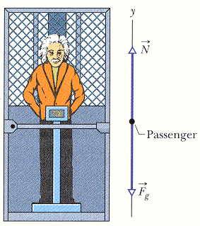
- 5.0 kg salmon is weighed by hanging it from a fish scale attached to the ceiling of an elevator. What is the apparent weight of the salmon, W_{a}, if the elevator (a) is at rest, (b) moves with an upward acceleration of 2.5m/s², or (c) moves with a downward acceleration of 3.2 m/s²?
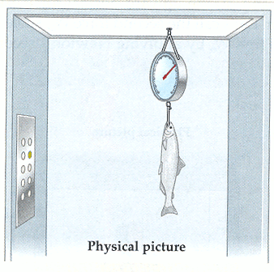
5.7 - Normal Force Example
- A 6.0 kg block of ice sits on a table and is acted on by two forces F₁ and F₂. If Force 1 = 13 N is applied at an angle of 60 degree from North of West and Force 2 = 11 N is applied at an angle of 30 degree North of East. Find the acceleration of the ice and the normal force exerted by the table

