Chapter 5 – Telescopes Name________________________

Tools of the Trade: Telescopes

- Stars and other celestial objects are too far away to test directly
  - Astronomers passively collect radiation emitted from distant objects
  - Extremely faint objects make collection of radiation difficult
- Specialized Instruments Required
  - Need to measure brightness, spectra, and positions with high precision
  - Astronomers use mirrored telescopes and observatories
- Modern Astronomers are rarely at the eyepiece, more often they are at a computer terminal!

The Powers of a Telescope

- ____________________________
  - Bigger telescope, more light collected!
- ____________________________
  - Use mirrors or lenses to bend the path of light rays to create images
- ____________________________
  - Picking out the details in an image
Light Gathering Power
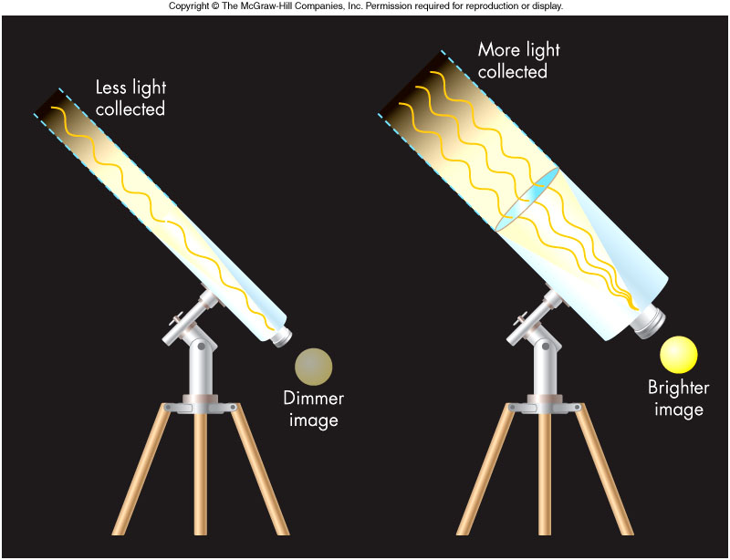

  - Light collected proportional to “collector”__________
  - Pupil for the eye
  - Mirror or lens for a telescope
  - Telescope “_________” light to our eyes for a brighter image
  - Small changes in “_______________” radius give large change in number of photons caught

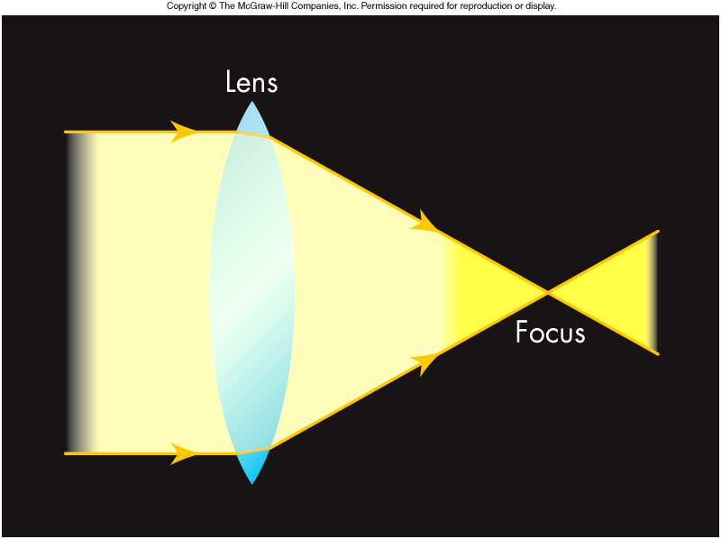
Focusing Power
- Refraction
  - Light moving at an angle from one material to another will bend due to a process called _______________
  - Refraction occurs because the ________ ________________ is different in different materials

Refraction

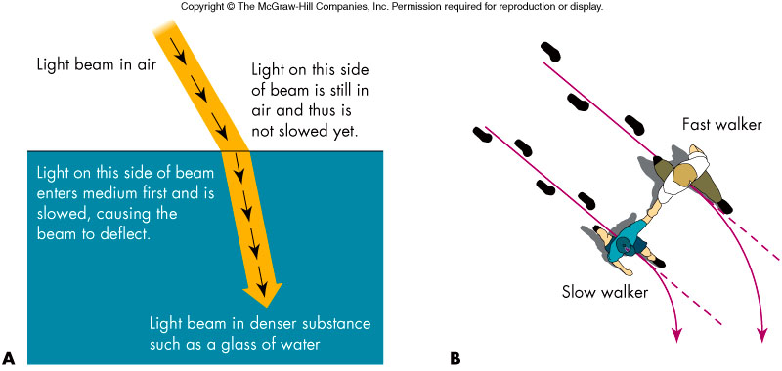

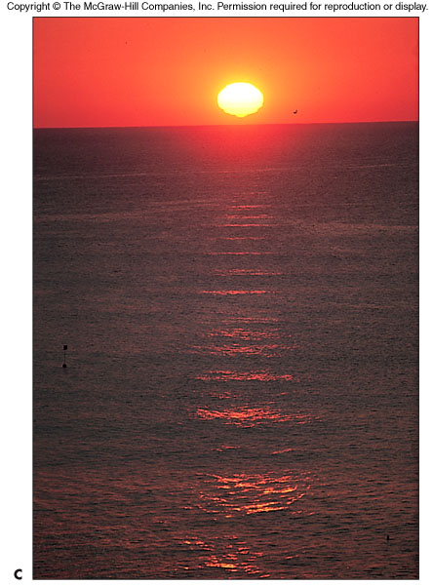
____________________causes different colors to travel at different speeds through the same material

Refraction is responsible for the distortion of the Sun near the horizon, but not the _____________________

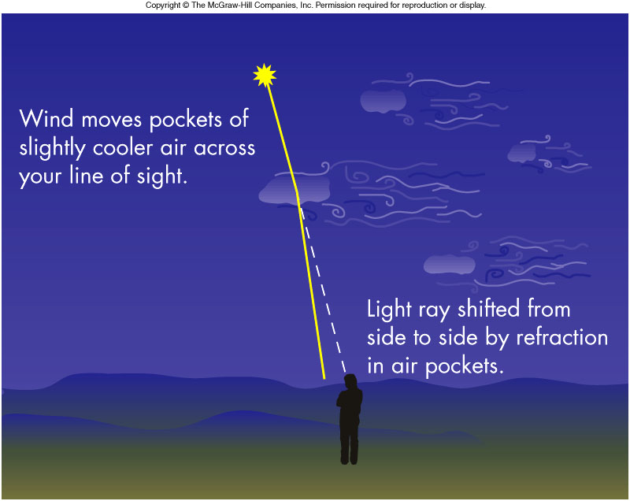
- Refraction is also responsible for _____________________
  - Twinkling of stars
  - AKA _________________
- Temperature and density differences in pockets of air shift the image of the star.

Refracting Telescopes
- A lens employs refraction to ___________________
- Telescopes that employ lenses to collect and focus light are called ______________________

Disadvantages to Refractors

- Lenses have many disadvantages in large telescopes!
  - Large lenses are extremely _______________________ to fabricate
  - A large lens will __________________in the center since it can only be supported on the edges
  - __________________ causes images to have colored fringes
  - Many lens materials _____________________ light

Reflecting Telescopes

- Reflectors
  - Used almost exclusively by astronomers today
  - Twin Keck telescopes, located on the 14,000 foot volcanic peak Mauna Kea in Hawaii, have _________________ collector mirrors!
  - Light is focused in front of the mirror

- A ______________ may be used to deflect the light to the side or through a hole in the _______________________
- ____________________ and ________________________ are two modern approaches to dealing with large pieces of glass in a telescope system

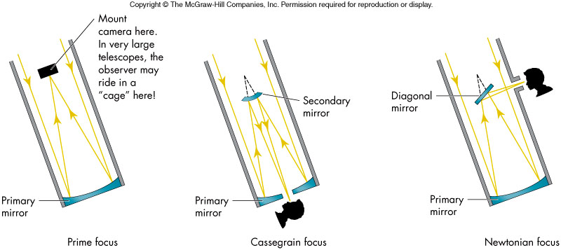
Resolving Power

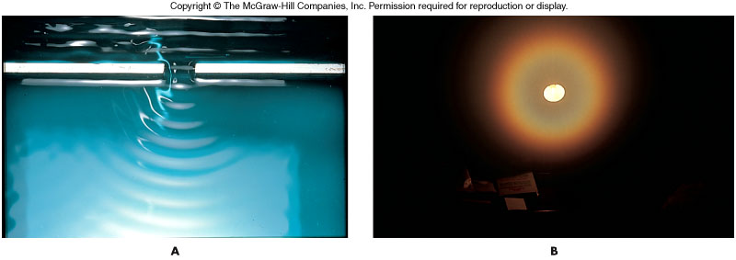
- A telescope’s ability to discern detail is referred to as its ______________
- Resolving power is limited by the wave nature of light through a phenomenon called ________________________
- Waves are diffracted as they pass through _______________________
- A diffracted point source of light appears as a point surrounded by ___________ of light

Resolving Power and Aperture

- Two points of light separated by an angle ________ (in arcsec) can be seen at a ___________ (in nm) only if the telescope diameter D (in cm) satisfies:
__________________

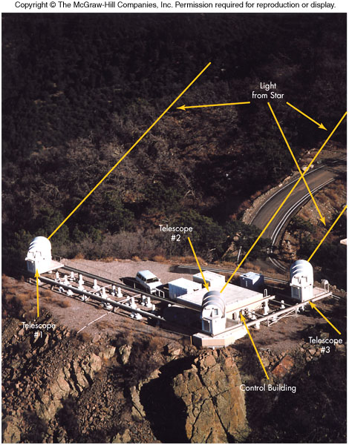
Increasing Resolving Power: Interferometers

For a given wavelength, _____________ is increased for a larger telescope diameter

An ___________________ accomplishes this by simultaneously combining observations from two or more widely-spaced telescopes.

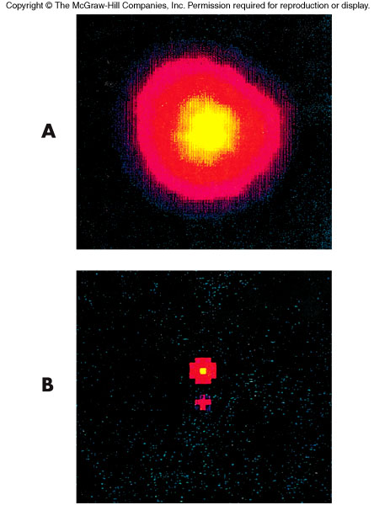

The resolution is determined by the individual telescope _____________________ and not the individual diameters of the telescopes themselves

Key to the process is the ______ ____________________and the electronic processing of the waves from the various telescopes

Detecting the Light

- _________________________
  - Once used with a telescope to record observations or make sketches
  - Not good at detecting faint light, even with the 10-meter Keck telescopes
- _____________________________
  - Chemically stores data to increase sensitivity to dim light
  - Very inefficient: Only 4% of striking photons recorded on film
- _____________________________
  - Incoming photons strike an array of semiconductor pixels that are coupled to a computer
  - Efficiencies of 75% possible
  - ____________(Charged-coupled Device) for pictures

Nonvisible Wavelengths

- Many astronomical objects radiate in wavelengths other visible
  - Cold gas clouds radiate in the ____________
  - Dust clouds radiate in the _______________
  - Hot gases around black holes emit ____________

Radio Observatories

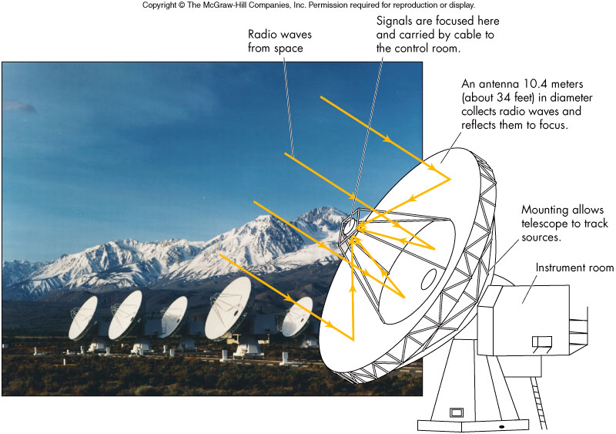

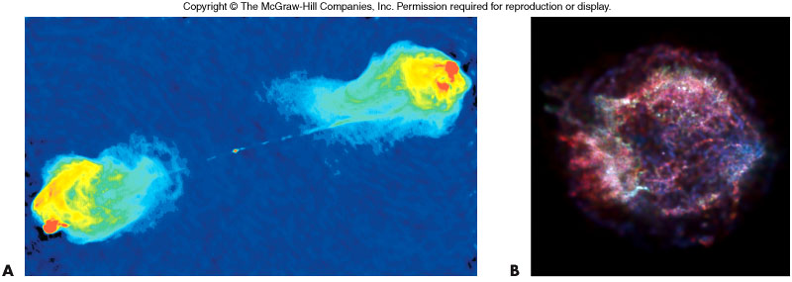
- False color images are typically used to depict wavelength distributions in _____________________ observations

Gamma Rays Bursts

- Exploring New Wavelengths: Gamma Rays
  - Gamma-ray astronomy began in 1965
  - By 1970s, gamma rays found to be coming from familiar objects: __________________________________________________.
  - 1967 gamma-ray bursts from space discovered by military satellites watching for Soviet nuclear bomb explosions
  - Source of gamma-ray bursts is likely due to _____________________!

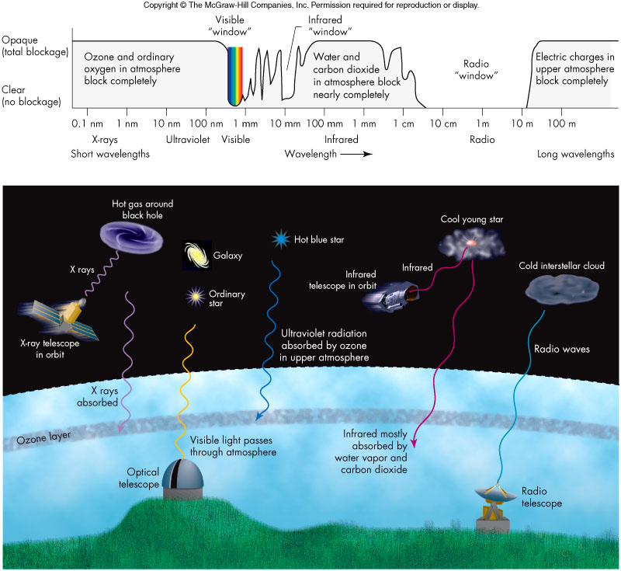

Major Space Observatories

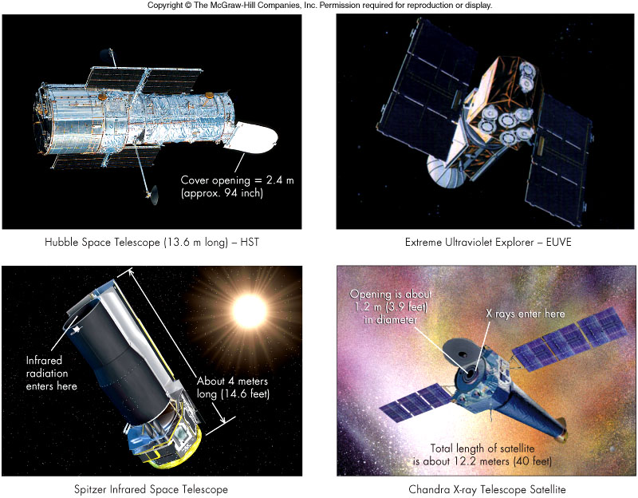
- Why put them in space?

Atmospheric Blurring

  - Twinkling of stars in sky, called ______________, is caused by moving atmospheric irregularities refracting star light into a blend of paths to the eye
  - The condition of the sky for viewing is referred to as the ___________
  - Distorted seeing can be improved by ___________________, which employs a powerful laser and correcting mirrors to offset scintillation

Observatories

- The immense telescopes and their associated equipment require observatories to facilitate their use and protection from the elements
- Thousands of observatories are scattered throughout the world and are on every continent including Antarctica
- Some observatories:
  - Twin 10-meter Keck telescopes are largest in U.S.
  - The Hobby-Eberly Telescope uses 91 1-meter mirrors set in an 11-meter disk
  - Largest optical telescope, VLT (Very Large Telescope) in Chile, is an array of four 8-meter mirrors

Space vs.Ground-Based Observatories

- ________________________________
  - Freedom from atmospheric blurring
  - Freedom of atmospheric absorption
- ________________________________
  - Larger collecting power
  - Equipment easily fixed
- ________________________________
  - Weather, humidity, and haze
  - Light pollution

