Chapter 4 Name___________________________________

Light – the Astronomer’s Tool

- Due to the vast distances, with few exceptions, direct measurements of astronomical bodies are not possible
- We study remote bodies indirectly by ________________________
- Understanding the properties of light is therefore essential
- Care must be given to distinguish light signatures that belong to the distant body from signatures that do not (e.g., our atmosphere may distort distant light signals)

Properties of Light

  - Light is ______________it does not require a ____________ for travel (unlike sound!)
  - Light travels at _____________ in a vacuum (fast enough to circle the Earth 7.5 times in one second)
  - Speed of light ___________ is constant and is denoted by the letter __
  - However, the speed of light is reduced as it passes through transparent materials
    - The speed of light in transparent materials is dependent on _____________
    - Fundamental reason telescopes work the way they do!
Sometimes light can be described as a wave…

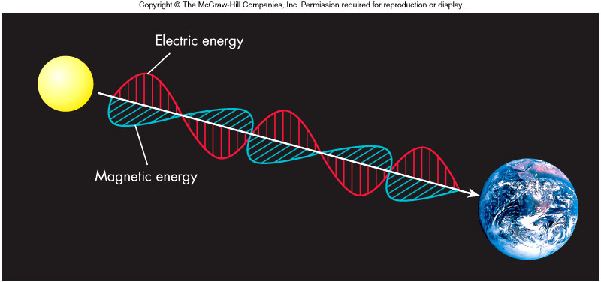
  - The wave travels as a result of a fundamental relationship between _________________________________
  - A _____________________ creates an ______________ and a ________ _______________ creates a _________________
…and sometimes it can be described as a particle!
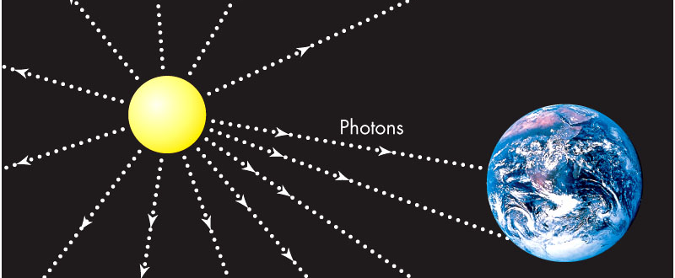
  - Light thought of as a stream of particles called ______________
  - Each photon particle carries energy, depending on its ___________ _______________________

So which model do we use?

  - Well, it depends!
    - In a vacuum, _________________________, but behave like ______________
    - ___________________ particles also act as waves
    - ___________________ All particles of nature behave as both a wave and a particle
    - Which property of light manifests itself depends on the situation
    - We concentrate on the wave picture henceforth

Light and Color

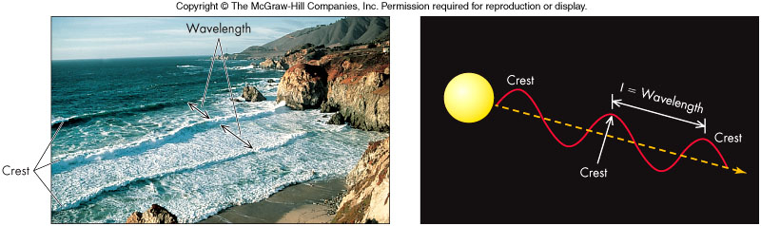

- Colors to which the human eye is sensitive is referred to as the ________
___________________________
- In the wave theory, color is determined by the light’s ______________ (symbolized as _______)
  - The __________________ is the convenient unit
  - ________= 700 nm (___________ wavelength), ________ = 400 nm (_________________ wavelength)

The Visible Spectrum

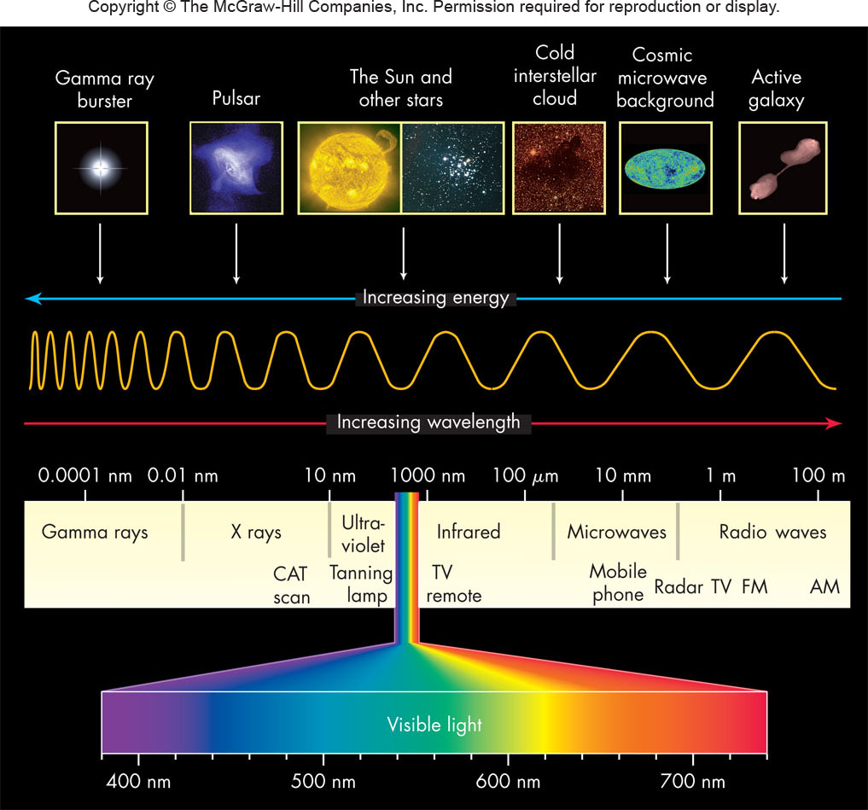

Frequency

- Sometimes it is more convenient to talk about light’s frequency
  - ___________________ is the number of wave crests that pass a given point in 1 second (measured in ________________)
  - Important relation: ________________
  - ___________wavelength = __________frequency
  - _______wavelength = ______________ frequency

White light – a mixture of all colors

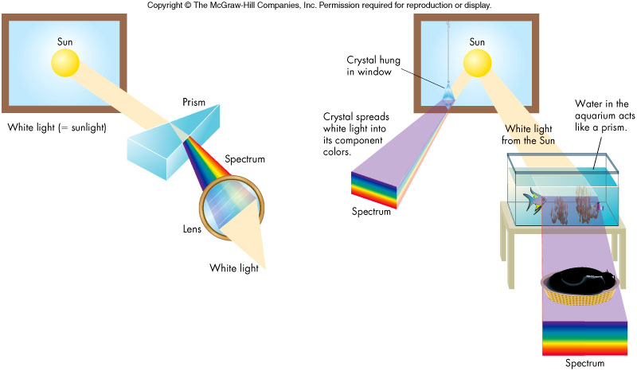

A _________ demonstrates that _________light is a _____________ of wavelengths by its creation of a spectrum

Additionally, one can _______________ a spectrum of colors and obtain white light

The Electromagnetic Spectrum

- The _______________________________ is composed of _______ ___________________________________________________________________________________________
- Longest wavelengths are more than __________
- Shortest wavelengths are less than __________
- Various instruments used to explore the various regions of the spectrum

Infrared Radiation

- Sir William Herschel (around 1800) showed _________________ related to visible light
- He measured an elevated temperature just off the red end of a solar spectrum – ____________________

Ultraviolet Light
- J. Ritter in 1801 noticed silver chloride blackened when exposed to “light” just beyond the ______________ of the visible spectrum
- Mostly absorbed by the ___________________.
- Responsible for suntans (and burns!)

Radio Waves

- Predicted by ___________in mid-1800s, Hertz produced radio waves in 1888
- Jansky discovered radio waves from cosmic sources in the 1930s, the birth of radio astronomy
- Radio waves used to study a wide range of astronomical processes
- Radio waves also used for communication, microwave ovens, and search for extraterrestrials

X-Rays

  - Roentgen discovered X rays in______________
  - First detected beyond the Earth in the Sun in late 1940s
  - Used by doctors to scan _____________________
  - Used by astronomers to detect ____________ and _____________ in distant galaxies
Energy Carried by Electromagnetic Radiation

  - Each photon of wavelength____ carries an energy E given by:

where h is Planck’s constant
  - Notice that a photon of _______________ radiation carries ____________energy than a long wavelength photon

Matter and Heat

- The Nature of Matter and Heat
  - The ancient Greeks introduced the idea of the atom (Greek for “________________”), which today has been modified to include a nucleus and a surrounding cloud of electrons
  - Heating (_______________________________) and the motion of atoms was an important topic in the 1700s and 1800s
A New View of Temperature

- The Kelvin Temperature Scale
  - An object’s temperature is directly related to its energy content and to the speed of molecular motion
  - As a body is cooled to zero Kelvin, molecular motion within it slows to a virtual halt and its energy approaches zero Þ no negative temperatures
Fahrenheit and Celsius are two other temperature scales that are easily converted to Kelvin.
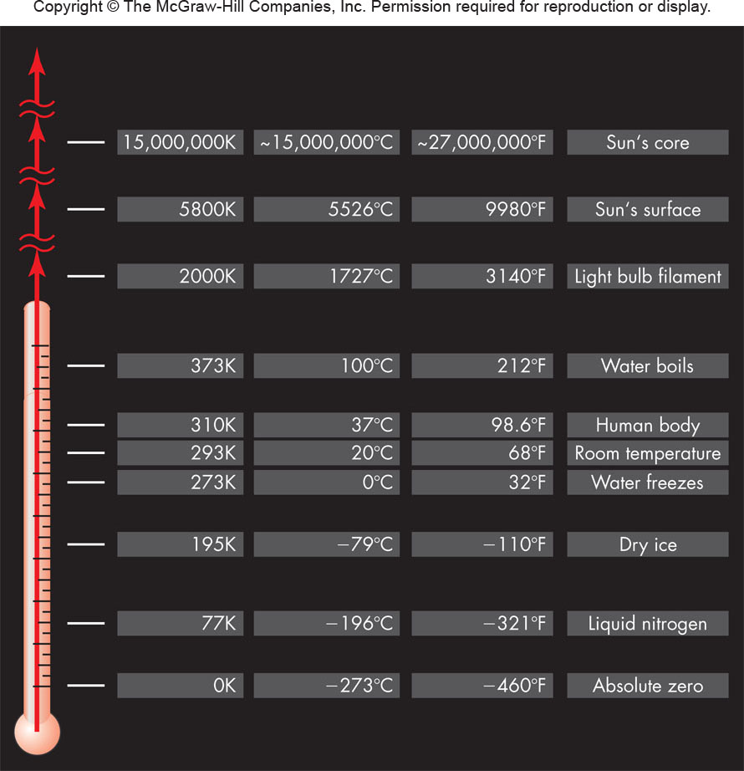
Radiation and Temperature
- Heated bodies generally radiate across the entire electromagnetic spectrum
- There is one particular wavelength, ______, at which the radiation is most intense and is given by Wien’s Law:

Where k is some constant and T is the temperature of the body

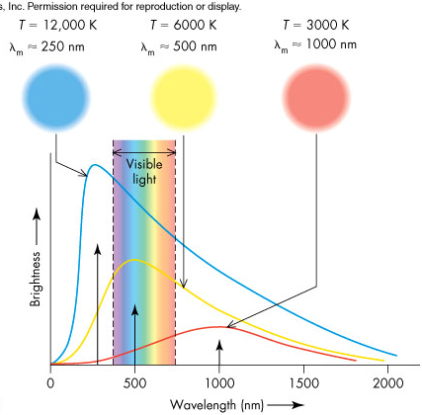
Radiation and Temperature

  - Note _________________ bodies radiate more strongly at _______ _____________________
  - As an object heats, it appears to change color from _____________ __________________
  - Measuring ________ gives a body’s temperature
  - Careful: Reflected light does not give the temperature
Blackbodies and Wien’s Law

  - A ________________ is an object that absorbs all the radiation falling on it
  - Since such an object _____________________________ any light, it appears black when cold, hence its name
  - As a blackbody is heated, it radiates more efficiently than any other kind of object
  - Blackbodies are excellent absorbers and emitters of radiation and follow Wien’s law
  - Very few real objects are perfect blackbodies, but many objects (e.g., the Sun and Earth) are close approximations
  - Gases, unless highly compressed, are not blackbodies and can only radiate in narrow wavelength ranges

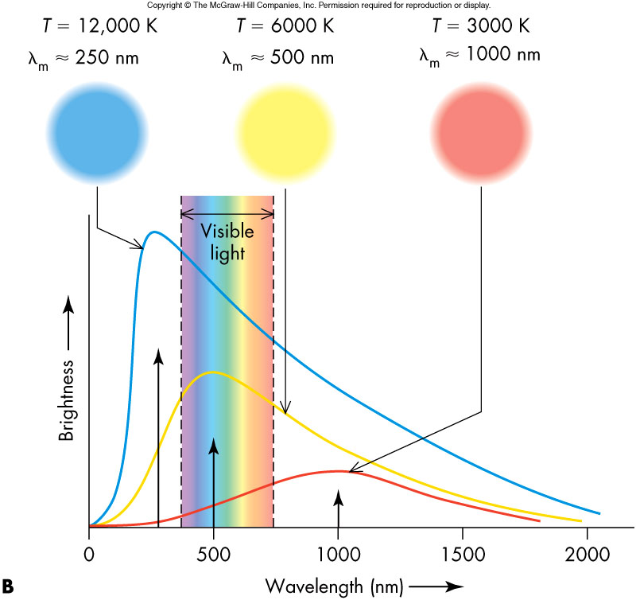

The Structure of Atoms
- Nucleus – Composed of densely packed __________ and positively charged _______________
- Cloud of negative ______________ held in orbit around nucleus by positive charge of protons
- Typical atom size: 10⁻¹⁰ m (= ______ = 0.1 nm)

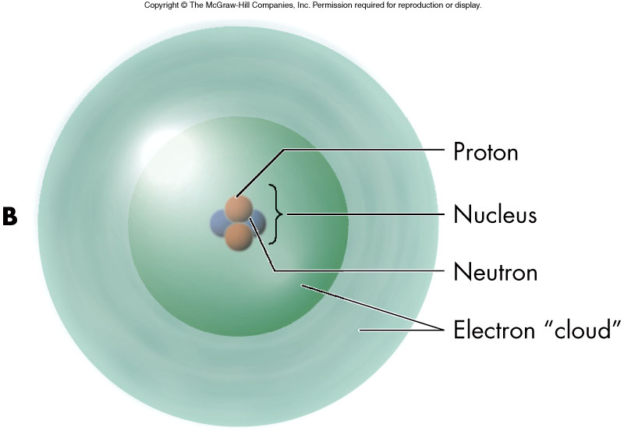
The Chemical Elements

- An ____________________is a substance composed only of atoms that have the _____________________ of protons in their nucleus
- A neutral element will contain an _____________ of ____________________
- The chemical properties of an element are determined by the number of electrons
Electron “Orbits”

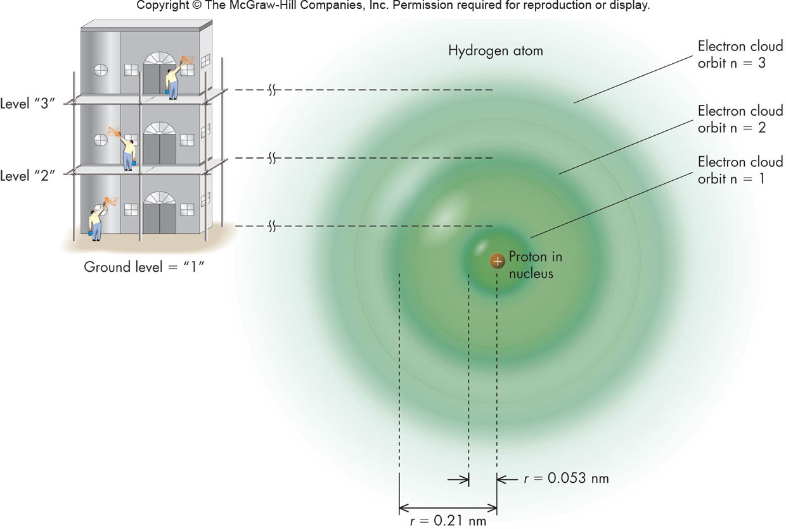

The electron orbits are _____________, can only have ____________values and nothing in between
Quantized orbits are the result of the __________________ of matter

As electrons move from one orbit to another, they ____________ their energy in discrete amounts

Energy Change in an Atom

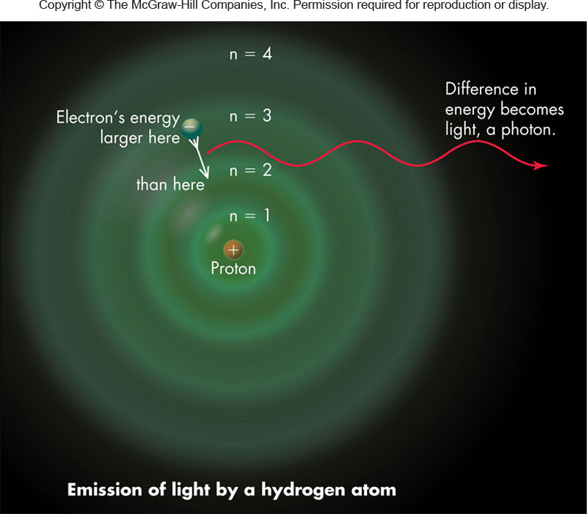
- An atom’s energy is increased if an electron moves to an outer orbit – the atom is said to be ________________.
- An atom’s energy is decreased if an electron moves to an ______________.

Conservation of Energy

- The energy change of an atom must be compensated elsewhere – ____________________________________
- _________________and ______________ of EM radiation are two ways to preserve energy conservation
- In the photon picture, a photon is _____________ as an electron moves to a higher orbit and a photon is______________as an electron moves to a lower orbit.
Emission
Absorption
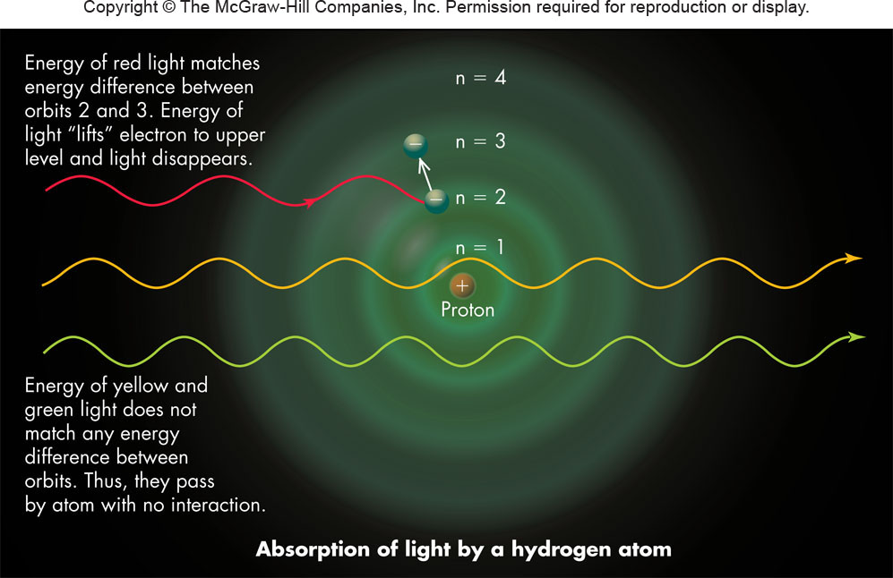

Spectroscopy
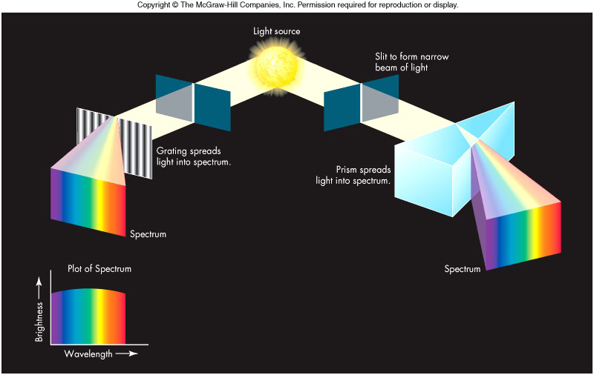

- ]

- Allows the determination of the ________________________ of an astronomical body
- In _______________, we capture and analyze a spectrum
- Spectroscopy assumes that every ____________________ will have a unique spectral signature
Emission Spectrum

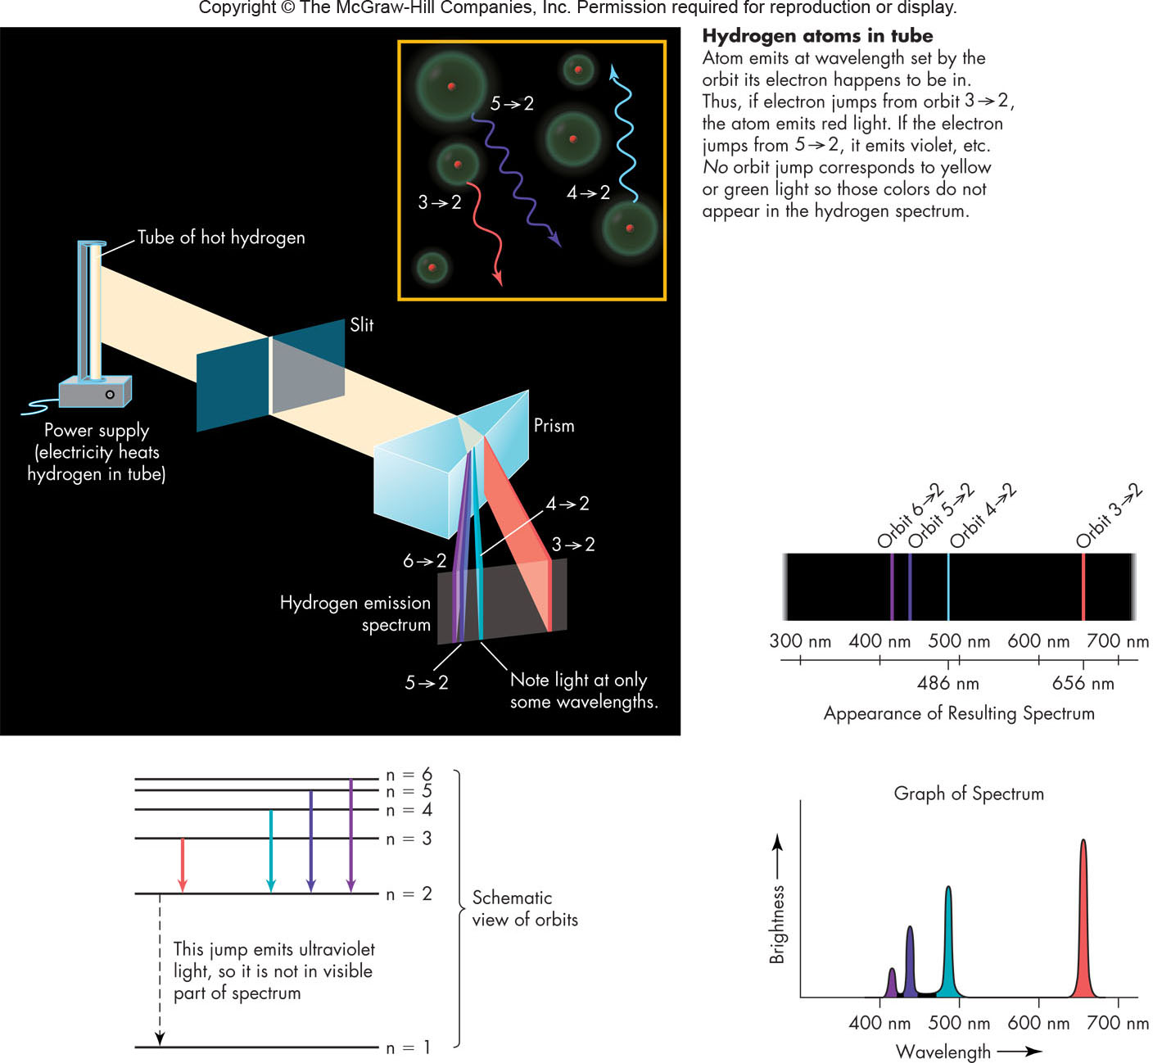
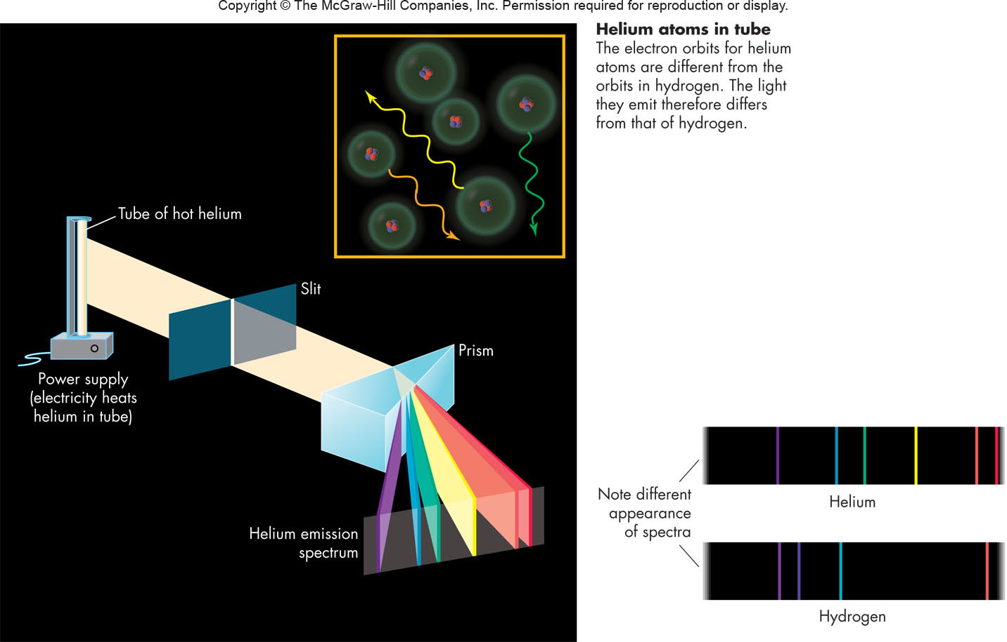
Continuous and Absorption Spectra

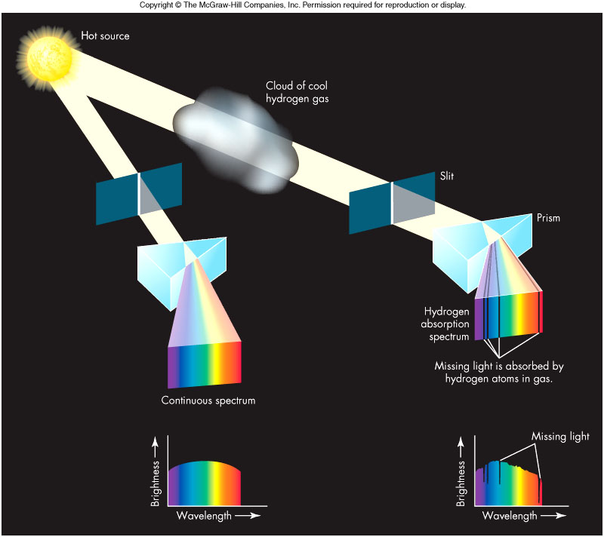

Astronomical Spectra

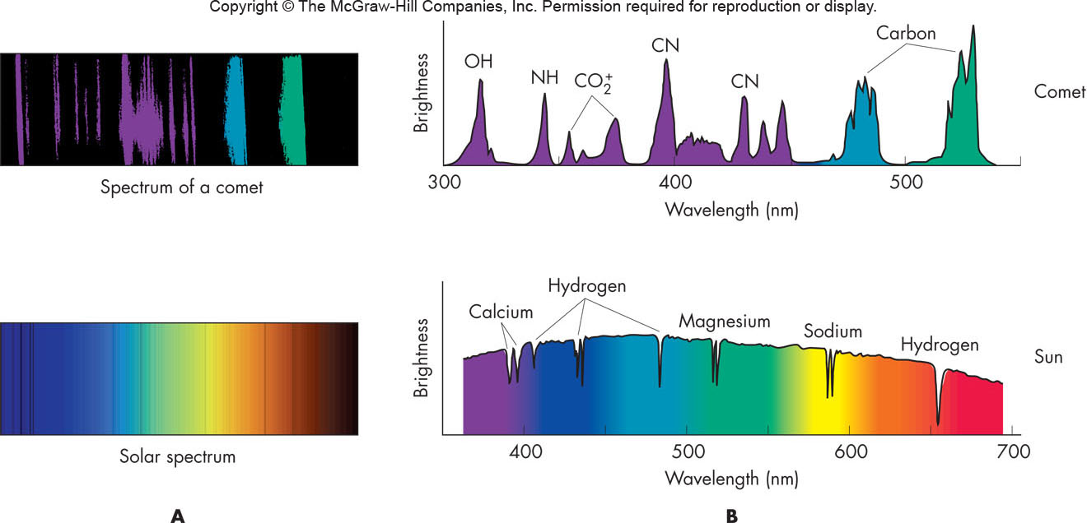
Doppler Shift in Sound

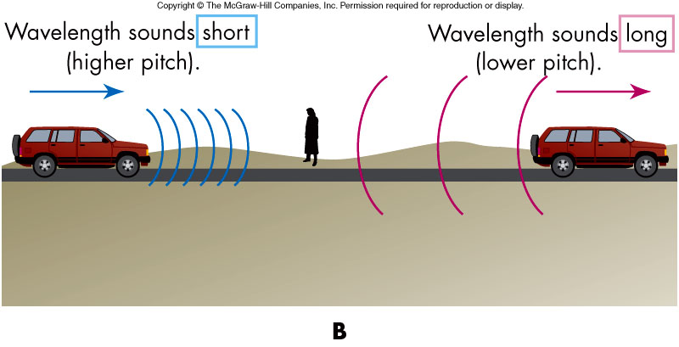
- If the source of sound is moving, the pitch ____________________!

The shift in wavelength is given as

where ___ is the observed (shifted) wavelength,_____ is the emitted wavelength, v is the source non-relativistic __________________, and c is the speed of light
Doppler Shift in Light

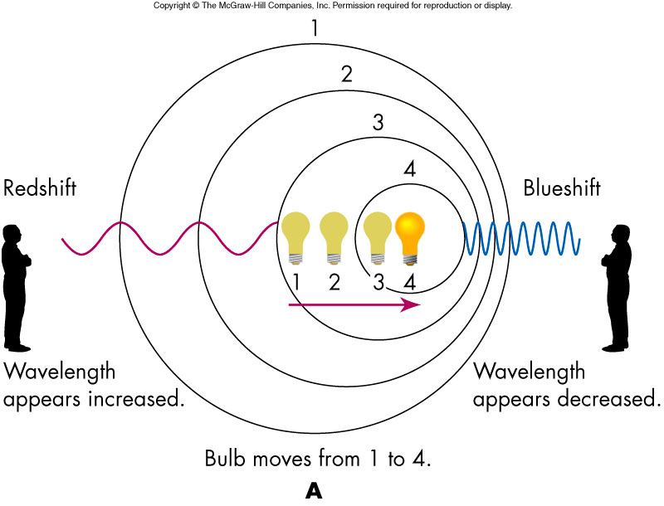
If a source of light is set in motion relative to an observer, its spectral lines ______________ to new wavelengths in a similar way

Redshift and Blueshift

- An observed increase in wavelength is called a __________, and a decrease in observed wavelength is called a ___________ (regardless of whether or not the waves are visible)
- Doppler shift is used to determine an object’s velocity

Absorption in the Atmosphere

- Gases in the Earth’s atmosphere absorb electromagnetic radiation to the extent that most wavelengths from space do not reach the ground
- Visible light, most radio waves, and some infrared penetrate the atmosphere through _______________________, wavelength regions of high transparency
- Lack of atmospheric windows at other wavelengths is the reason for astronomers placing telescopes in space.

