Chapter 2 – Practice problems
Section 2.1-2.3 Displacement & Velocity
1. You drive a beat-up pickup truck along a straight road for 8.4 km at 70 km/hr, at which point the truck runs out of gasoline and stops. Over the next 30 minutes, you walk another 2.0 km farther along the road to a gasoline station.
a) What is your overall displacement from the beginning of your drive to your arrival at the station?

b) What is the time interval Δt from the beginning of your drive to your arrival at the station?

- What is your average velocity from the beginning of your drive to your arrival at the station? Find it both numerically and graphically.

- Suppose that to pump the gasoline, pay for it, and walk back to the truck takes you another 45 minutes. What is your average speed from the beginning of your drive to your return to the truck with the gasoline?

2. Heather and Matthew walk with an average velocity of 0.98 m/s eastward. If it takes them 34 min to walk to the store, what is their displacement?

3. Simpson drives his car with an average velocity of 48 km/h to the east. How long will it take to drive 144 km on a straight highway?

4. Look back at problem before - How much time would Simpson save by increasing his average velocity to 56.0 km/h to the east?

5. A bus travels 280 km south along a straight path with an average velocity of 88 km/h to the south. The bus stops for 24 min. Then travels 210 km south with an average velocity of 75 km/h to the south.
- How long does the total time trip last?
- What is the average velocity for the total trip?

6. Plot the position v. time graph for an elevator that is initially stationary, then moves upward, and then stops. Plot velocity v. time for the elevator. Plot acceleration v. time for the elevator.

Section 2.4 - Acceleration
7. Turner’s treadmill runs with a velocity of -1.2 m/s and speeds up at regular intervals during a half-hour workout. After 25 min, the treadmill has a velocity of -6.5 m/s. What is the average acceleration of the treadmill during this period?

8. Suppose a treadmill has an average acceleration of 4.7 x 10⁻⁵ m/s²
- How much does its speed change after 5.00 minutes?
- If the treadmill’s initial speed is 1.7 m/s, what will its final speed be?

9. (a) If the velocity of an object is zero, does it mean that the acceleration is zero?
(b) If the acceleration is zero, does it mean that the velocity is zero?
Think of some examples.

Section 2.5 – 2.6 Constant Acceleration Equation
10. When Maggie applies the brake of her car, the car slows uniformly from 15.0 m/s to 0.0 m/s in 2.50 s. How many meters before a stop sign must she apply her brakes in order to stop at the sign?

11. A driver in a car traveling at a speed of 21.8 m/s sees a cat 101 m away on the road. How long will it take for the car to accelerate uniformly to stop in exactly 99 m?

12. A car enters the freeway with a speed of 6.4 m/s and accelerates uniformly for 3.2 km in 3.5 min. How fast (in m/s) is the car moving after this time?

13. An automobile with an initial speed of 4.30 m/s accelerates uniformly at the rate of 3.00 m/s². Find the final speed and the displacement after 5.0 s.

14. A car starts from rest and travels for 5.0 s with constant acceleration of -1.5 m/s². What is the final velocity of the car? How far does the car travel in this time interval?

15.A driver of a car traveling at 15.0 m/s applies the brakes, causing a uniform accelerates of -2.0 m/s². How long does it take the car to accelerate to a final speed of 10.0 m/s? How far has the car moved during the braking period?

16.A car accelerates uniformly in a straight line from rest at the rate of 2.3 m/s².
- What is the speed of the car after it has traveled 55 m?
- How long does it take the car to travel 55 m?

17. A motorboat accelerates uniformly from a velocity of 6.5 m/s to the west to a velocity of 1.5 m/s to the west. If its acceleration was 2.7 m/s² to the east, how far did it travel during the acceleration?

18. An aircraft has a liftoff speed of 33 m/s. What minimum constant acceleration does this require if the aircraft is to be airborne after a takeoff run of 240 m?

19. Jets at JFK International Airport accelerate from rest at one end of a runway, and must attain takeoff speed before reaching the other end of the runway. (a) Plane A has acceleration a and takeoff speed V_{to}. What is the minimum length of runway, ∆X_{A} , required for this plane? Give a symbolic answer. (b) Plane B has the same acceleration as Plane A, but requires twice the takeoff speed. Find ∆X_{B} and compare with ∆X_{A} . (c) Find the minimum runway length for plane A if a = 2.20 m/s² and V_{to} = 95.0 m/s. (These values are typical for a 747 jetliner.)
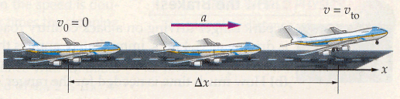

20. A park ranger driving on a back country road suddenly sees a deer "frozen" in his headlights. The ranger, who is driving at 11.4 m/s, immediately applies the brakes and slows with an acceleration of 3.80 m/s². (a) If the deer is 20.0 m from the ranger's vehicle when the brakes are applied, how close does the ranger come to hitting the deer? (b) How much time is needed for the ranger's vehicle to stop?
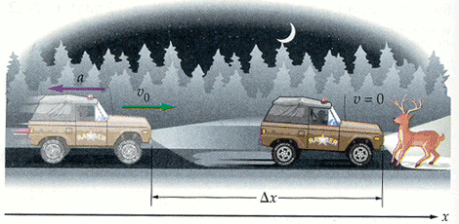

21. The ranger brakes for 17.1 m to come to rest. After braking for only half that distance, 8.55 m, is the ranger's speed (a) equal to ½ V_{o}, (b) greater than ½ V_{o},(c) less than ½ V_{o},?

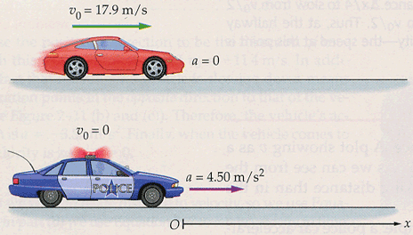
22. A speeder doing 40.0 mi/hr (about 17.9 m/s) in a 25 mi/hr zone approaches a parked police car. The instant the speeder passes the police car, the police begin their pursuit. If the speeder maintains a constant velocity, and the police car accelerates with a constant acceleration of 4.50 m/s², (a) how long does it take for the police car to catch the speeder, (b) how far have the two cars traveled in this time, and (c) what is the velocity of the police car when it catches the speeder?

Free Fall – Section 2.7

23. A robot probe drops a camera off the rim of a 239 m high cliff on Mars, where the free fall acceleration is -3.7 m/s².
- Find the velocity with which the camera hits the ground.
- Find the time period for it to hit the ground.

24. A flowerpot falls from a windowsill 25.0 m above the sidewalk.
- How fast is the flowerpot moving when it strikes the ground?
- How much time does a passerby on the sidewalk below have to move out of the way before the flowerpot hits the ground?

25. A person steps off the end of a 3.00 m high diving board and drops to the water below. (a) How long does it take for the person to reach the water? (b) What is the person's speed on entering the water?

26. You drop a rock from a bridge to the river below. When the rock has fallen 4 m, you drop a second rock. As the rocks continue their free fall, does their separation (a) increase, (b) decrease, or (c) stay the same?
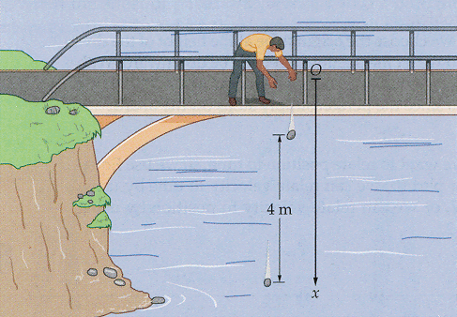

27. A volcano shoots out blobs of molten lava, called lava bombs, from ground level. A geologist observing the eruption uses a stopwatch to time the flight of a particular lava bomb that is projected straight upward. If the time for it to rise and fall back to the ground is 4.75 s, and its acceleration is 9.81 m/s^2 downward, what is its initial speed?
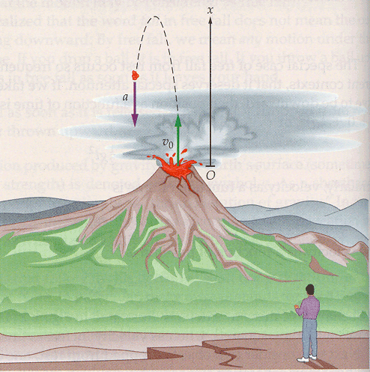

28. A hot air balloon is rising straight upward with a constant speed of 6.5 m/s. When the basket of the balloon is 20.0 m above the ground a bag of sand tied to the basket comes loose. (a) How long is the bag of sand in the air before it hits the ground? (b) What is the greatest height of the bag of sand during its fall to the ground?
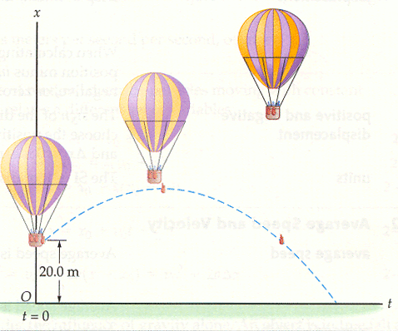

29. A tennis ball is thrown vertically upward with an initial velocity of +8.0 m/s.
- What will the ball’s speed be when it returns to its starting point?
- How long will the ball take to research its starting point?

