Electric Current Chapter 21
Battery
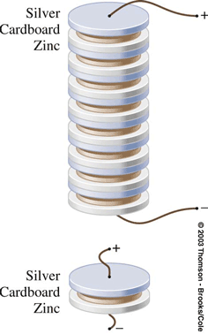
- in which the elementary cell was a zinc-card-board-silver sandwich
21- 1 Electric Current
A battery uses chemical reactions to produce a . It causes current to flow through the flashlight bulb similar to the way the person lifting the water causes the water to flow through the paddle wheel.
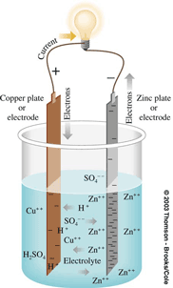
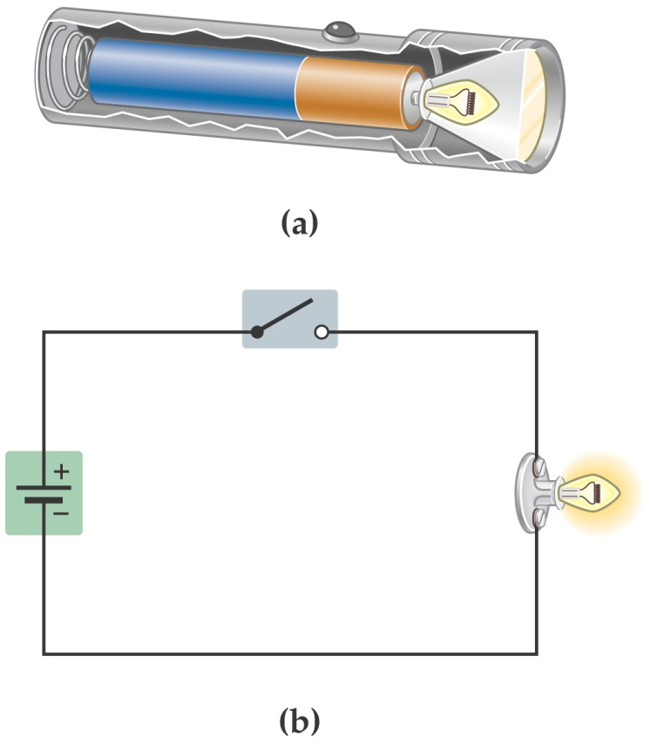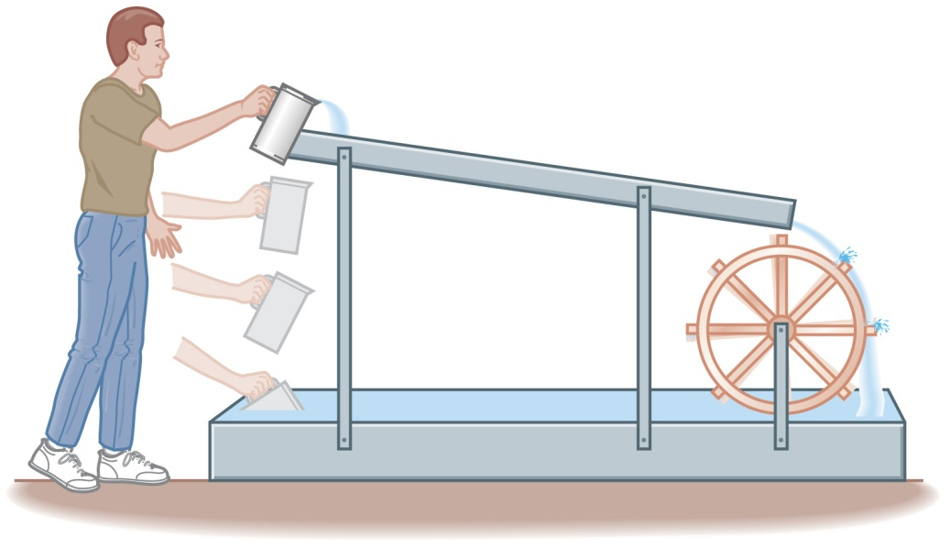
Electromotive Force ε

Electromotive Force: the emf, ε, is the voltage measured across the terminals of a source when no current is being drawn from or delivered to it.
21-1 Electric Current
A battery that is disconnected from any circuit has an electric potential difference between its terminals that is called the electromotive force or emf
Remember – despite its name, the emf is an electric potential, not a force.
The amount of work it takes to move a charge ΔQ from one terminal to the other is:

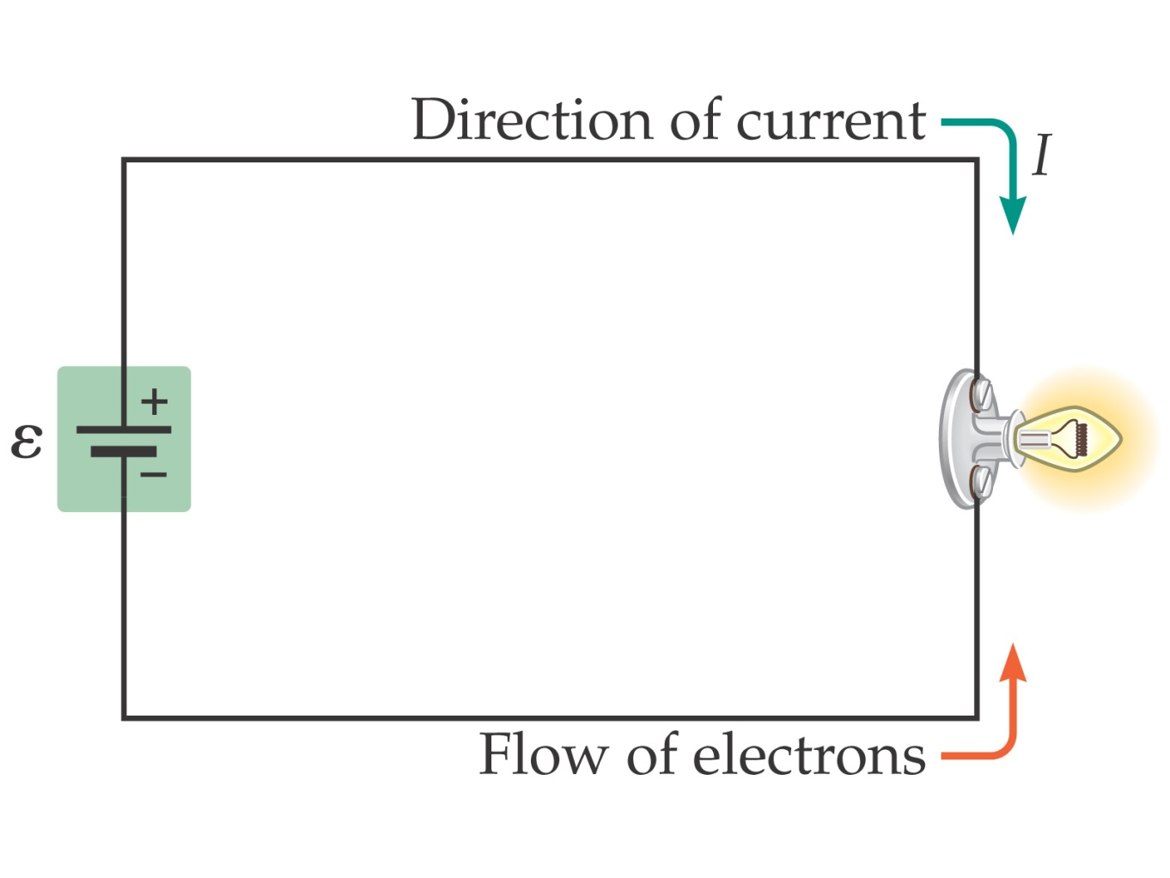
The direction of current flow – . – was decided before it was realized that electrons are negatively charged. Therefore, . ; electrons move the other way. However, this does not matter in most circuits

Finally, the actual motion of electrons along a wire is quite slow; the electrons spe
nd most of their time bouncing around randomly, and have only a small velocity component opposite to the direction of the current. (The electric signal propagates much more quickly!)
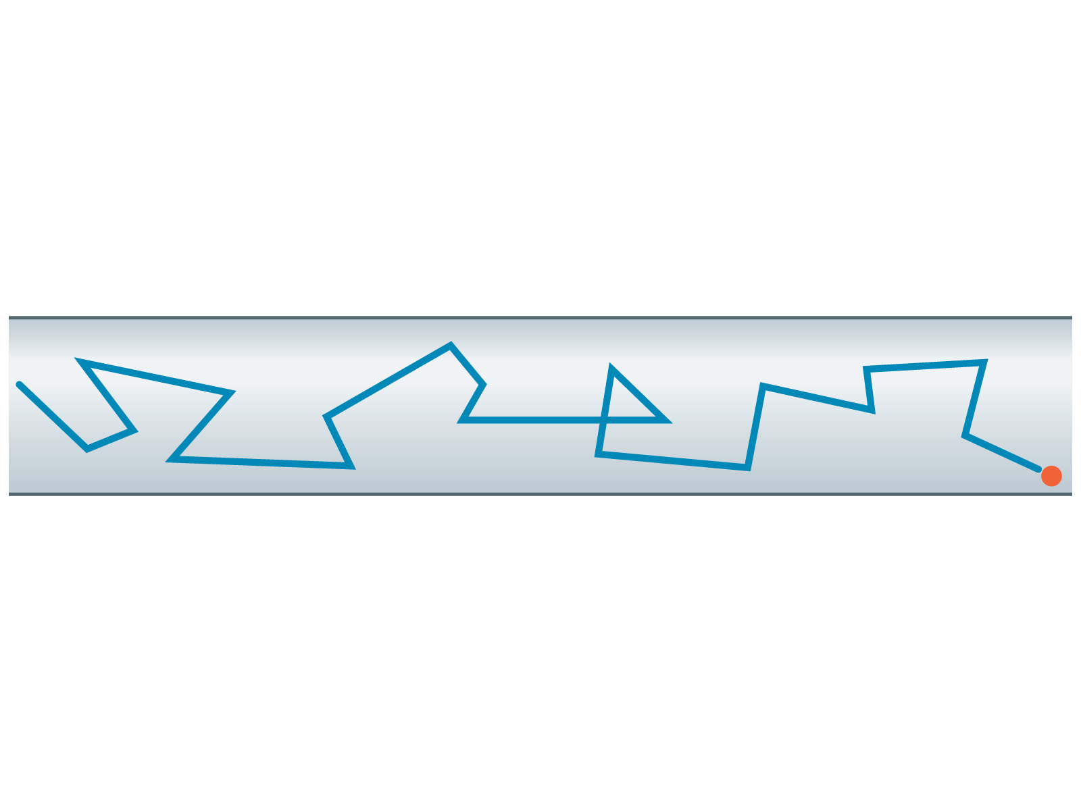

Electric Current and Circuits
current: the rate of charge flow (NOT the speed of charge flow)

Amount of  Charge Flow | Time of Flow | Rate of  Charge Flow
100 charges | 2 s
500 charges | 25 s

One equation for current:

5.8 C of charge flow through a bulb filament in 3.1 s. Find current flowing through filament.

How many e– flow through bulb in one hour?

If 1.0 mole of e– flow through an appliance in 5.6 hours, find current pulled by appliance.

21-2 Resistance and Ohm’s
Under normal circumstances, wires present some resistance to the motion of electrons. Ohm’s law relates the voltage to the current:

Be careful – Ohm’s law is not a universal law and is only useful for certain materials (which include most metallic conductors).

Ohm’s Law
Voltage is an electric…
R
L
L
L

Equation for Ohm’s law: R = resistance, in ohms (Ω)

ΔV
I
I
ΔV

ohmic resistor non-ohmic resistor
-- --

Hair dryer ^{w}/resistance 280 Ω is plugged into a standard outlet. What current flows through hair dryer?

Suppose hair dryer is plugged into an outlet with potential difference 220 V. Find current.

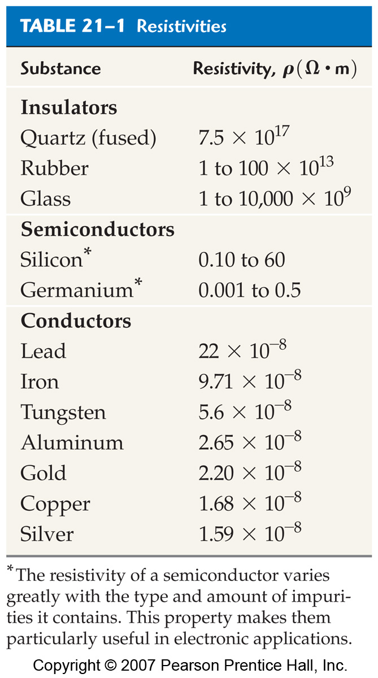
The difference between insulators, semiconductors and conductors can be clearly seen in their

Two wires of the same length and diameter will have different resistances if they are made of different materials. This property of a material is called the resistivity.

In general, the resistance of materials goes , due to thermal effects. This property can be used in thermometers.
Resistivity decreases as the temperature decreases, but there is a certain class of materials . in which the resistivity drops suddenly to zero at a finite temperature, called the critical temperature T_{C}.
21-3 Energy & Power in Electrical Circuits

When a charge moves across a potential difference, its potential energy changes:

Therefore, the power it takes to do this is

In materials for which Ohm’s law holds, the power can also be written:

This power mostly becomes heat inside the resistive material.

Electric Power Equation:
P = power rating / power consumed (W)

A microwave has power rating 1.0 x 10³ W. What current flows through it?

A refrigerator “pulls” 6.25 A. What is its power rating?

What is the resistance of a 75 W light bulb?

For a 100 W bulb…

When the electric company sends you a bill, your usage is quoted in kilowatt-hours (kWh). They are charging you for energy use, and kWh are a measure of energy.

Cost of Electricity Equation:

A computer “pulls” 4.0 A and runs constantly. Electricity costs $0.08/kWh. Find cost to run computer for one year.

21-4 Resistors in Series & Parallel
Resistors connected end to end are said to be in _________. They can be replaced by a single equivalent resistance without changing the current in the circuit.
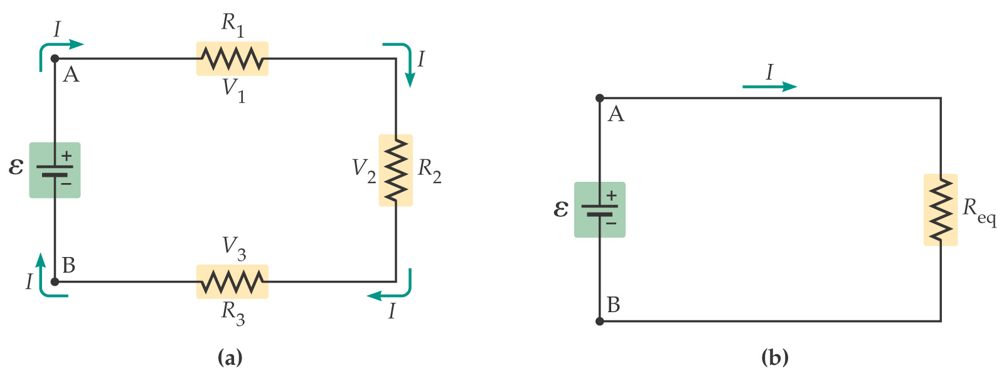
Since the current through the series resistors must be the same in each, and the total potential difference is the sum of the potential differences across each resistor, we find that the equivalent resistance is:

Series Circuits
equivalent resistance: the resistance of several resistors taken together; depends on value
of each resistor and configuration of resistors

For series circuits:
R₁
R₂
R₃
ΔV
 | ΔV(V) | I(A) | R(Ω)
Batt. | 24
R₁ |  |  | 2
R₂ |  |  | 6
R₃ |  |  | 4
R₁
R₂
ΔV
 | ΔV(V) | I(A) | R(Ω)
Batt. | 15 | 1.5
R₁ |  | 1.5
R₂ | 6 | 1.5

Also for series circuits:

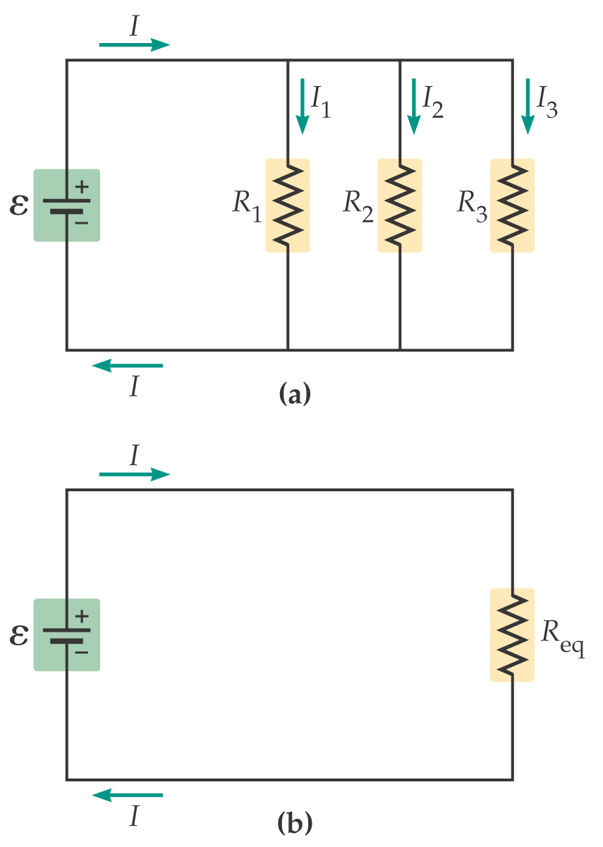

Resistors are in _____________ when they are across the same potential difference; they can again be replaced by a single equivalent resistance
Using the fact that the potential difference across each resistor is the same, and the total current is the sum of the currents in each resistor, we find:

Note that this equation gives you the inverse of the resistance, not the resistance itself!

Parallel Circuits For parallel circuits:
R₁
R₂
ΔV
 | ΔV(V) | I(A) | R(Ω)
Batt. | 12
R₁ |  |  | 6
R₂ |  |  | 3

Also for parallel circuits:

R₁
R₂
R₃
R₄
ΔV
 | ΔV(V) | I(A) | R(Ω)
Batt.
R₁ | 16 |  | 2
R₂ |  |  | 4
R₃ |  |  | 6
R₄ |  |  | 8

If a circuit is more complex, start with combinations of resistors that are either purely in series or in parallel. Replace these with their equivalent resistances; as you go on you will be able to replace more and more of them. 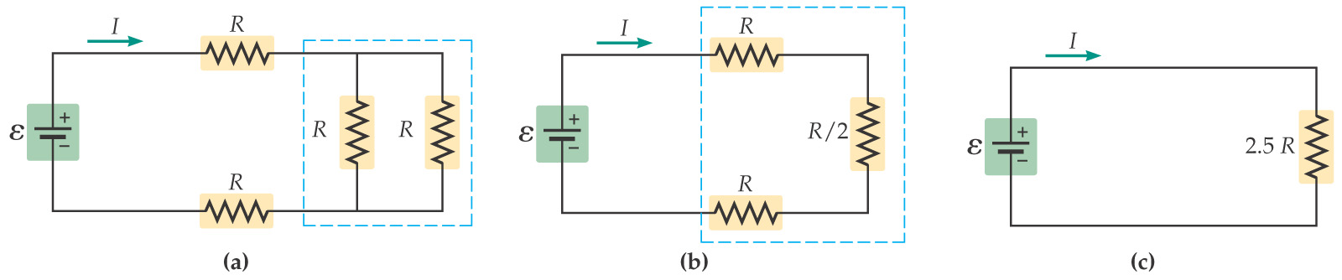

Combination Circuits Solve the following problems.
R₁
R₂
ΔV
R₃

 | ΔV(V) | I(A) | R(Ω)
Batt. | 24
R₁ |  |  | 8
R₂ |  |  | 8
R₃ |  |  | 4

R₁
R₂
ΔV
R₃
R₈
R₄
R₅
R₆
R₇
 | ΔV(V) | I(A) | R(Ω)
Batt. | 36
R₁ | 8.7 |  | 6.5
R₂ |  |  | 8.5
R₃ |  |  | 4.2
R₄ |  |  | 4.8
R₅ | 4.3 |  | 10.6
R₆ |  |  | 7.5
R₇ |  |  | 5.7
R₈ |  |  | 3.8

ΔV  R₂  R₃  R₁  R₄  R₅  R₆ | ΔV(V) | I(A) | R(Ω)
Batt. | 25
R₁ |  |  | 3.5
R₂ |  |  | 5.5
R₃ |  | 1.77 | 3.5
R₄ |  |  | 4.5
R₅ |  |  | 2.5
R₆ |  |  | 6.5

ΔV
R₁
R₃
R₇
R₈
R₆
R₅
R₄
R₂

 | ΔV(V) | I(A) | R(Ω)
Batt. | 12
R₁ |  |  | 8
R₂ |  | 0.202 | 10
R₃ |  |  | 12
R₄ |  |  | 12
R₅ |  |  | 10
R₆ |  |  | 8
R₇ |  |  | 6
R₈ |  |  | 2

21-5 Kirchhoff’s Rules
More complex circuits cannot be broken down into series and parallel pieces.
For these circuits, Kirchhoff’s rules are useful.
The junction rule is a consequence of charge conservation; the loop rule is a consequence of energy conservation.
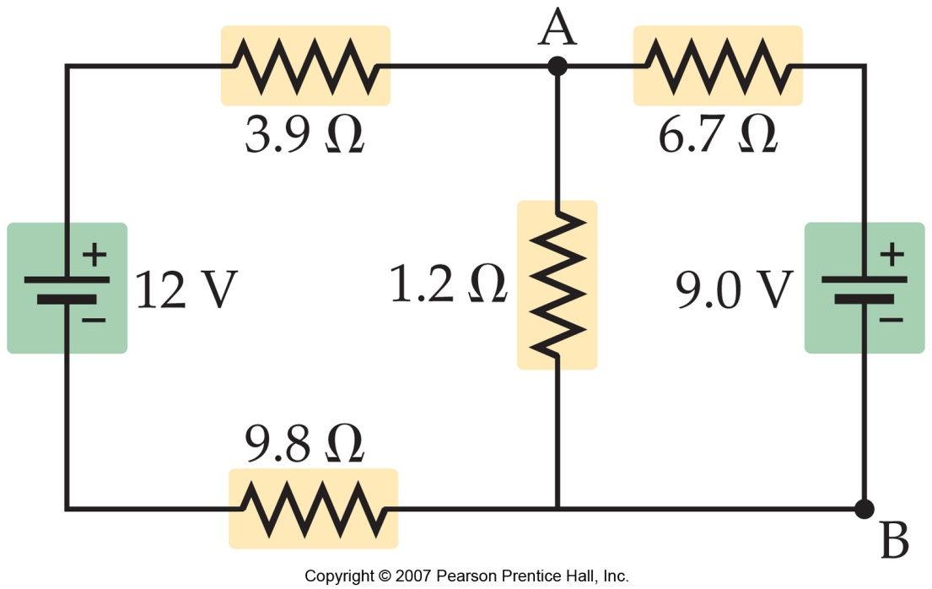

The junction rule: At any junction, the current entering the junction must equal the current leaving it.
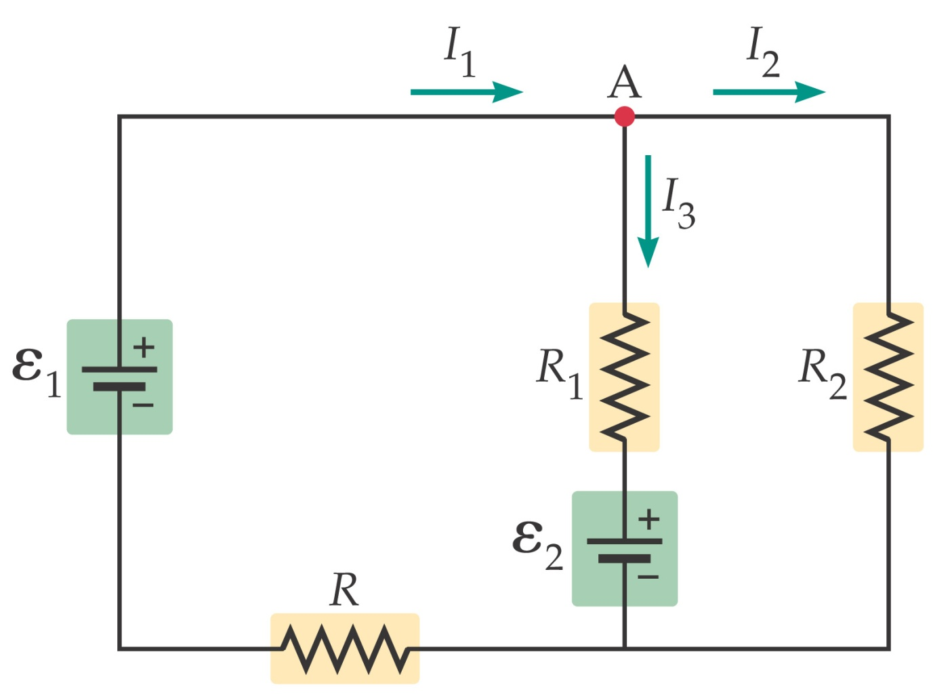
Using Kirchhoff’s rules:
- The variables for which you are solving are the currents through the resistors.
- You need as many independent equations as you have variables to solve for.
- You will need both loop and junction rules.
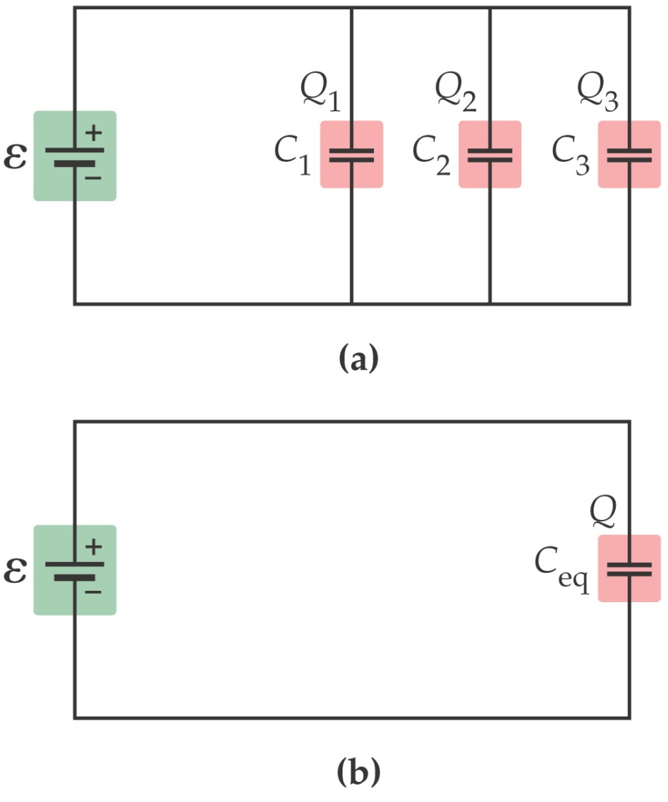
21-6 Circuits Containing Capacitors
Capacitors can also be connected in series or in parallel.

When capacitors are connected in parallel, the potential difference across each one is the same.
Therefore, the equivalent capacitance is the sum of the individual capacitances:

Capacitors connected in series do not have the same potential difference across them, but they do all carry the same charge. The total potential difference is the sum of the potential differences across each one.
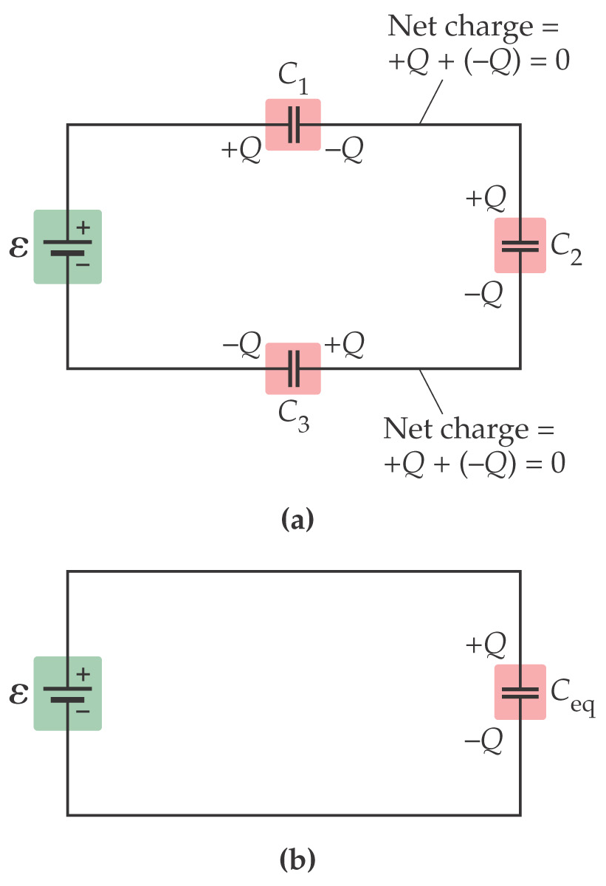

Therefore, the equivalent capacitance is

Note that this equation gives you the inverse of the capacitance, not the capacitance itself!
Capacitors in series combine like resistors in parallel, and vice versa.

21-8 Ammeters and Voltmeters
An ammeter is a device for measuring current, and a voltmeter measures voltages.
The current in the circuit must flow through the ammeter; therefore the ammeter should have as low a resistance as possible, for the least disturbance.
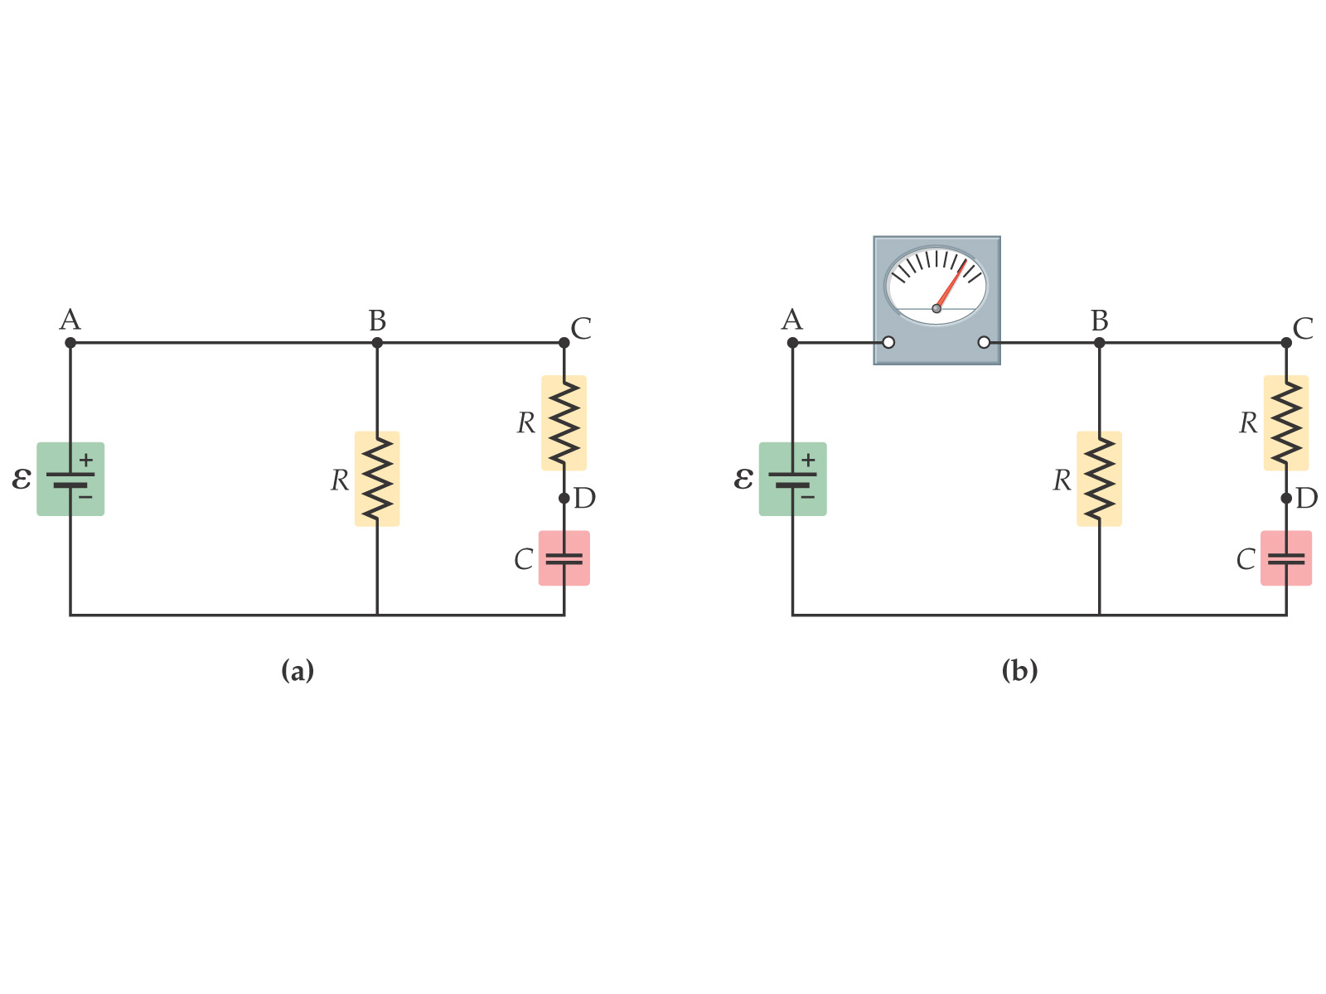
A voltmeter measures the potential drop between two points in a circuit. It therefore is connected in parallel; in order to minimize the effect on the circuit, it should have as large a resistance as possible.

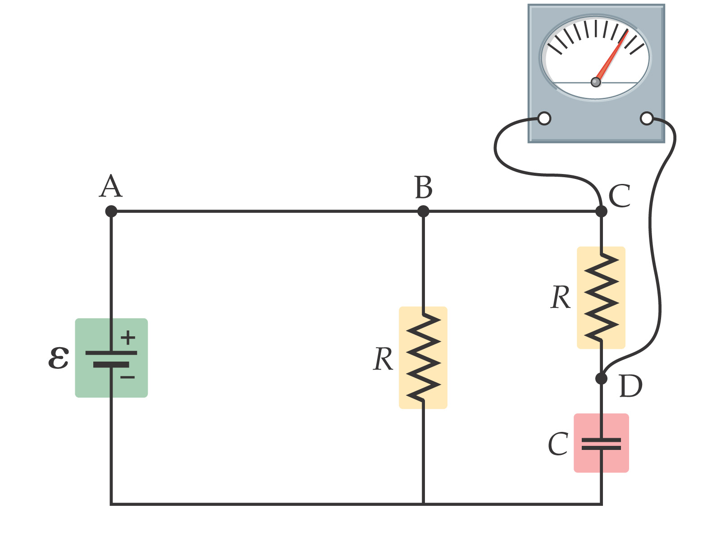

voltmeter: measures.. TARGET CIRCUIT

 | Low Resistance | High Resistance

Series
Parallel

voltmeter →

ammeter: measures…
 | Low Resistance | High Resistance

Series
Parallel

ammeter →

