Name: ___________________________

Chapter 1- Guided Notes

Section 1.1 - The Celestial Sphere
- Vast distances to stars prevent us from sensing their true 3-D arrangement
- Naked eye observations treat all stars at the same distance, on a giant _____________ with the Earth at its center
Models and Science
- The celestial sphere is a _____________ which does not necessarily match physical reality
- Models provide a means to enhance our understanding of nature
Constellations
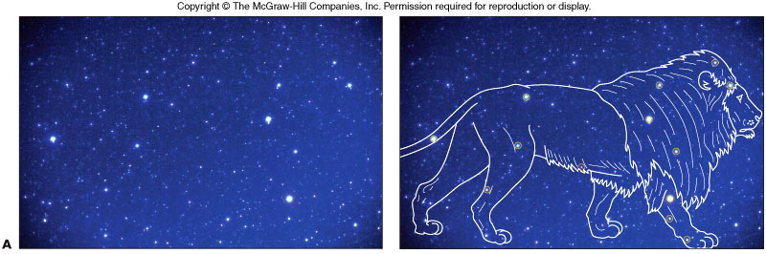
- ________________________ are fixed arrangements of stars that resemble animals, objects, and mythological figures
- Stars in a constellation are not physically related
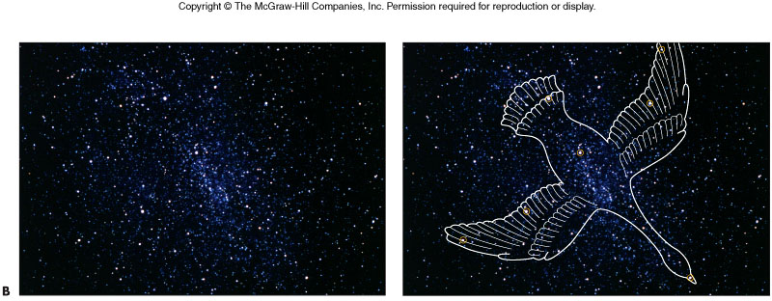
- Positions of stars change very slowly; constellations will look the same for thousands of years
- Origin of the ancient constellations is unknown although they probably served as mnemonic tools for tracking __________________________________.
Diurnal vs. Annular Motion
- Diurnal Motion
  - ______________________
  - Sun, Moon, planets, and stars rise in the east and set in the west
  - Due to the Earth’s _______________.
  - Ancient astronomers took all celestial motion to be diurnal
  - The Celestial Sphere!
- Annual Motion
  - ________________
  - Due to the Earth’s _________________.
  - Is the sky different from day to day?
  - Month to month?
  - Year to year?
Diurnal Motion
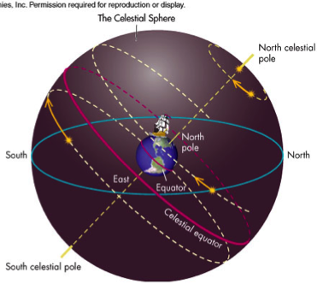
- Daily motion can be explained by the rotation of the celestial sphere about the north and south ________________ located directly above the Earth’s north and south poles
- The _________________ which lies directly above the Earth’s equator, provides another astronomical reference marker

Annual Motion

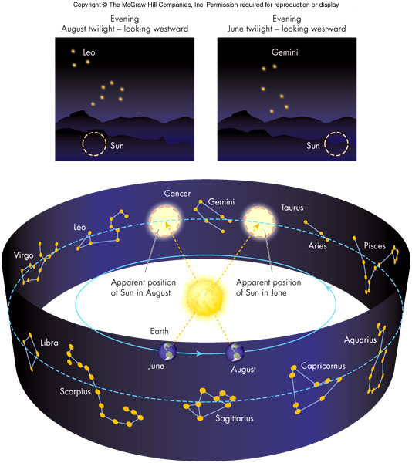
- For a given time (say 10:00 PM), as the months proceed, constellations do not appear in the same part of the sky

- A given star rises ___________________ earlier each night
- This annual motion is caused by the Earth’s motion around the Sun, the result of projection
- The ancients used the periodic annual motion to ______________________.

The Ecliptic
- The path of the Sun through the stars on the celestial sphere is called the ___________
- The ecliptic is a projection of the Earth’s orbit onto the celestial sphere and is tipped relative to the ______________________.
Section 1.2 - The Seasons
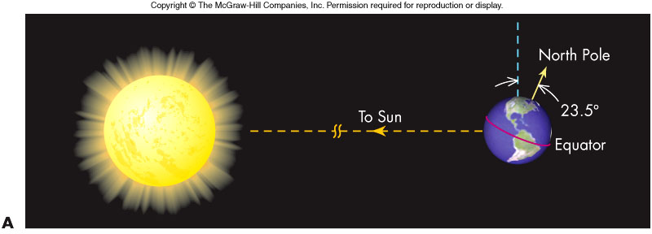
- The Earth is closest to the Sun in _____________ which is winter in the ____________ hemisphere
- Therefore, the seasons cannot be caused by the Sun’s proximity to the Earth
- The Earth’s _______________ is tilted 23.5º from a line perpendicular to the Earth’s orbital plane
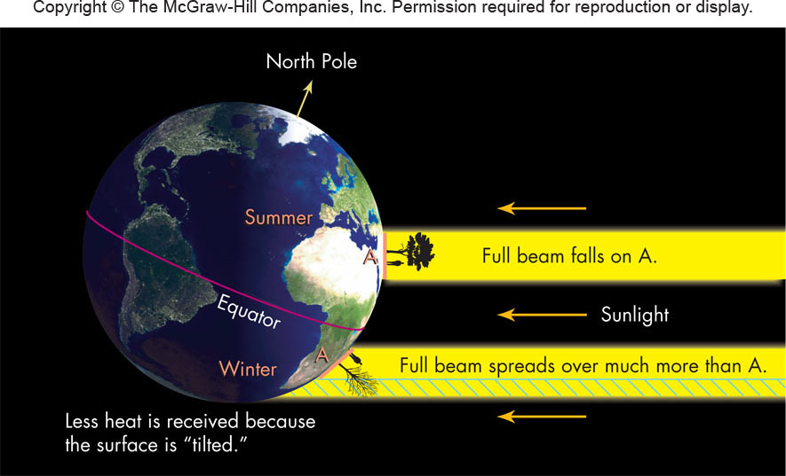
Seasons and The Ecliptic
- The tilt of the Earth’s rotation axis causes the ecliptic ______________________with the celestial equator
- Sun is above celestial equator in June when the Northern Hemisphere is tipped toward the Sun, and is below the equator in December when tipped away
- Tilting explains seasonal ______________of Sun at noon, highest in summer and lowest in winter
Solstices and Equinoxes page 25 cool photos
- Points on horizon where Sun rises and sets changes periodically throughout year
- In summer months of Northern hemisphere, the Sun rises ___________ and sets _____ ___________
- In winter months of Northern hemisphere, the Sun rises _____________ and sets ____ ___________
- The ______________(about June 21 and December 21) are when the Sun rises at the most extreme north and south points
- The ______________ (equal day and night and about March 21 and September 23) are when the Sun rises directly east
- Ancients marked position of Sun rising and setting to determine the seasons (e.g., Stonehenge)
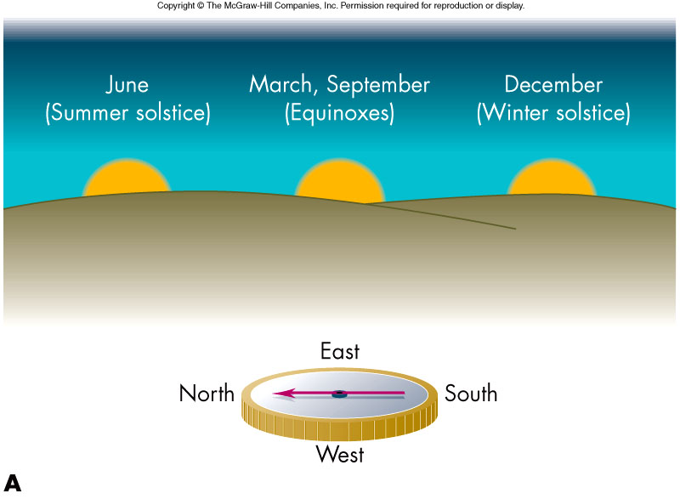

Section 1.3 - The Moon
- Rises in the __________________________
- Like the planets and Sun, the Moon moves from _________________________ (roughly the width of the Moon in one hour)
The Phases of the Moon
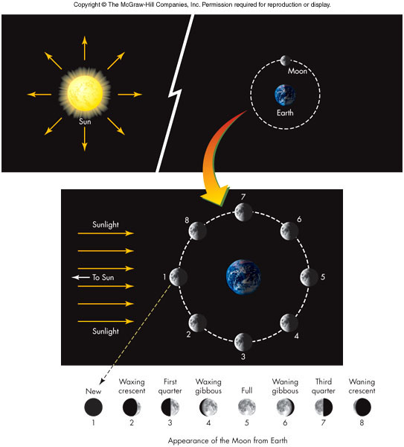
During a period of about ________, the Moon goes through a complete set of ____________
______
_______________
_________________
_________________
_________
__________________
_________________
_____________________

  - The phase cycle is the origin of the month (derived from the word moon) as a _____________________.
  - The phases of the Moon are caused by the relative positions of the ____, ______ and ________________.
Lunar Rise and Set Times
- The Moon rises roughly ______________ later each day.
Section 1.4 - Eclipses
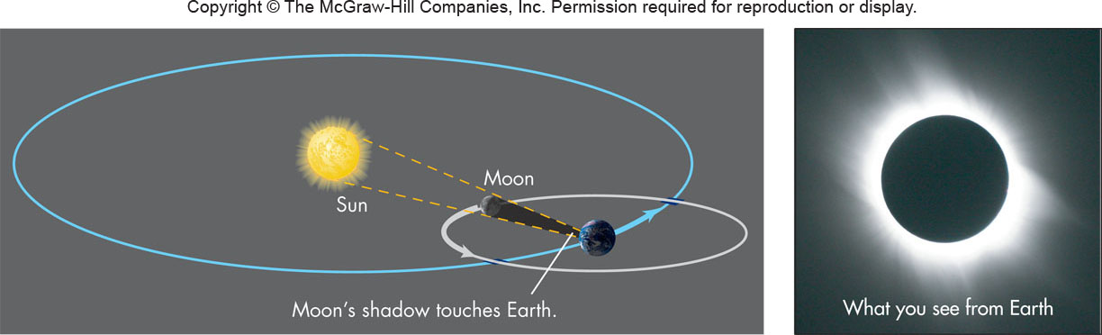
- An ________ occurs when the Sun, Earth, and Moon are directly in line with each other
- A _______________________ occurs when the Moon passes between the Sun and Earth, with the Moon casting its shadow on the Earth causing a midday sky to become dark as night for a few minutes
Lunar Eclipses
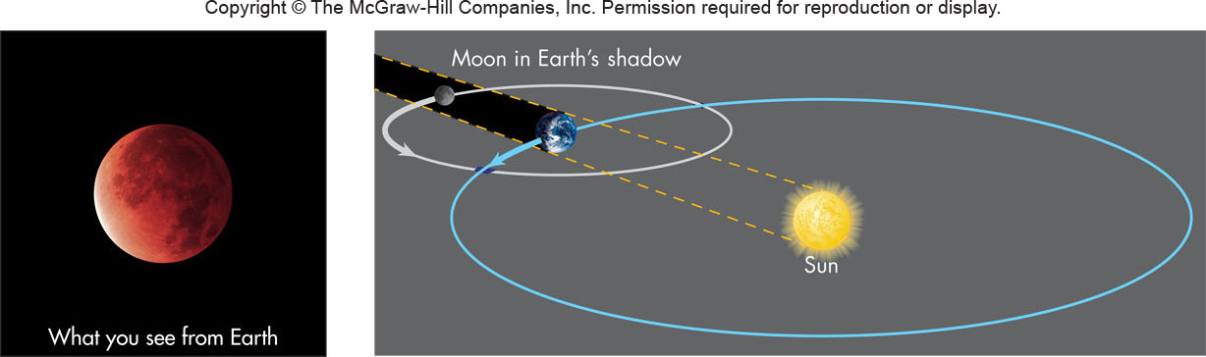
- A ________________ occurs when the Earth passes between the ________________, with the Earth casting its shadow on the Moon giving it a dull red color



