Chapter 19 Notes

Magnets attract iron-containing objects.

Magnets have two distinct poles called the ___________________ and the ______________________ These names are derived from a magnet’s behavior on Earth.

Like poles of magnets ___________each other; unlike poles ___________ each other.

Magnetic Domain
A region composed of a group of atoms whose magnetic fields are aligned in the same direction is called a ________________.

Some materials can be made into _________________.
Soft magnetic materials (for example ______) are easily magnetized but tend to lose their magnetism easily.
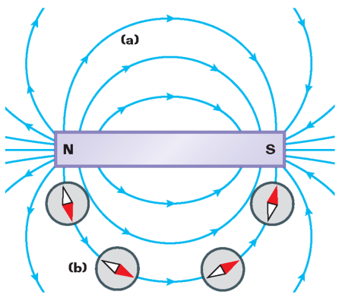
Hard magnetic materials (for example _______) tend to retain their magnetism.

Magnetic Fields
A magnetic field is a region in which a magnetic force can be __________

Magnetic field lines can be drawn with the aid of a ___________

Earth’s magnetic field is similar to that of a _______ magnet.

The magnetic ______________ is near the Geographic North Pole. The magnetic north pole is near the Geographic South Pole.

Magnetic ____________is a measure of the difference between true north and north indicated by a compass.

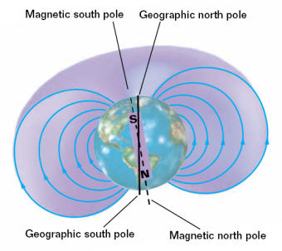
19.2 Magnetic Field of a Current-Carrying Wire

A long, straight, current-carrying wire has a _____________ magnetic field.

Compasses can be used to shown the direction of the _________________ induced by the wire.

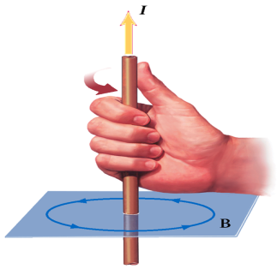
The __________________ rule can be used to determine the direction of the magnetic field in a current-carrying wire.

Magnetic Field of a Current Loop
Solenoids produce a strong magnetic field by combining several loops.

A solenoid is a long, helically wound coil of insulated wire.
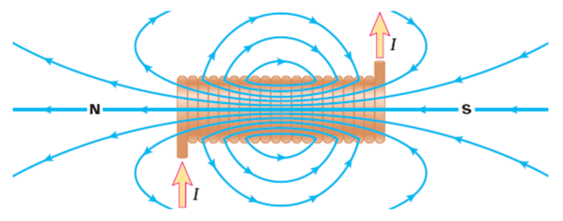

19.3 Charged Particles in a Magnetic Field
A charge moving through a magnetic field experiences a force proportional to the charge, velocity, and the magnetic field.

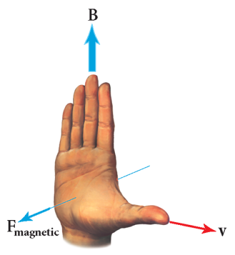

The direction of the magnetic force on a moving charge is always _____________ to both the magnetic field and the velocity of the charge.

An alternative right-hand rule can be used to find the direction of the magnetic force.

A charge moving through a ____________________ follows a circular path

Practice Problem
A proton moving east experiences a force of 8.8  10–19 N upward due to the Earth’s magnetic field. At this location, the field has a magnitude of 5.5  10–5 T to the north. Find the speed of the particle.

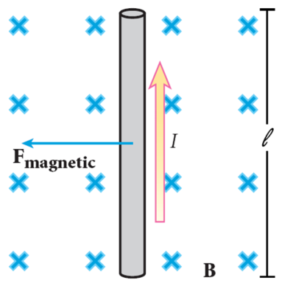
A current-carrying wire in an external magnetic field undergoes a magnetic force. The force on a current-carrying conductor ______________ to a magnetic field is given by:

_____ parallel current-carrying wires exert a force on one another that are equal in magnitude and opposite in direction. If the currents are in the ____________, the two wires attract one another. If the currents are in opposite direction, the wires _________one another. Loudspeakers use magnetic force to produce sound.
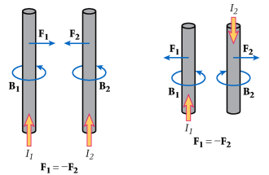

Practice Problem
Force on a Current-Carrying Conductor
A wire 36 m long carries a current of 22 A from east to west. If the magnetic force on the wire due to Earth’s magnetic field is downward (toward Earth) and has a magnitude of 4.0  10–2 N, find the magnitude and direction of the magnetic field at this location.

Force on a Current-Carrying Conductor
Using the right-hand rule to find the direction of B, face north with your thumb pointing to the west (in the direction of the current) and the palm of your hand down (in the direction of the force). Your fingers point north. Thus, Earth’s magnetic field is from south to north.

