Electromagnetism Chapter 16
Electrostatics
- There are two kinds of electric charge.

  - Electric charge is conserved.
  - Positively charged particles are called
  - Uncharged particles are called
  - Negatively charged particles are called

Electric charge is quantized:
-- charge is measured in coulombs (C)
-- charge on one p⁺ or e– =

A conductor loses –1.05 x 10^{–18} C of charge. How many e– did it lose?

The experiment that lead to determining the charge of a particle was
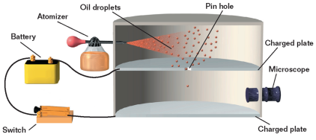

Transfer of Charge
- An is a material in which charges can move freely.

- An is a material in which charges cannot move freely.

- Insulators and conductors can be charged by .

- Conductors can be charged by .

- is a process of charging a conductor by bringing it near another charged object and grounding the conductor.
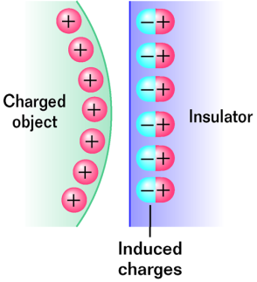
A surface charge can be induced on insulators by .

With , the charges within individual molecules are realigned such that the molecule has a slight charge separation.
Coulomb Law
- Two charges near one another exert a force on one another called the

- Coulomb’s law states that the electric force is to the magnitude of each charge and to the of the distance between them.

- The resultant force on a charge is the of the individual forces on that charge. (pp A)

- Adding forces this way is an example of the principle of . (pp b)

- When a body is in , the net external force acting on that body is zero. (pp C)

- The Coulomb force is a .
- A is a force that is exerted by one object on another even though there is no physical contact between the two objects.

Electrostatic force can be:
ATTRACTIVE REPULSIVE
+
+
+
–

–
–
Magnitude of elec. force between two charges is found using Coulomb’s law:
k_{c} = 9 x 10⁹ N.m²/C²
q = magnitude of charge (C)
r = separation between charges (m)

A +4.0 x 10^{–8} C charge and +7.6 x 10^{–9} C charge are 28 cm apart.
+
+
Find mag. and dir. of force between them.

How far apart must two protons be for them to repel each other with a force of 7.6 x 10^{–26} N?
+
+

Electric Field
- An is a region where an electric force on a test charge can be detected.
- The SI units of the
- The , is in the direction of the electric force that would be exerted on a small positive test charge.

Electric Field Strength
- Electric field strength depends on and . An electric field exists in the region around a charged object.

- Electric Field Strength Due to a Point Charge

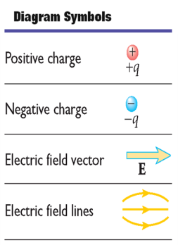
Electric Field Lines
- The number of electric field lines is to the electric field strength.

- Electric field lines are to the electric field vector at any point.

Conductors in Electrostatic Equilibrium
- The electric field is everywhere inside the conductor.

- Any on an isolated conductor resides entirely on the conductor’s outer surface.

- The electric field just outside a charged conductor is to the conductor’s surface.

- On an irregularly shaped conductor, charge tends to accumulate where the radius of the surface is smallest, that is, at sharp points.

