Electromagnetism Chapter 16 Name: ____________________
Electrostatics

Electricity is……….
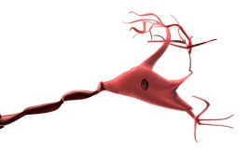

Electric charge is quantized:
-- charge is measured in coulombs (C)
-- charge on one p⁺ or e– =

A conductor loses –1.05 x 10^{–18} C of charge. How many e– did it lose?

Electrostatic force can be:
ATTRACTIVE REPULSIVE
+
+
+
–

–
–

Magnitude of elec. force between two charges is found using Coulomb’s law:
k_{c} = 9 x 10⁹ N.m²/C²
q = magnitude of charge (C)
r = separation between charges (m)

A +4.0 x 10^{–8} C charge and +7.6 x 10^{–9} C charge are 28 cm apart.
+
+
Find mag. and dir. of force between them.

How far apart must two protons be for them to repel each other with a force of 7.6 x 10^{–26} N?
+
+

Principle of Superposition

What happens when there are more than two charges present?

Experiments show that

