Chapter 15 – Diffraction & Interference

Combining Light Waves

takes place only between waves with the same wavelength. A light source that has a single wavelength is called

, component waves combine to form a resultant wave with the same wavelength but with an amplitude that is than the either of the individual component waves.

In the case of , the resultant amplitude is less than the amplitude of the larger component wave.

Interference Between Transverse Waves
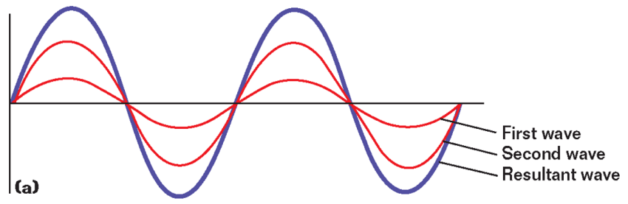

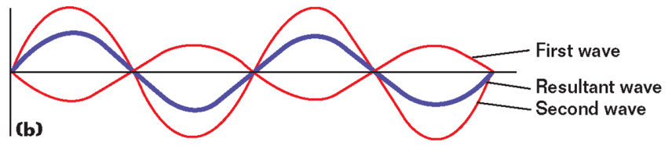

Waves must have a for interference to be observed.

is the correlation between the phases of two or more waves.

Sources of light for which the phase difference is constant are said to be

Sources of light for which the phase difference is not constant are said to be

Demonstrating Interference
can be demonstrated by passing light through

- If is used, the light from the two slits produces a series of bright and dark parallel bands, or , on a viewing screen.

Conditions for Interference of Light Waves

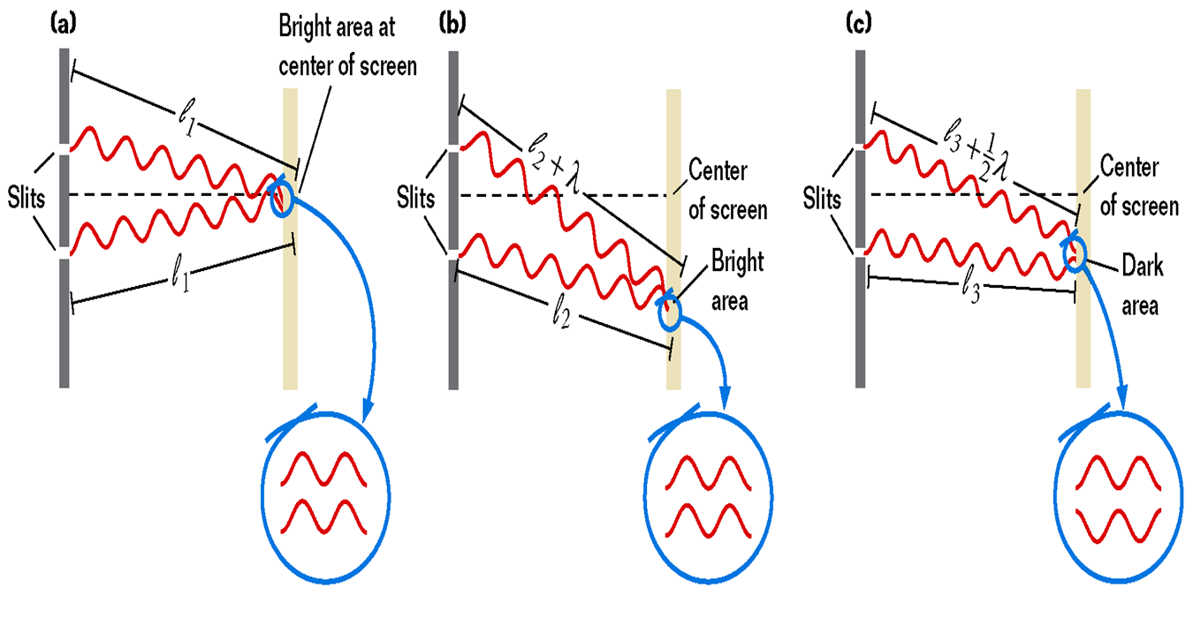
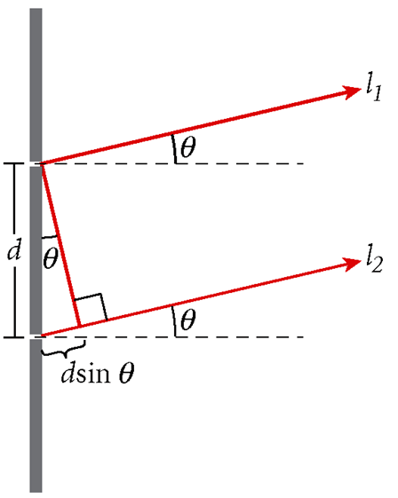
Demonstrating Interference
- The location of can be predicted.

- The is the difference in the distance traveled by two beams when they are scattered in the same direction from different points.

- The path difference equals

- The number assigned to interference fringes with respect to the central bright fringe is called The order number is represented by the symbol .

- The fringe at q = 0 (m = 0) is called the , or the .

- The on either side of the central maximum is called the .
- Equation for constructive interference

- Equation for destructive interference

Sample Problem
Interference
The distance between the two slits is 0.030 mm. The second-order bright fringe (m = 2) is measured on a viewing screen at an angle of 2.15º from the central maximum. Determine the wavelength of the light.

The Bending of Light Waves

- is a change in the direction of a wave when the wave encounters an obstacle, an opening, or an edge.

- Light waves form a by passing around an obstacle or bending through a slit and interfering with each other.

- Wavelets (as in in a wave front with each other.

Destructive Interference in Single-Slit Diffraction

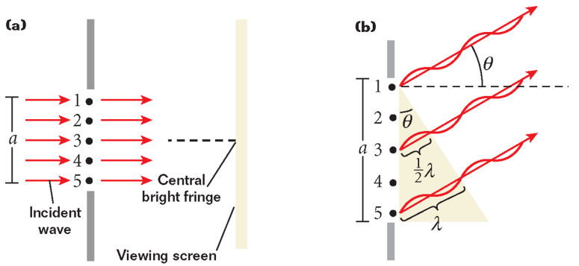

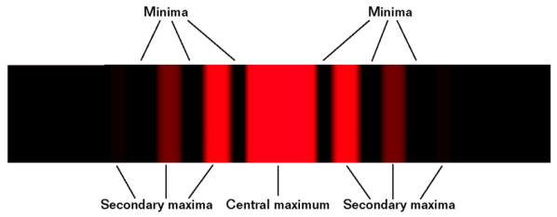
- In a the central maximum is twice as wide as the secondary maxima.

- by an obstacle also produces a pattern.

Diffraction Gratings

A uses diffraction and interference to disperse light into its component colors.

The position of a maximum depends on the separation of the slits in the grating, d, the order of the maximum m,

Constructive Interference by a Diffraction Grating

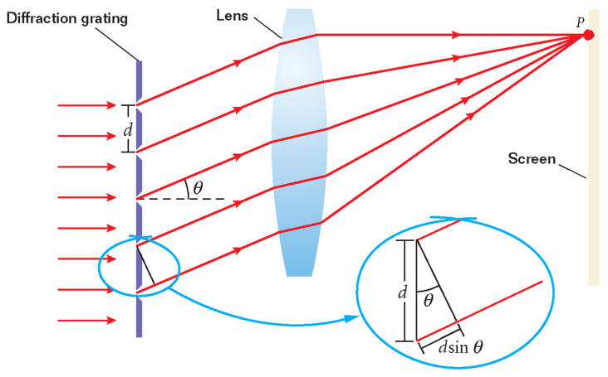
Sample Problem
Diffraction Gratings
Monochromatic light from a helium-neon laser (l = 632.8 nm) shines at a right angle to the surface of a diffraction grating that contains 150 500 lines/m. Find the angles at which one would observe the first-order and second-order maxima.

Diffraction and Instrument Resolution

- The ability of an optical system to distinguish between closely spaced objects is

- power is the ability of an optical instrument to form separate images of two objects that are close together.

- depends on wavelength and aperture width.

Resolution of Two Light Sources

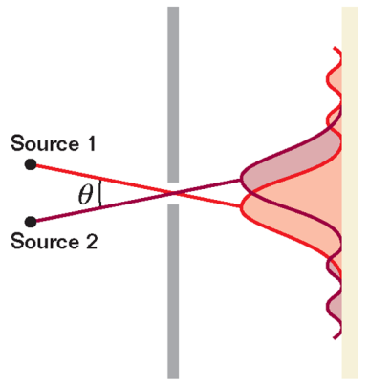
Lasers and Coherence

- A is a device that produces coherent light at a single wavelength.

- The word laser is an acronym of “ - .”

- Lasers transform other forms of energy into .

Applications of Lasers
- Lasers are used to measure distances with great precision.

- use lasers to read digital data on these discs.

- Lasers have many applications in medicine.
-

-

-
Components of a Compact Disc Player
Incoherent and Coherent Light
