Chapter 13 – Properties of Stars Name________________________

The Family of Stars

- Those tiny glints of light in the night sky are in reality huge, dazzling _____ _______, many of which are _______________________ than the Sun
- They look dim because of their ___________________
- Astronomers cannot probe stars directly, and consequently must devise __________________ to ascertain their intrinsic properties
- ____________________ to stars and galaxies __________________
- Distance is very important for determining the ___________________ of astronomical objects
Triangulation
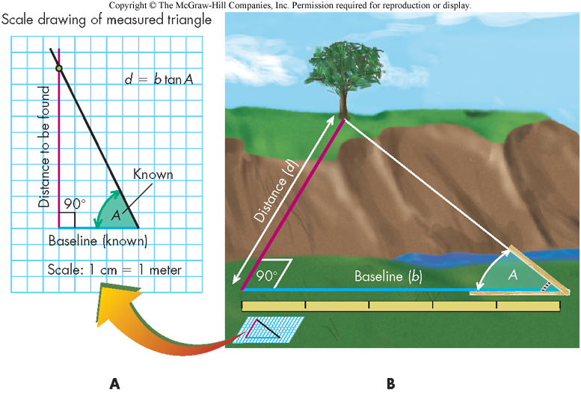

- Fundamental method for measuring distances to nearby stars is _____________
- Measure length of a triangle’s “______________” and the angles from the ends of this baseline to a distant object
- Use trigonometry or a scaled drawing to determine distance to object
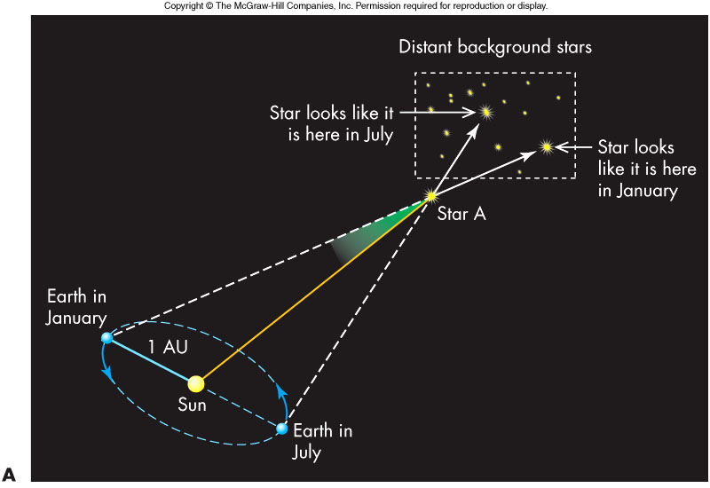
Trigonometric Parallax

Calculating Distance Using Parallax

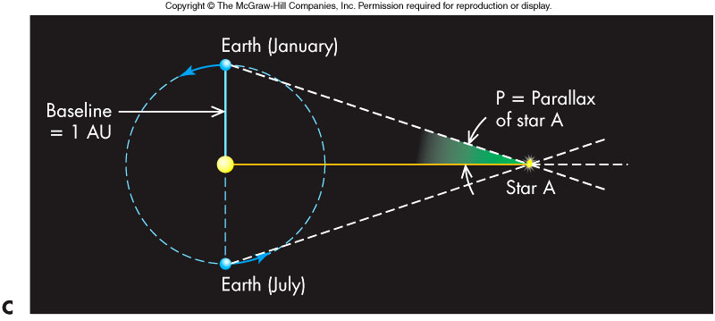
- A method of triangulation used by astronomers is called _________________
  - Baseline is the Earth’s orbit radius ____________
  - _________ measured with respect to very distant stars

- The shift of nearby stars is small, so angles are measured in _____________
- The parallax angle, __, is half the angular shift of the nearby star, and its distance in parsecs is given by:

__________________________
- A ____________________________________.
- Useful only to distances of about 250 parsecs
Example: Distance to Sirius
- Measured parallax angle for Sirius is 0.377 arc second
- From the formula,

Light, the Astronomer’s Tool

- Astronomers want to know the ____________________________ of stars
- This information helps to understand the nature of stars as well as their _______________
- The light from stars received at Earth is all that is available for this analysis
Temperature

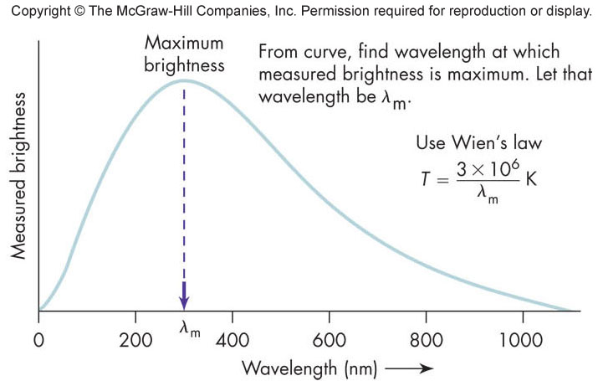
- The ______________ indicates its ________________ – blue stars are hotter than red stars
- More precisely, a star’s surface temperature (in Kelvin) is given by the __________________ (nm) at which the star radiates most strongly

Luminosity

- The amount of energy a star emits each second is its _____________ (usually abbreviated as L)
- A typical unit of measurement for luminosity is the ______________.
- Compare a 100-watt bulb to the Sun’s luminosity, 4 × 10²⁶ watts
- Luminosity is a measure of a star’s ________________ (or ______________ ______________
- Knowing a star’s luminosity will allow a determination of a star’s __________ ________________
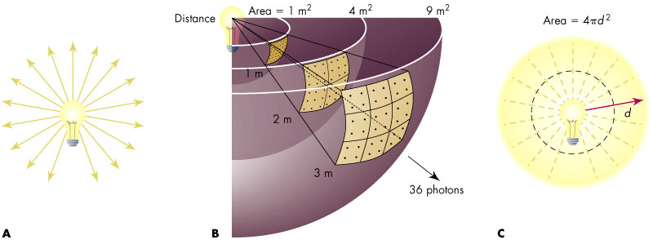
The Inverse-Square Law

- The ________________ relates an object’s luminosity to its ____________________ _______________ (how bright it appears to us)

- This law can be thought of as the result of a _______________________, spreading out evenly in all directions as they leave the source
- The photons have to cross ______________ concentric spherical shells.
- For a given shell, the number of photons crossing _____________________ ___________________
- The inverse-square law (IS) is:
- ____________________ at a distance d from a source of luminosity L
- This relationship is called the inverse-square law because the distance appears in the denominator as a square
- The inverse-square law is one of the most important mathematical tools available to astronomers:
- Given ______________________________, a star’s L can be found (A star’s B can easily be measured by an electronic device, called a ___________________, connected to a telescope.)
- Or if L is known in advance, a star’s distance can be found
The “Standard Candle” Method

- If an object’s _______________brightness is known, its distance can be determined from its ___________brightness
- Astronomers call this method of distance determination the ____________ _____________________
- This method is the principle manner in which astronomers determine distances in the universe
Radius

- Common sense: Two objects of the same temperature but different sizes, the _____________________________ than the smaller one
- In stellar terms: a star of __________________________________ than a smaller star at the same temperature

Knowing L “In Advance”

- We first need to know how much energy is emitted per unit area of a surface held at a certain temperature
- The Stefan-Boltzmann (SB) Law gives this:

- Here s is the ___________________________________
Tying It All Together

- The Stefan-Boltzmann law ___________________ but not hot, low-density gases
- We can combine SB and IS to get:
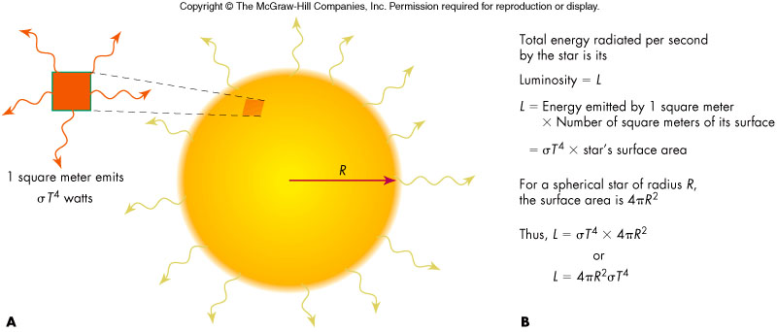
R is the radius of the star
- Given L and T, we can then find a star’s radius!
- The methods using the Stefan-Boltzmann law and ______________observations show that stars differ enormously in radius
  - Some stars are hundreds of times larger than the Sun and are referred to as ____________
  - Stars smaller than the giants are called _____________
Example: Measuring the Radius of Sirius

- Solving for a star’s radius can be simplified if we apply L = 4pR²sT⁴ to both the star and the Sun, divide the two equations, and solve for radius:

- Where s refers to the star and ¤ refers to the Sun
Given for Sirius L_{s} = 25L¤, T_{s} = 10,000 K, and for the Sun T¤= 6000 K, one finds R_{s} = 1.8R¤
The Magnitude Scale

- About 150 B.C., the Greek astronomer Hipparchus measured apparent brightness of stars using units called ___________________
  - Brightest stars had _____________________________________ ________________
  - The system is still used today and units of measurement are called _____________________ to emphasize how bright a star looks to an observer
- A star’s apparent magnitude depends on the star’s luminosity and distance – a star may appear dim because it is very far away or it does not emit much energy
- The apparent magnitude can be confusing
  - _______________________________________________
  - Modern calibrations of the scale create negative magnitudes
  - Magnitude differences equate to brightness ratios:
    - A difference of 5 magnitudes = a brightness ratio of 100
    - 1 magnitude difference = brightness ratio of 100^{1/5}=2.512
- Astronomers use _______________________ to measure a star’s luminosity
  - The absolute magnitude of a star is the apparent magnitude that same star would have at 10 parsecs
  - A comparison of absolute magnitudes is now a ________________ __________________________________
  - An absolute magnitude of 0 approximately equates to a luminosity of 100L¤
The Spectra of Stars

- A star’s spectrum typically depicts __________________________ ___________________________
- A spectrum also can reveal a star’s _________________________ ____________________________________________________
- On certain occasions, it may reveal ________________________

Measuring a Star’s Composition

- As light moves through the gas of a star’s surface layers, atoms absorb radiation at some wavelengths, _____________________ lines in the star’s spectrum
- ___________________________________________________
- Determining a star’s surface composition is then a matter of ________ _______________________ lines to those known for atoms
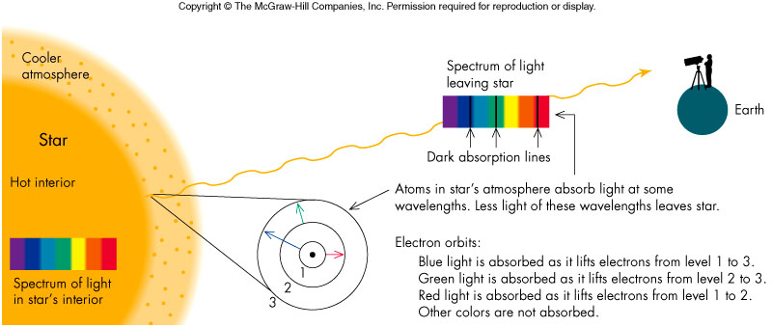
- To find the __________ _______ in the star, we use the ____________ ___________________
- This technique of determining composition and abundance can be tricky!

- Possible overlap of absorption lines from several varieties of atoms being present
- _____________ can also ________ how ____________an absorption line is
Temperature’s Effect on Spectra

- A ________ is ________when its energy matches the difference between two electron energy levels and an electron occupies the _____________
- Higher temperatures_______________, on average, to _____________ _______________ – lower temperatures, lower electron levels
- Consequently, __________________________________________ ____________on the presence or absence of an electron at the right energy level and this is very much ____________________________
- Adjusting for temperature, a star’s composition can be found – interestingly, virtually all stars have compositions very similar to the Sun’s: ________ ____________, and a 2% mix of the remaining elements

Early Classification of Stars

- Historically, stars were first classified into four groups according to their color (________________________________), which were subsequently subdivided into classes using the letters _________________
Modern Classification of Stars

- ____________________ discovered the classes were more orderly in appearance if rearranged by temperature – Her reordered sequence became ___________________ (_________________________________) and are today known as _________________
- ______________________ then demonstrated the physical connection between temperature and the resulting absorption lines

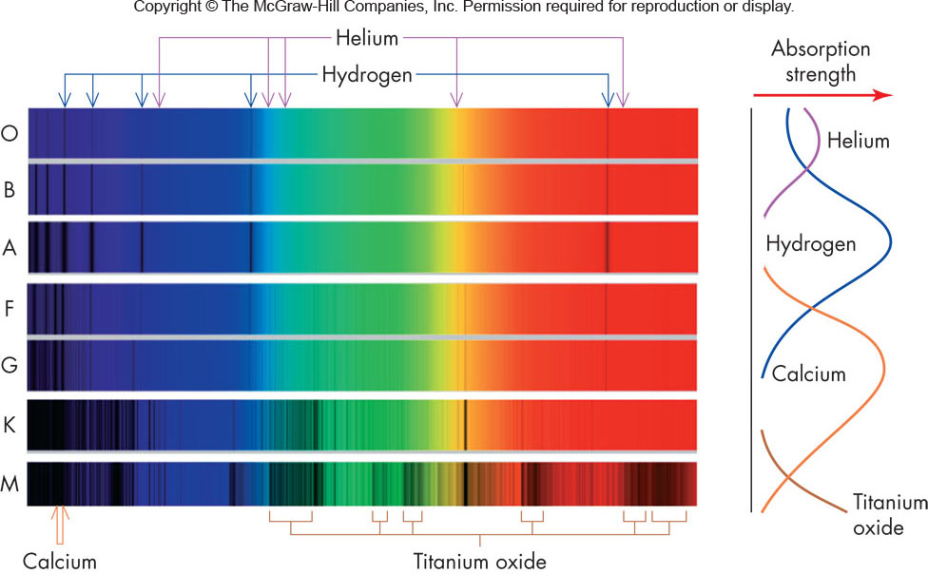

Spectral Classification

- _________________ and the _________________ absorption lines indicate that hydrogen is in a highly ____________
- __________ have just the right temperature to put ______________ _____________________, which results in strong absorption lines in the visible
- ____________________ are of a __________________ to show absorption lines of metals such as calcium and iron, elements that are typically ionized in hotter stars
- ____________ stars are cool enough to form molecules and their absorption “bands” become evident.
- Temperature range: more than _____________________ and less than _________________ stars
- Spectral classes subdivided with numbers - the _______________.

Measuring a Star’s Motion

- A star’s motion is determined from the Doppler shift of its spectral lines
  - The amount of shift depends on the star’s ___________________ which is the star’s speed along the line of sight
  - Given that we measure ______ the shift in wavelength of an absorption line of wavelength _____, the radial speed v is given by:

  - c is the speed of light
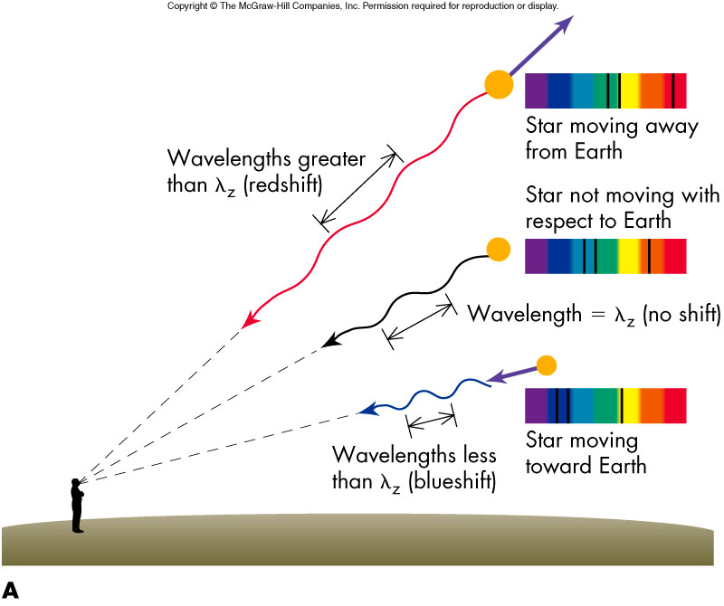
- Note that ____is the wavelength of the absorption line for an object at rest and its value is determined from laboratory measurements on nonmoving sources
- An ______________ means the _________________ a decrease means it is approaching – speed across the line on site cannot be determined from _________________
- Doppler measurements and related analysis show:
  - ____________ and that those near the Sun share approximately the same direction and speed of revolution (_________________) around the center of our galaxy
  - Superimposed on this orbital motion are small random motions of about 20 km/sec
  - In addition to their motion through space, stars spin on their axes and this spin can be measured using the Doppler shift technique – ______ _________________________________
Binary Stars

- _______________ that revolve around each other as a result of their mutual gravitational attraction are called _____________
- Binary star systems offer one of the few ways to measure _____________ – and stellar mass plays the leading role in a star’s evolution
- At least 40% of all stars known have orbiting companions (some more than one)
- Most binary stars are only a few AU apart – a __________________ ____________________
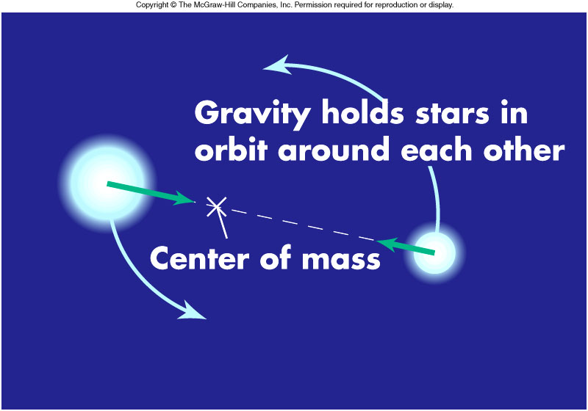
Visual Binary Stars

- _____________________ are binary systems where we can directly see the orbital motion of the stars about each other by __________________ _______________________________

Spectroscopic Binaries

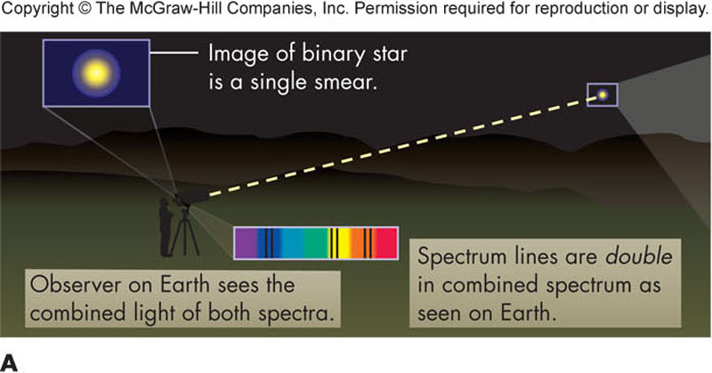
- _________________________ are systems that are inferred to be binary by a comparison of the system’s spectra over time.
- Doppler analysis of the spectra can give a _____________ and by observing a full cycle of the motion the ______________ and ____________ can be determined

Stellar Masses

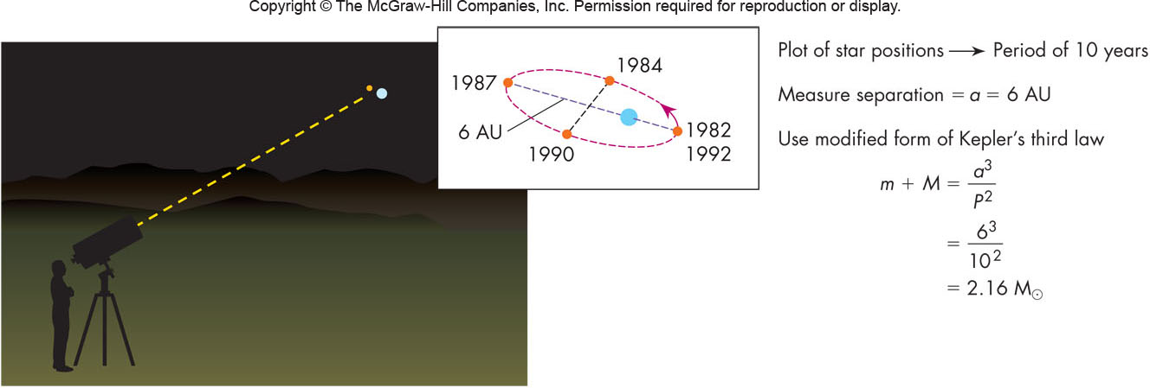
- Kepler’s third law as modified by Newton is

________________ are the binary star masses (in solar masses), P is their period of revolution (in years), and a is the semimajor axis of one star’s orbit about the other (in AU)
- _______________________ are determined from observations (may take a few years) and the above equation gives the combined mass (m + M)
- Further observations of the stars’ orbit will allow the determination of each star’s individual mass
- Most stars have masses that fall in the narrow range____________________

Eclipsing Binaries
- A binary star system in which one star can eclipse the other star is called an _____________ _____________
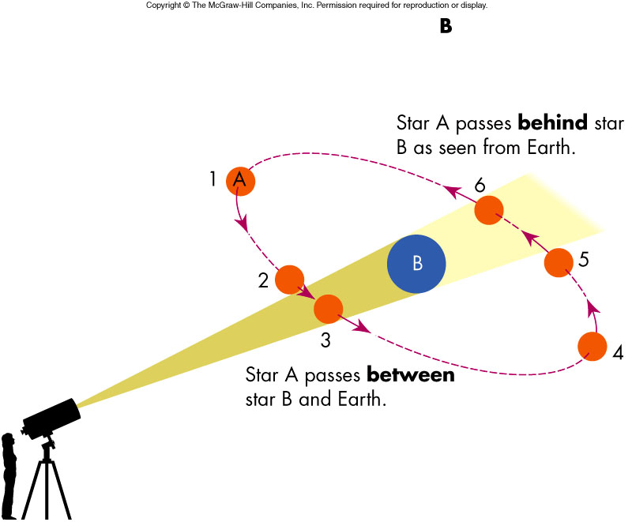
- Watching such a system over time will reveal a combined light output that will periodically dim
- The duration and manner in which the combined light curve changes together with the _____________________ allows astronomers to ________________________ of the two eclipsing stars

Summary of Stellar Properties
- ____________________
  - Parallax (triangulation) for nearby stars (distances less than 250 pc)
  - Standard-candle method for more distant stars
- ____________________
  - Wien’s law (color-temperature relation)
  - Spectral class (O hot; M cool)
- __________________
  - Measure star’s apparent brightness and distance and then calculate with inverse square law
  - Luminosity class of spectrum (to be discussed)
- ___________________
  - Spectral lines observed in a star
- ________________
  - Stefan-Boltzmann law (measure L and T, solve for R)
  - Interferometer (gives angular size of star; from distance and angular size, calculate radius)
  - Eclipsing binary light curve (duration of eclipse phases)
- _____________
  - Modified form of Kepler’s third law applied to binary stars
- ___________________
  - Doppler shift of spectrum lines
Putting it all together –______________________________________

- So far, only properties of stars have been discussed – this follows the historical development of studying stars
- The next step is to understand why stars have these properties in the combinations observed
- This step in our understanding comes from the H-R diagram, developed independently by Ejnar Hertzsprung and Henry Norris Russell in 1912

The HR Diagram
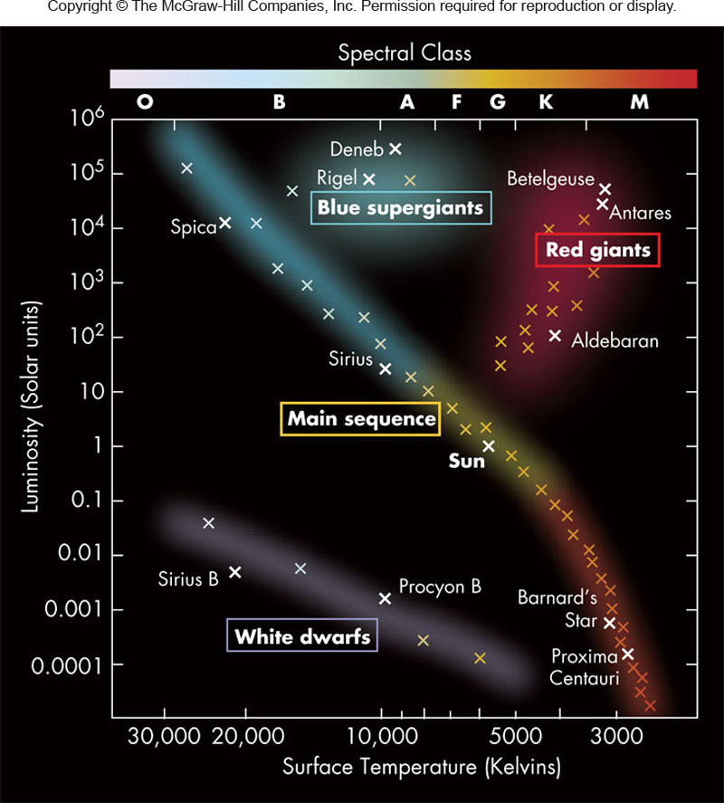
- The _________________ is a plot of stellar _________________________
- Interestingly, most of the stars on the H-R diagram lie along a smooth diagonal running from hot, luminous stars (upper left part of diagram) to cool, dim ones (lower right part of diagram)
- By tradition, ______________________ __________________of the H-R diagram and ____________________________ are on the left with ____________ stars on the right (Note: temperature does not run in a traditional direction)
- The diagonally running group of stars on the H-R diagram is referred to as the ______________________
- Generally, ___________________________ be on the main sequence; however, a few stars will be cool but very luminous (upper right part of H-R diagram), while others will be hot and dim (lower left part of H-R diagram)
Analyzing the HR Diagram

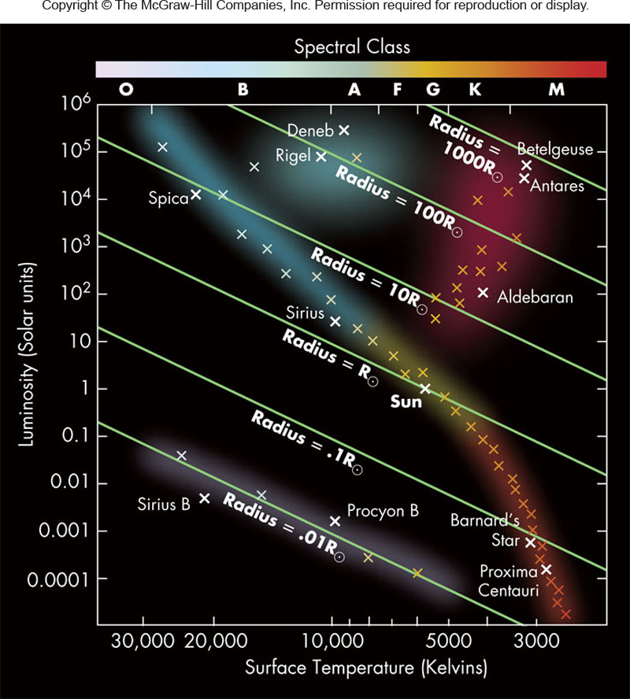
- The Stefan-Boltzmann law is a key to understanding the H-R diagram
  - For stars of a given temperature, ________________________ _____________________
  - Therefore, as one moves up the H-R diagram, a star’s radius must become bigger
  - On the other hand, for a given luminosity, __________________ ______________________
  - Therefore, as one moves right on the H-R diagram, a star’s radius must increase
  - The net effect of this is that the ____________________________ _________________of the diagram and the _________________ ________________________
Giants and Dwarfs
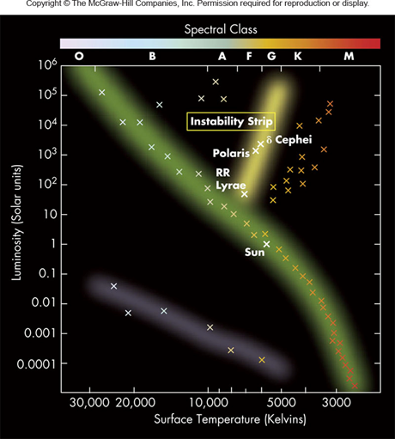

- Stars in the upper left are called _________________(red because of the low temperatures there)
- Stars in the lower right are __________________
- Three stellar types: main sequence, red giants, and white dwarfs
The Mass-Luminosity Relation
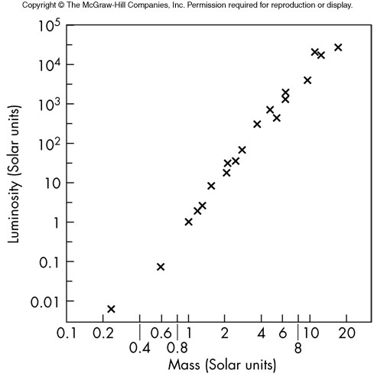

- Main-sequence stars obey a __________ _____________, approximately given by:

- L and M are measured in solar units
- Consequence: Stars at top of main-sequence are more massive than stars lower down

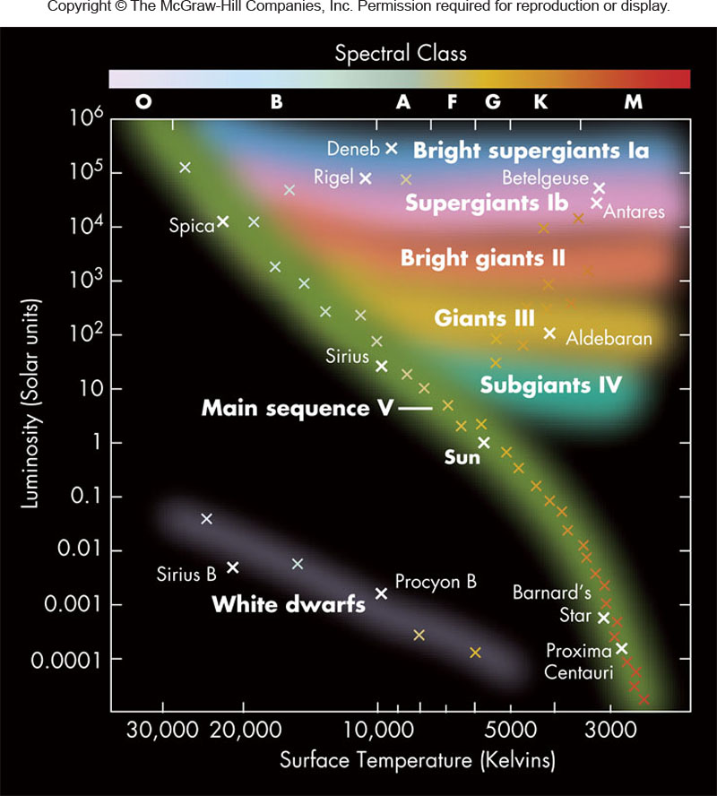
Luminosity Classes

- Luminous stars (in upper right of H-R diagram) tend to be less dense, hence narrow absorption lines
- H-R diagram broken into luminosity classes: ______________________ ______________________________ ______________________________ ______________________________
  - Star classification example: The Sun is G2V

Summary of the HR Diagram

- Most stars lie on the main sequence
  - Of these, the hottest stars are blue and more luminous, while the coolest stars are red and dim
  - Star’s position on sequence determines its mass, being more near the top of the sequence
- Three classes of stars:
  - ___________________
  - ___________________
  - ___________________

Variable Stars

- Not all stars have a constant luminosity – some change brightness: __________________
- There are several varieties of stars that vary and are important distance indicators
- Especially important are the ______________________ stars with rhythmically _______________________________
- Most variable stars plotted on H-R diagram lie in the narrow “__________________”
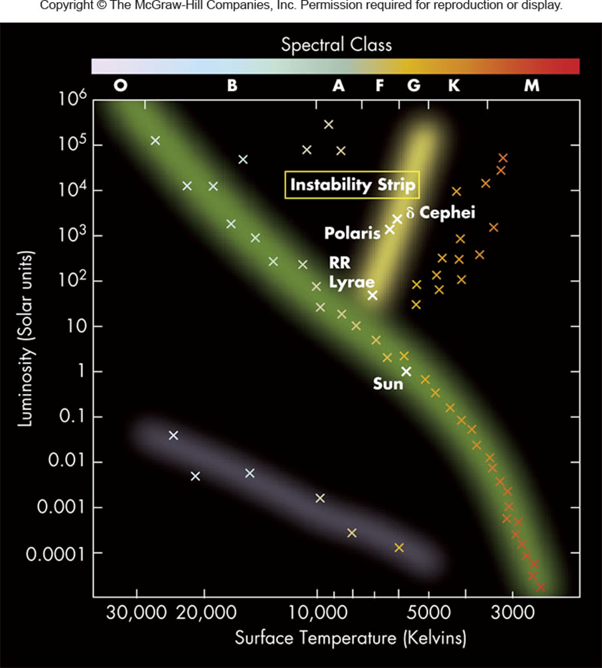
The Instability Strip
- Most variable stars plotted on H-R diagram lie in the narrow ________________ _________________
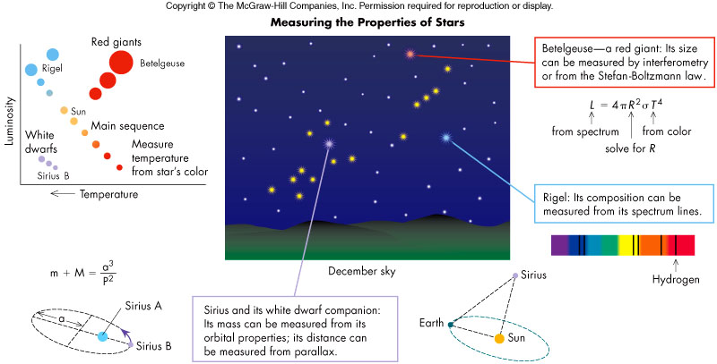
Summary

