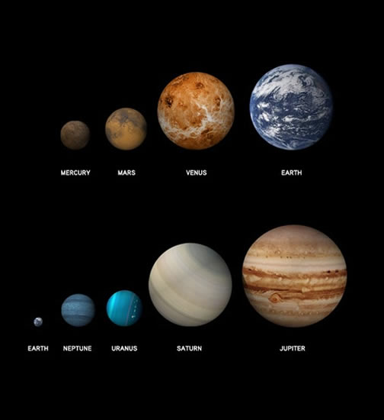
Chapter 8 –Activity
Solar System Formation

This activity asks you to explore how planet formation is connected to star formation. The purpose of this activity is to give you an opportunity to use your intuition and logic to make deductions about what might happen next to the matter that is left over after a star has formed.

First Activity Watch the first video HERE

Second Activity – Using Chapter 8 Notes/PPT and the following website HERE

Think about the following questions as you review chapter 8 and go the website.
What were the factors working against life forming on the early Earth?

Should we be surprised that life formed here at all? Explain why or why not

Submit your answer to the above questions HERE

Third Activity
The formation of the Earth roughly 4.6 billion years ago was a violent process. Scientists are continually learning more about planet formation in our Solar System as well as in other solar systems. You can join in this process by searching for news stories about solar systems or exoplanets. Record your sources and some of the details about what you discover. Check out Newsela.com for great articles, or look at the Pinterest board Newsela set up on this topic.

Here are some other places to get started with your research:
Oldest Objects in Solar System Indicate a Turbulent Beginning
Modeling Jupiter and Saturn’s Possible Origins
Our Solar System Is Not Quite as Special as Once Believed, New Research SuggestsNASA Lunar Scientists Develop New Theory on Earth and Moon FormationFound! First Earth-Size Planet That Could Support Life
Modern Plate Tectonics Arose 3.2 Billion Years Ago

In Chalk up – Answer the following questions
1. Post a link to the article that you found most interesting.
2. List one way that the article(s) connects to today’s lesson
3. Comment on someone else’s link, adding another way that their article connects to today’s lesson
Be sure to check back later to see if anyone commented on your post!

