

1. (15 points)

Block *A* of mass 4.0 kg is on a horizontal, frictionless tabletop and is placed against a spring of negligible mass and spring constant 650 N m. The other end of the spring is attached to a wall. The block is pushed toward the wall until the spring has been compressed a distance *x*, as shown above. The block is released and follows the trajectory shown, falling 0.80 m vertically and striking a target on the floor that is a horizontal distance of 1.2 m from the edge of the table. Air resistance is negligible.

1. Calculate the time elapsed from the instant block *A* leaves the table to the instant it strikes the floor.
2. Calculate the speed of the block as it leaves the table.
3. Calculate the distance *x* the spring was compressed.

Block *B*, also of mass 4.0 kg, is now placed at the edge of the table. The spring is again compressed a distance *x*, and block *A* is released. As it nears the end of the table, it instantaneously collides with and sticks to block *B*. The blocks follow the trajectory shown in the figure below and strike the floor at a horizontal distance *d* from the edge of the table.



1. Calculate *d* if *x* is equal to the value determined in part (c).
2. Consider the system consisting of the spring, the blocks, and the table. How does the total mechanical energy

*E*2 of the system just before the blocks leave the table compare to the total mechanical energy *E*1 of the

system just before block *A* is released?

____ *E*2 < *E*1 ____ *E*2 = *E*1 ____ *E*2 > *E*1

Justify your answer.

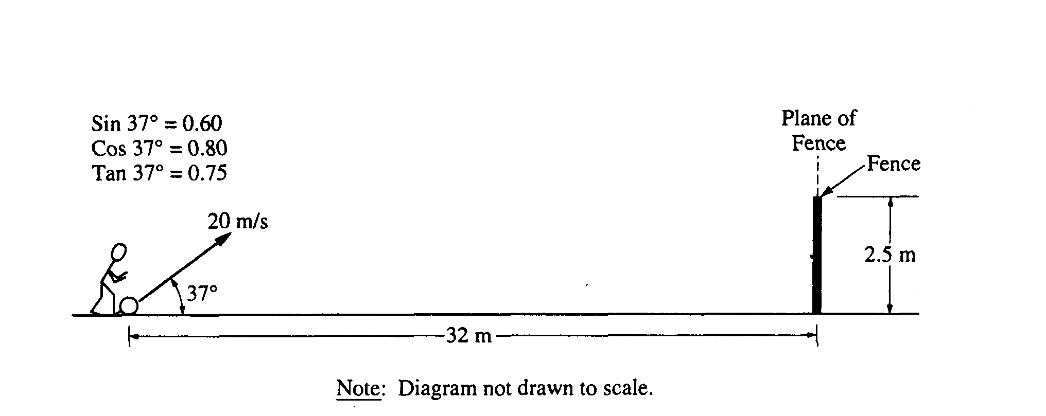

2. A ball of mass 0.5 kilogram, initially at rest, is kicked directly toward a fence from a point 32 meters away, as shown above. The velocity of the ball as it leaves the kicker's foot is 20 meters per second at an angle of 37° above the horizontal. The top of the fence is 2.5 meters high. The ball hits nothing while in flight and air resistance is negligible.

a. Determine the time it takes for the ball to reach the plane of the fence.

b. Will the ball hit the fence? If so, how far below the top of the fence will it hit? If not, how far above the top of the fence will it pass?

c. On the axes below, sketch the horizontal and vertical components of the velocity of the ball as functions of time until the ball reaches the plane of the fence.

