AP Physics Multiple Choice Practice – Kinematics

1. A car travels 30 miles at an average speed of 60 miles per hour and then 30 miles at an average speed of 30 miles per hour. The average speed the car over the 60 miles is
(A) 35 m.p.h. (B) 40 m.p.h. (C) 45 m.p.h. (D) 10 m.p.h. (E) 53 m.p.h.

Questions 2 – 4 relate to two particles that start at x = 0 at t = 0 and move in one dimension independently of one another. Graphs, of the velocity of each particle versus time are shown below

Particle A Particle B
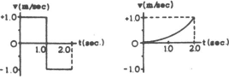
2.0
1.0
1.0 2.0

2. Which particle is farthest from the origin at t = 2 seconds.
(A) A (B) B (C) they are in the same location at t = 2 seconds (D) They are the same distance from the origin, but in opposite directions (E) It is not possible to determine

3. Which particle moves with constant non-zero acceleration?
(A) A (B) B (C) both A and B (D) neither A nor B (E) It is not possible to determine

4. Which particle is in its initial position at t = 2 seconds?
(A) A (B) B (C) both A and B (D) neither A nor B (E) It is not possible to determine

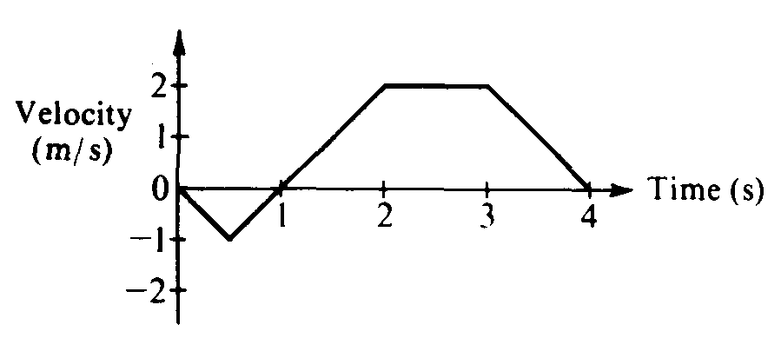
5. The graph above shows the velocity versus time for an object moving in a straight line. At what time after
t = 0 does the object again pass through its initial position?
(A) Between 0 and 1 s (B) 1 s (C) Between 1 and 2 s (D) 2 s (E) Between 2 and 3 s

6. A body moving in the positive x direction passes the origin at time t = 0. Between t = 0 and t = 1 second, the body has a constant speed of 24 meters per second. At t = 1 second, the body is given a constant acceleration of 6 meters per second squared in the negative x direction. The position x of the body at t = 11 seconds is
(A) + 99m (B) + 36m (C) – 36 m (D) – 75 m (E) – 99 m

7. The displacement, x, of an object moving along the x-axis is shown above as a function of time, t. The acceleration of this object must be
(A) zero (B) constant but not zero (C) increasing (D) decreasing (E) equal to g

