Topic: Two Dimensional Motion

**Unit:** Kinematics (Motion)

**Section:**  4.1-4.3

### Knowledge/Understanding Goals:

* How Two Dimensional Problems are similar yet different from one dimensional problems
* Set up and solve word problems involving projectiles

### Skills:

* Solve problems involving motion in two dimension

### Language Objectives:

* Understand and correctly use the term “projectile”.

### Notes:

**Two-Dimensional Kinematics**

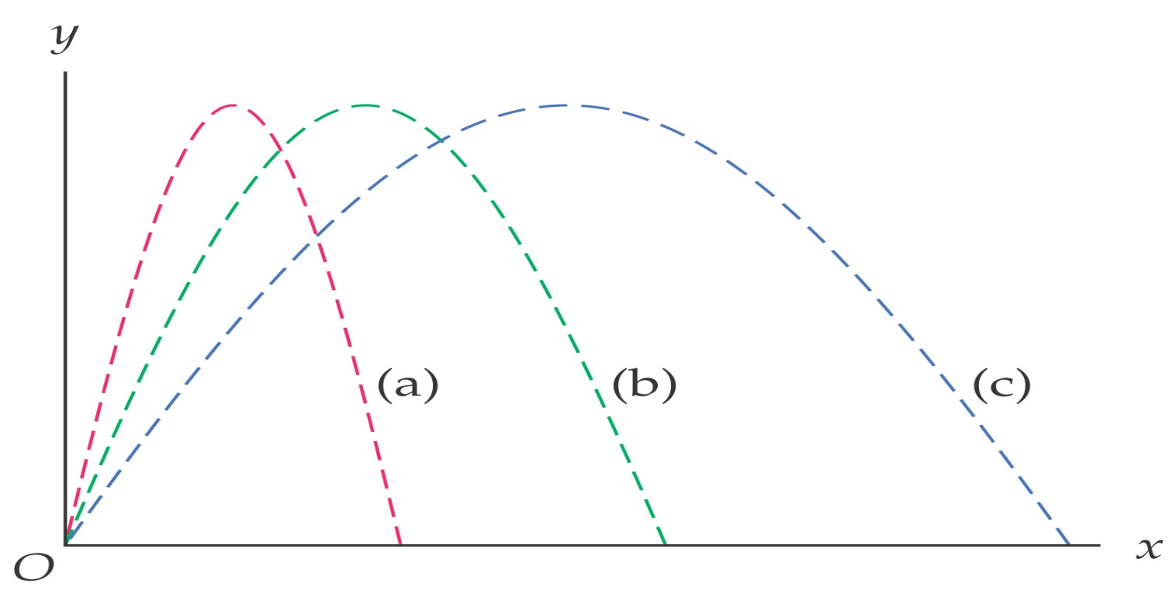

**Projectile Motion**

projectile: an airborne object acted upon “only” by gravity

-- other forces are NOT significant

examples:

non-examples:

**4-1 Motion in Two Dimensions**

**If velocity is constant,**

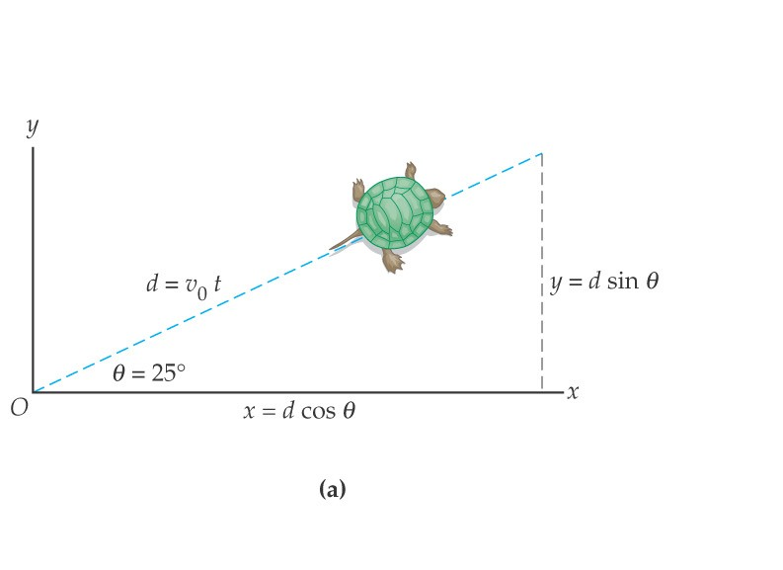 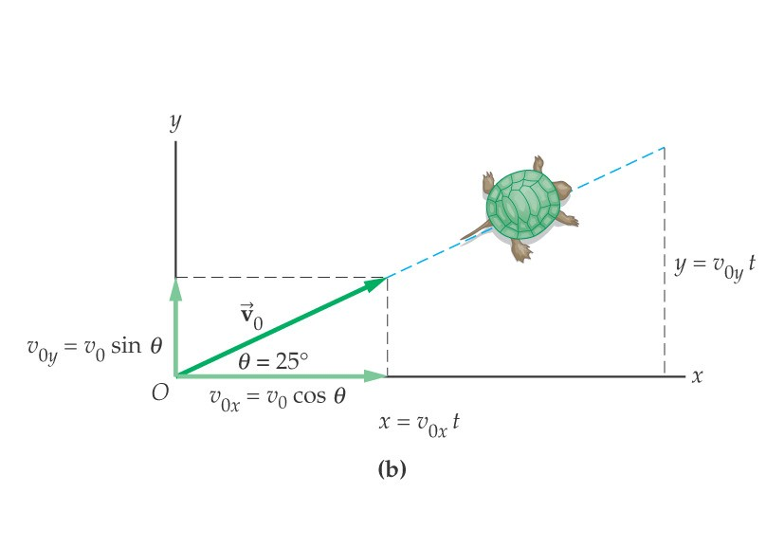

**Motion in the *x*- and *y*-directions should be solved separately:**

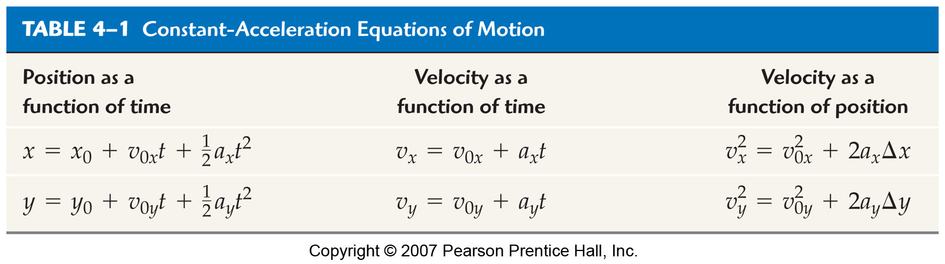

***4-2 Projectile Motion: Basic Equations***

***Assumptions:***

***The acceleration***

***`***

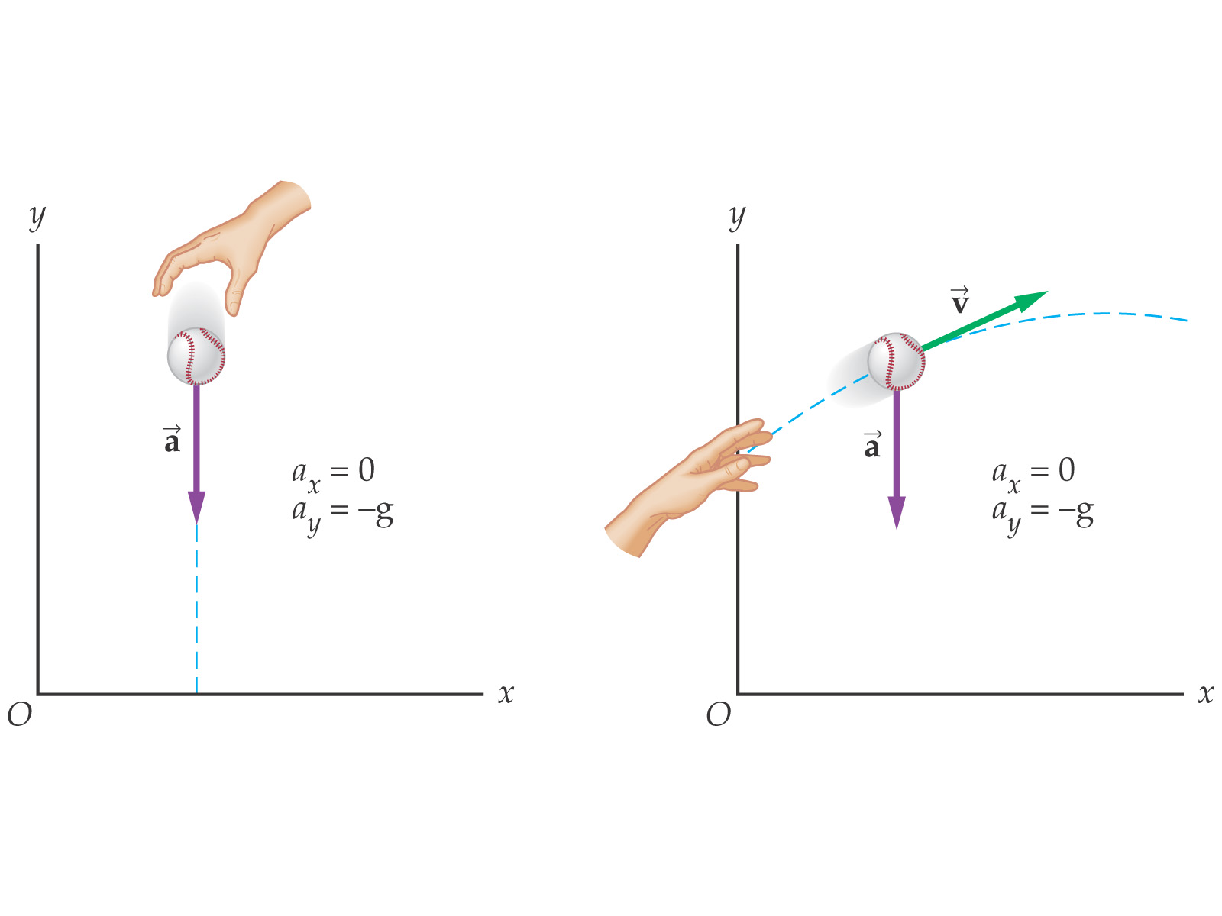

**These, then, are the basic equations of projectile motion:**

**4-3 Zero Launch Angle**

**Launch angle:**

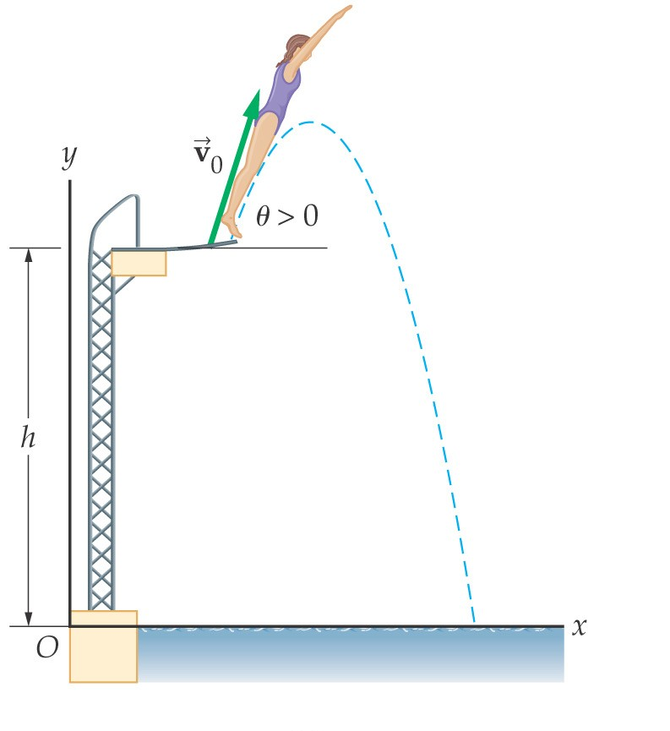 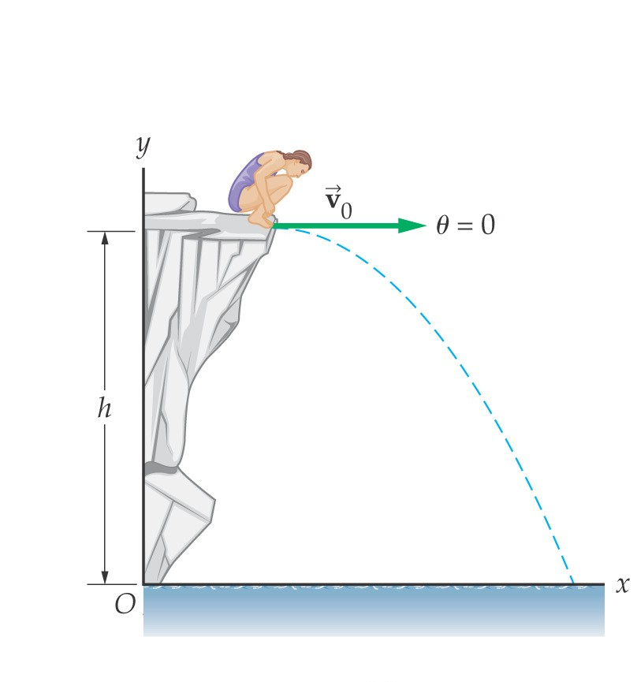

**In this case, the initial velocity in the *y*-direction is zero. Here are the equations of motion, with *x*0 = 0 and *y*0 = *h*:**

**This is the trajectory of a projectile launched horizontally:**

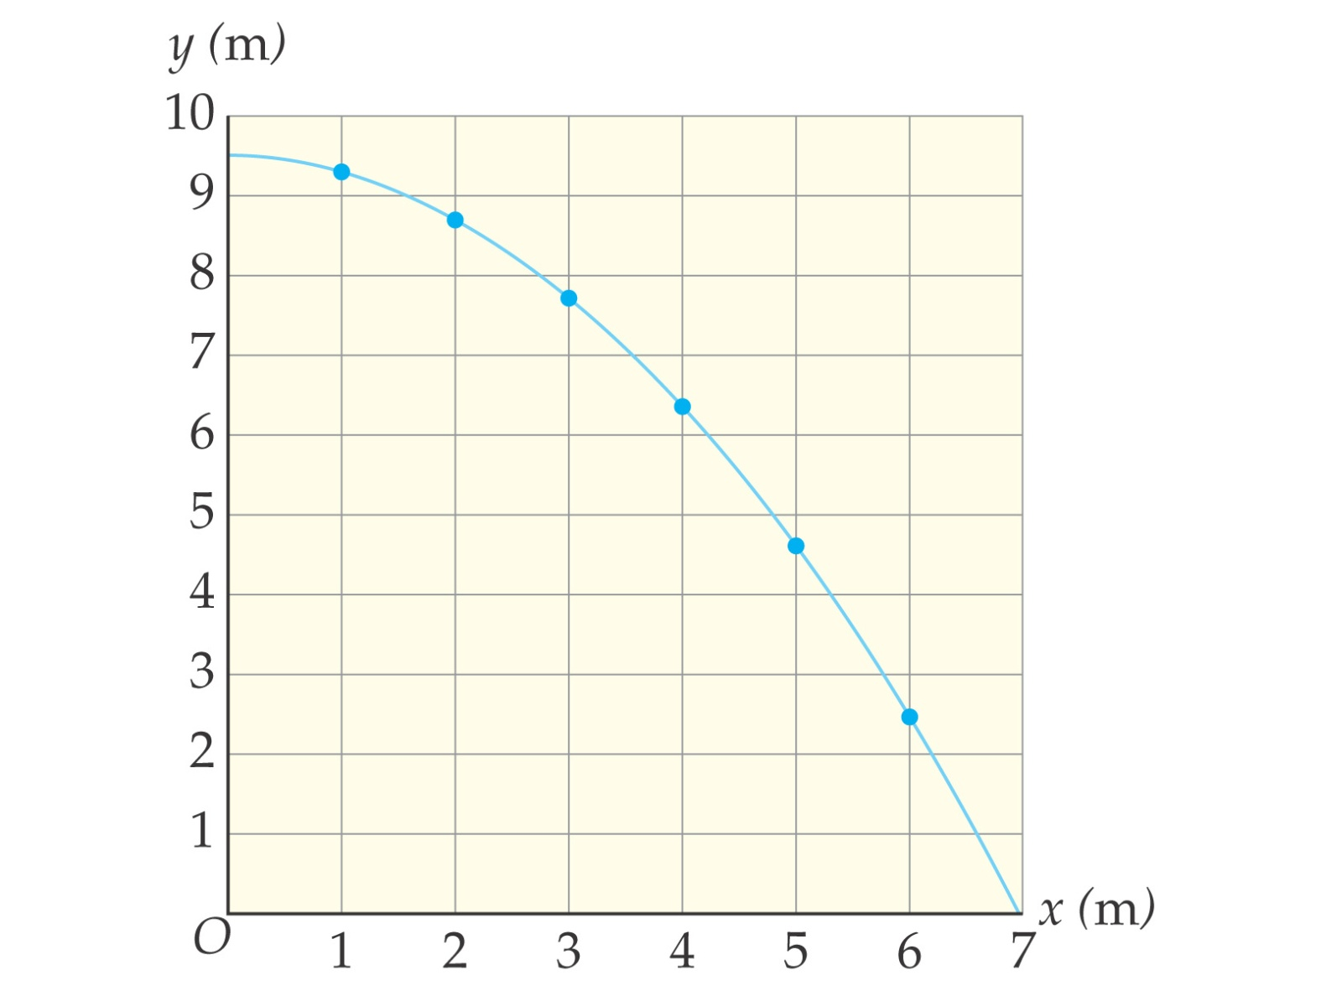

**Eliminating *t* and solving for *y* as a function of *x*:**

**This has the form *y* = *a* + *bx*2, which is the equation of a parabola.**

**The landing point can be found by setting *y* = 0 and solving for *x***

***Horizontally-Launched Projectiles***

y

vx

Theory: A projectile is launched horizontally

w/velocity vx from height y.

-- vx is...

-- vy starts at...



A rifle bullet is fired horizontally w/initial velocity

850 m/s from height 1.73 m. Find…

a. …time bullet is in air

b. …bullet’s range (max. horizontal displacement)

c …horizontal distance the bullet is from the rifle at t = 0.38 s

d. …bullet’s height above ground at t = 0.38 s.

Military plane flies horizontally at altitude 8.34 km at speed 412 km/h. As measured along ground, how far from target must plane be when it releases target’s provisions?



B.G.

B.G.

besieged city

of G.G.

How fast are provisions moving

when they land?

62 m

238 m

**.**

Projectile is launched horizontally from height 62 m. Its range is measured to be 238 m. Find launching speed.

For how long will the projectile remain airborne?

105 m

105 m

330 m

84 m/s

Coordinates of Horizontally-Launched Projectiles

For the plane/target/provisions problem, what are the coordinates of the provisions at any time?

1000

2000

3000

4000

5000

0

5000

0

1000

2000

3000

4000

6000

7000

8000

y (m)

x (m)

|  |  |  |  |  |
| --- | --- | --- | --- | --- |
| **t (s)** | **x-coord. (m)** | **ystraight (m)** | **yfall (m)** | **y-coord. (m)** |
| 0 |  |  |  |  |
| 10 |  |  |  |  |
| 20 |  |  |  |  |
| 30 |  |  |  |  |
| 40 |  |  |  |  |
| 50 |  |  |  |  |

**4-4 General Launch Angle**

In general, *v*0x = *v*0 cos *θ* and *v*0y = *v*0 sin *θ* this gives the equations of motion:

Snapshots of a trajectory; red dots are at *t* = 1 s, *t* = 2 s, and *t* = 3 s

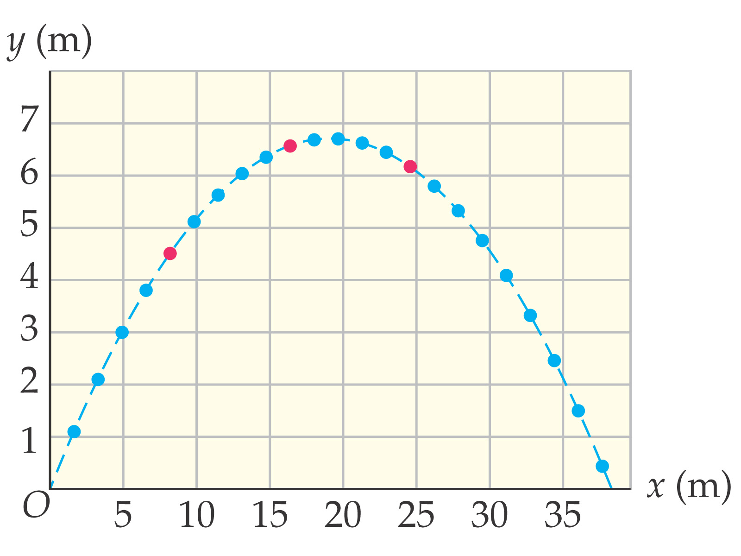

**4-5 Projectile Motion: Key Characteristics**

Range: the horizontal distance a projectile travels. If the initial and final elevation are the same:

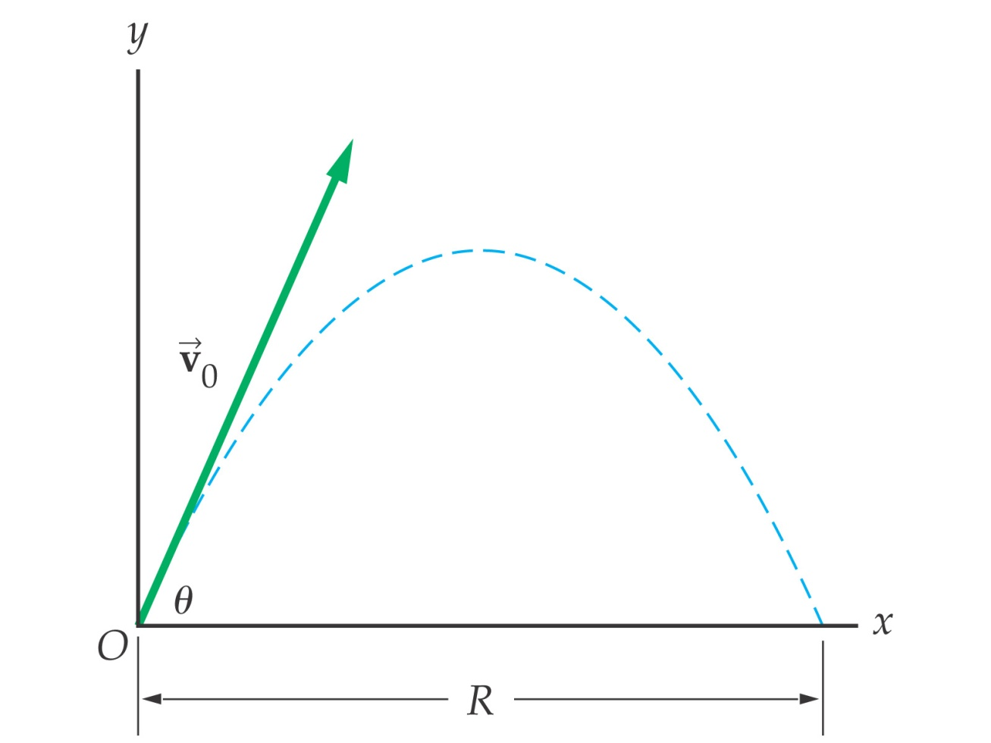

The range is a maximum when θ = 45°:

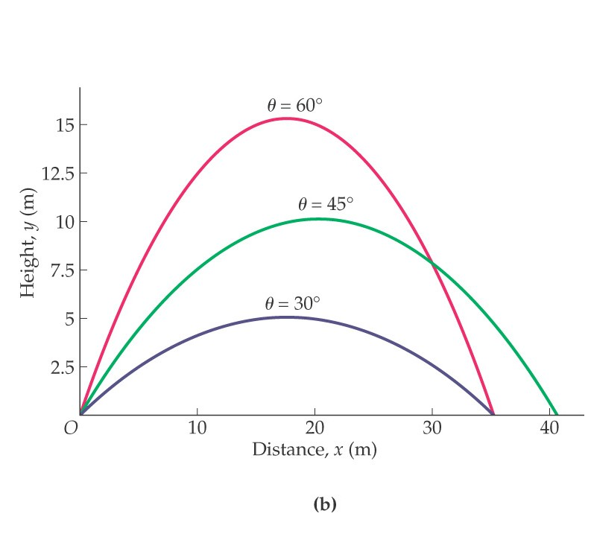

**Symmetry in projectile motion:**

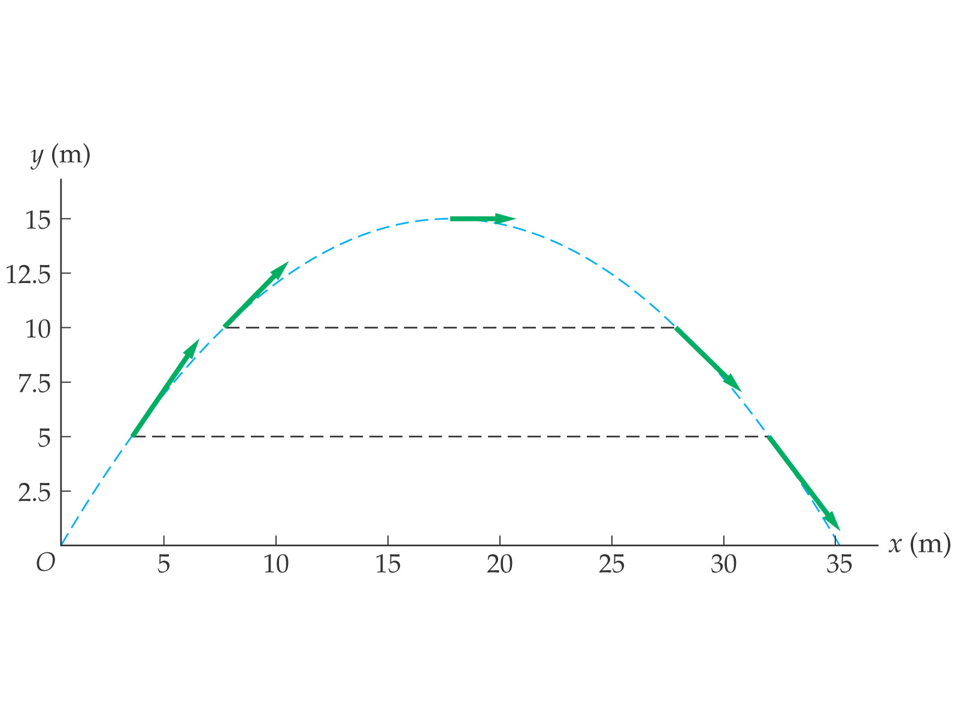

* ***Projectiles Launched at an Angle***

Theory: A projectile is launched at initial angle  with initial velocity vi.

**vi**

**vx**

**vyi**



-- vx is...

-- vy starts at...

Projectile is launched w/initial velocity 56.4 m/s at 41o above horizontal.

a. Find time object is in air.

41o

56.4 m/s



b. Find max height object attains.

c. Find projectile’s range.

An angled projectile.

Projectile is launched w/initial velocity 18.6 m/s at 28o above horizontal.

18.6 m/s

28o

a. Find time object is in air.

b. Find max height object attains.

c. Find projectile’s range.

Projectile is launched from height 575 m w/initial velocity 87 m/s @ 25o below horizontal.

575 m

25o

87 m/s

a. Find time object is in air.

b. Find projectile’s range.

Coordinates of Projectiles Launched at an Angle

Object is launched from ground w/initial velocity 35.58 m/s @ 55.8o above horizontal.

Find its x and y coordinates at each second it is in the air.



0

20

40

60

80

100

120

x (m)

y (m)

0

20

40

60

80

|  |  |  |  |  |
| --- | --- | --- | --- | --- |
| **t (s)** | **x-coord. (m)** | **ystraight (m)** | **yfall (m)** | **y-coord. (m)** |
| 0 |  |  |  |  |
| 1 |  |  |  |  |
| 2 |  |  |  |  |
| 3 |  |  |  |  |
| 4 |  |  |  |  |
| 5 |  |  |  |  |
| 6 |  |  |  |  |