Topic: Free Fall

**Unit:** Kinematics (Motion)

**Section:**  2.7

### Knowledge/Understanding Goals:

* what free falls due gravity means

### Skills:

* calculate problems involving free fall objects

### Language Objectives:

* Understand and correctly use the term “free fall”.
* Accurately describe and apply the concepts described in this section using appropriate academic language.

### Notes:

When an object is accelerating because of gravity, we say that the object is in “free fall”.

On earth, the average acceleration due to gravity is approximately  at sea level (which we will usually round to , or sometimes just ). Any time gravity is involved (and the problem takes place on Earth), assume that .

Free fall is the motion of an object subject only to the influence of gravity. The acceleration due to gravity is a constant, *g.* An object falling in air is subject to air resistance.(and therefore is not freely falling).

**2-7 Freely Falling Objects**

. 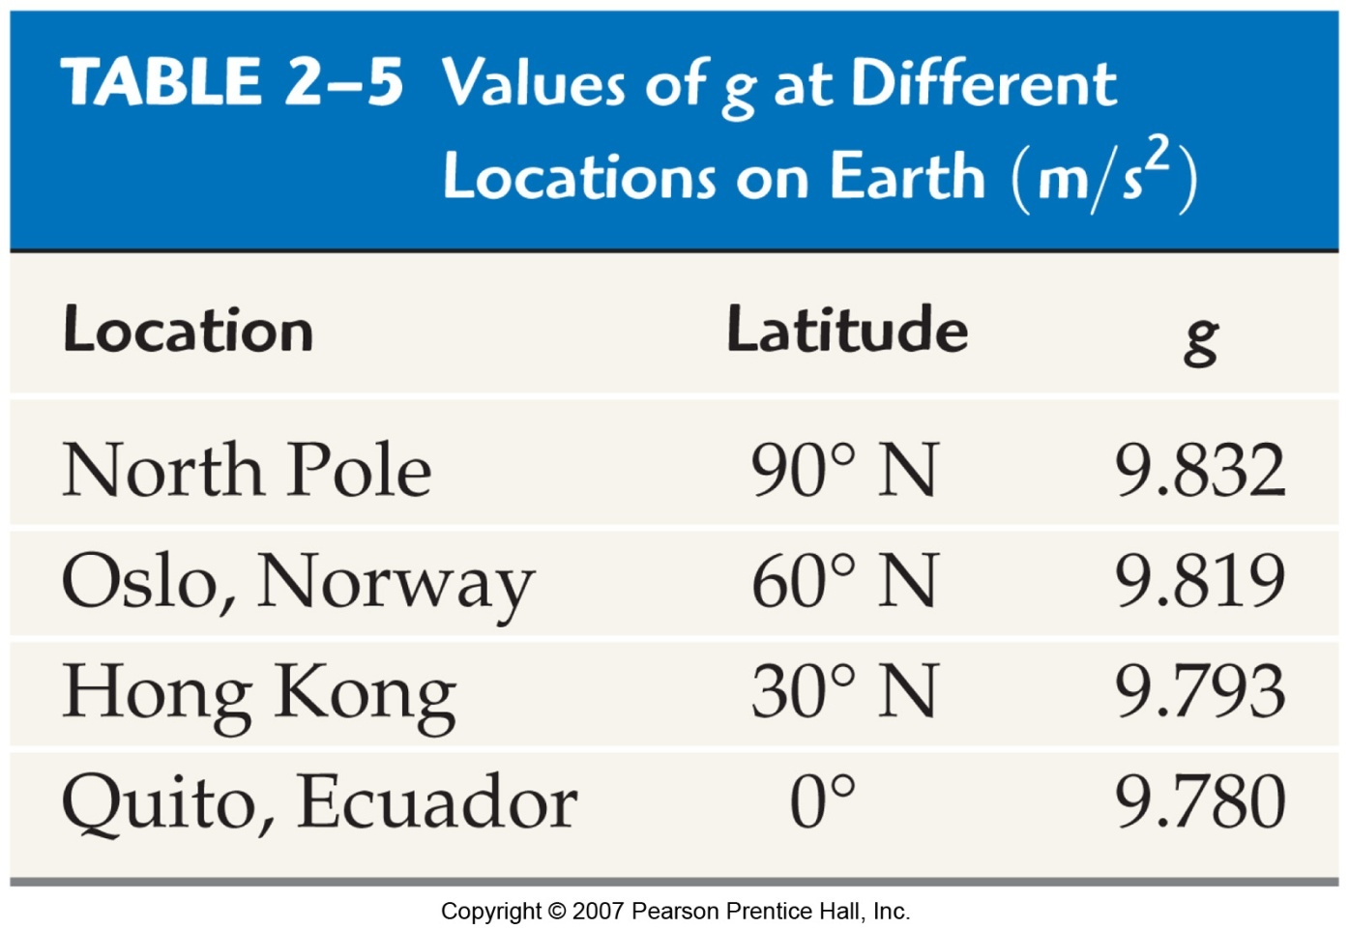 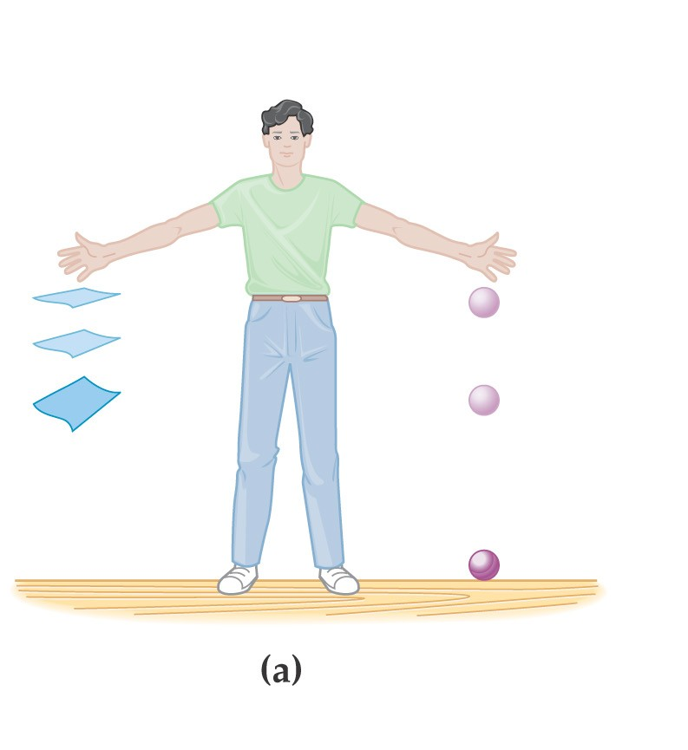 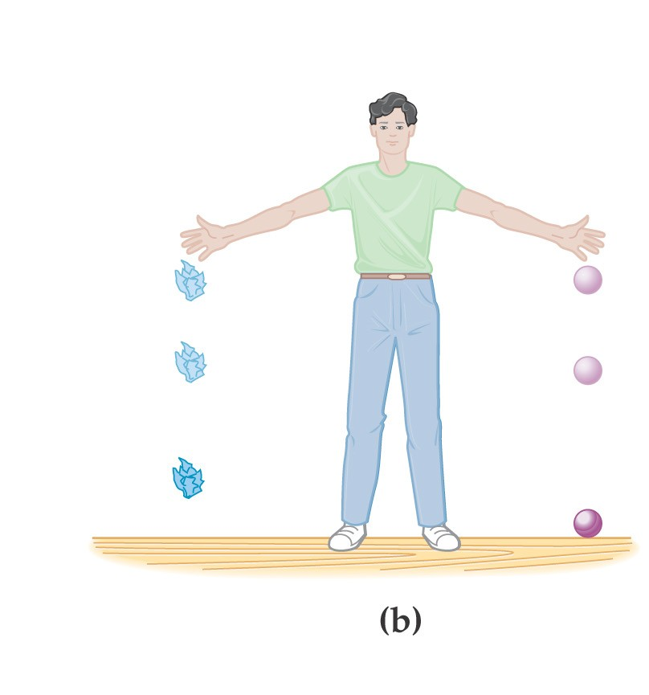

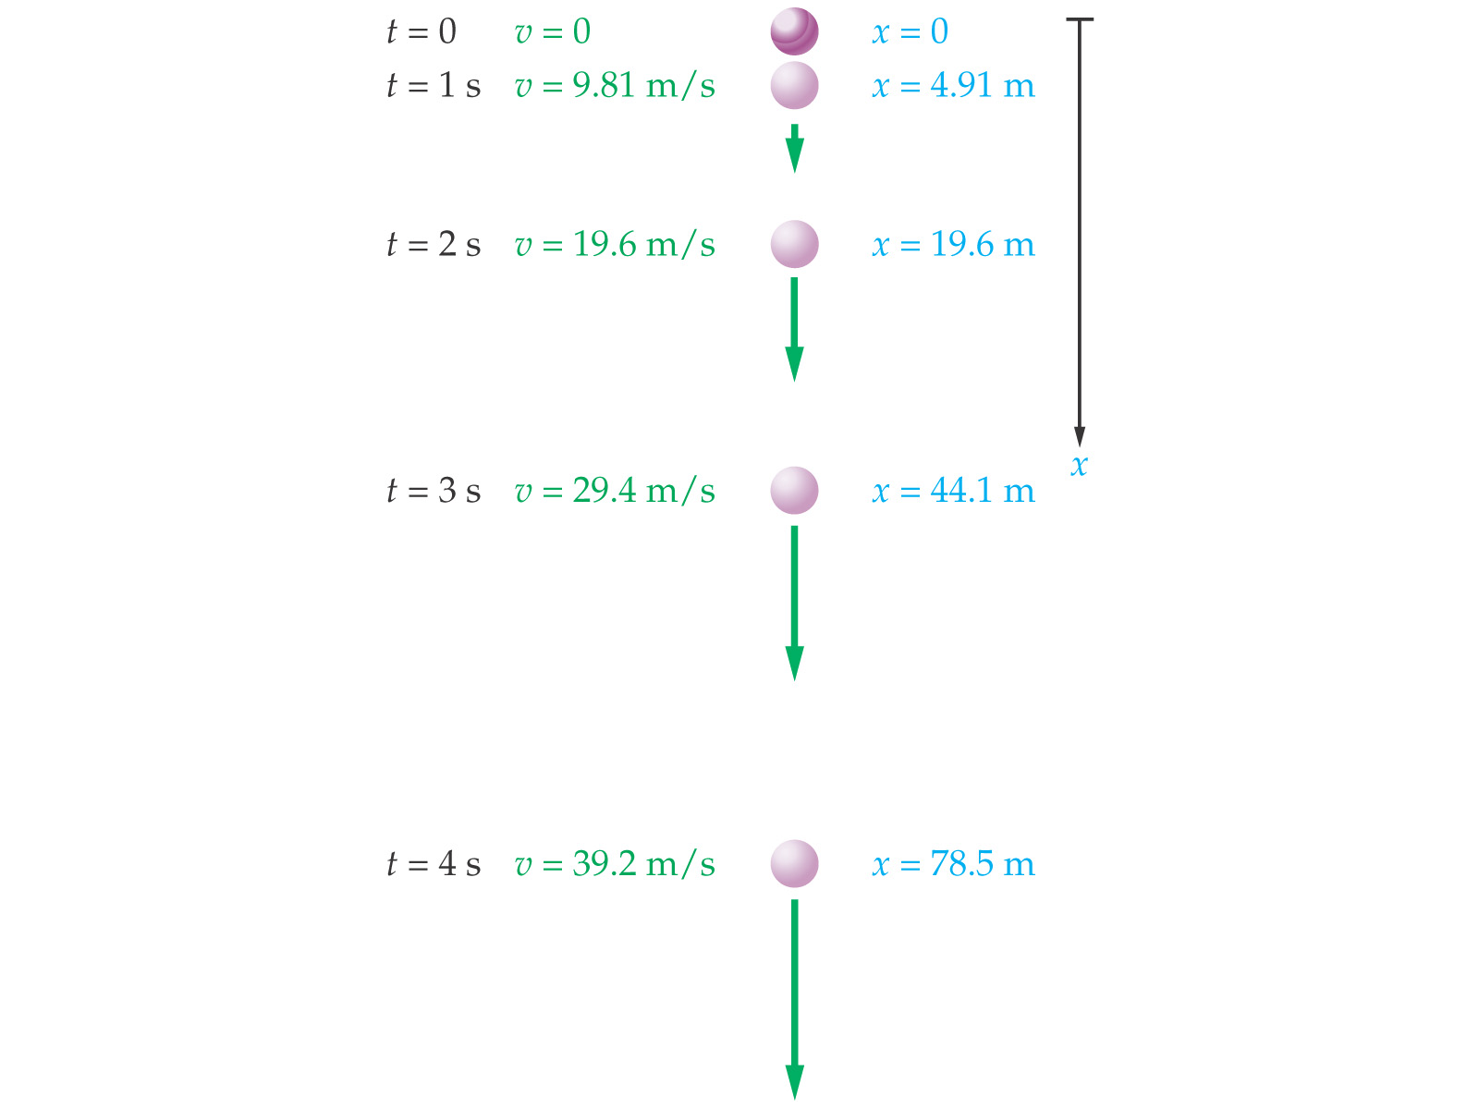

Free fall from rest

t

P

t

v

t

a

0

0



**Free Fall** 

An alarm clock is “fire-escaped” from rest from height 38.0 m.

a. How long is clock in the air?

b. Find velocity of clock at impact.

c. Find velocity of clock halfway down.

A full beverage can is launched upward with initial velocity 22.8 m/s. Find…

a. …time to get to the top

b. …total time in air

c. …maximum height attained

d. ...location of can when its speed is half its original speed

Trajectory of a projectile:

