Topic: Acceleration

**Unit:** Kinematics (Motion)

**Section:**  2.4-2.5

### Knowledge/Understanding Goals:

* what acceleration means
* what positive *vs.* negative acceleration means

### Skills:

* calculate position, velocity and acceleration for problems that involve movement in one direction

### Language Objectives:

* Understand and correctly use the term “acceleration.”
* Accurately describe and apply the concepts described in this section using appropriate academic language.

### Notes:

**2-4 Acceleration**

Average acceleration:

Acceleration:

-- speed up

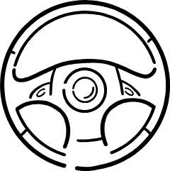 -- slow down

-- change direction

unit 🡪

Car traveling 65 m/s approaches stop sign. Driver applies brakes for 8.2 s. Find car’s acceleration.



Car traveling 65 m/s slams into tree and stops in 0.15 s

na01140_[1]

Find car’s (and driver’s) acceleration

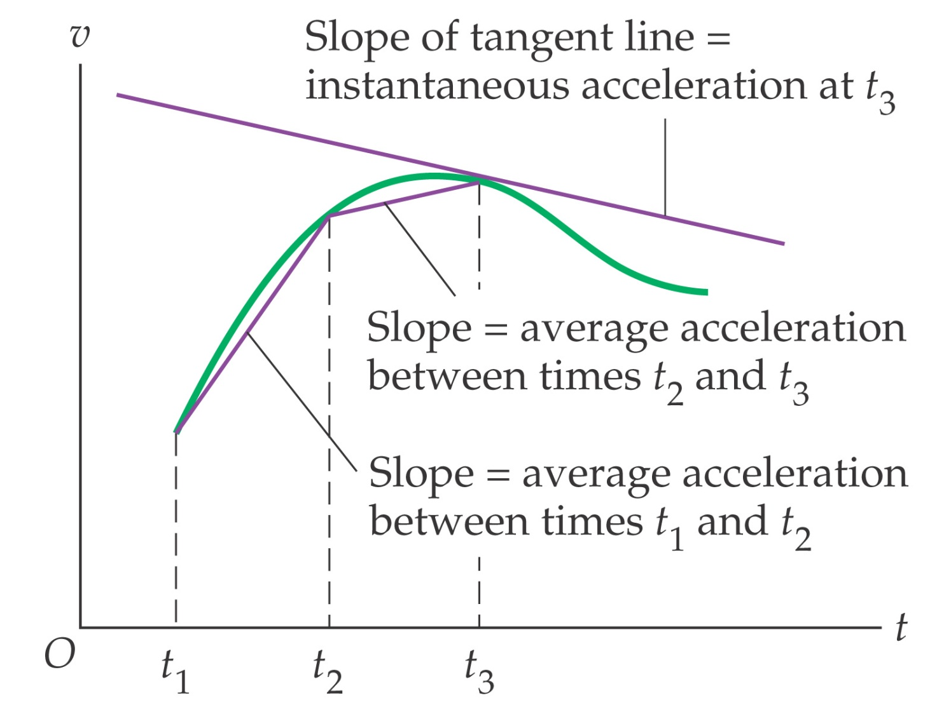Graphical Interpretation of Average and Instantaneous Acceleration:

Consider the following v-t curve.

**t (s)**

**v (m/s)**

0

1

2

3

4

5

6

7

-5

0

5

8

10

-10



slope of curve is:

Consider the following a-t curve.

**t (s)**

**a (m/s2)**

0

1

2

3

4

5

6

-1

0

1

2

-2



**t (s)**

**v (m/s)**

0

1

2

3

4

5

6

0

2

4

6

If the object starts at rest, the associated v-t curve looks like…

Find object’s average velocity.

Acceleration (increasing speed) and deceleration (decreasing speed) should not be confused with the directions of velocity and acceleration:

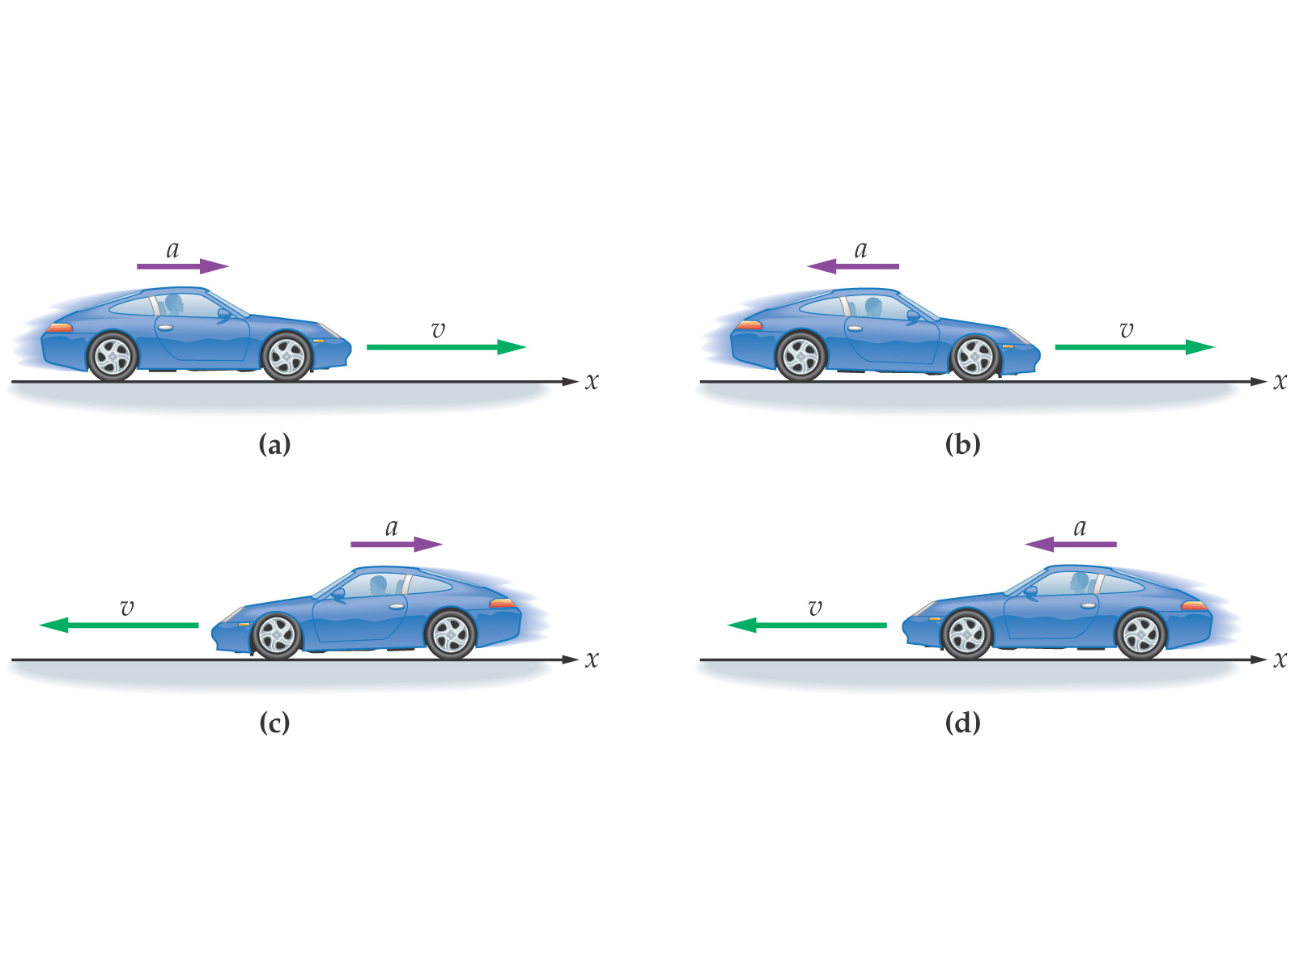

**2-5 Motion with Constant Acceleration**

If the acceleration is constant, the velocity changes linearly:

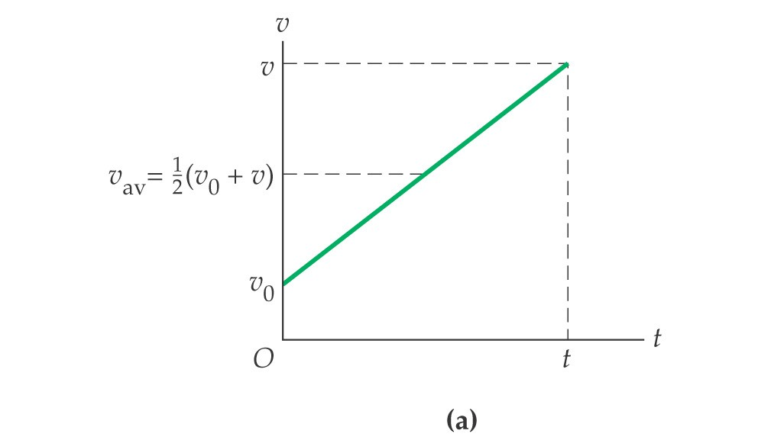

Average velocity:

Position as a function of time:

Velocity as a function of position:

Boy runs from inside garage and slides down icy

driveway. At top, he moves at 2.3 m/s. He slides

down in 4.5 s, accelerating at 0.75 m/s2.

a. How fast is he moving at the bottom?

b. How long is the driveway?

c. Assuming the same acceleration, find the time for him to reach the bottom if

he starts at the top from rest.

Penguin moves with initial speed 0.65 m/s. At a later time, he has speed

1.9 m/s. During this interval, penguin travels 7.3 m - find his acceleration.

b) How long is the driveway?

c) Assuming same acceleration, find the time for him to reach the bottom if he starts at the top from rest.

The relationship between position and time follows a characteristic curve.

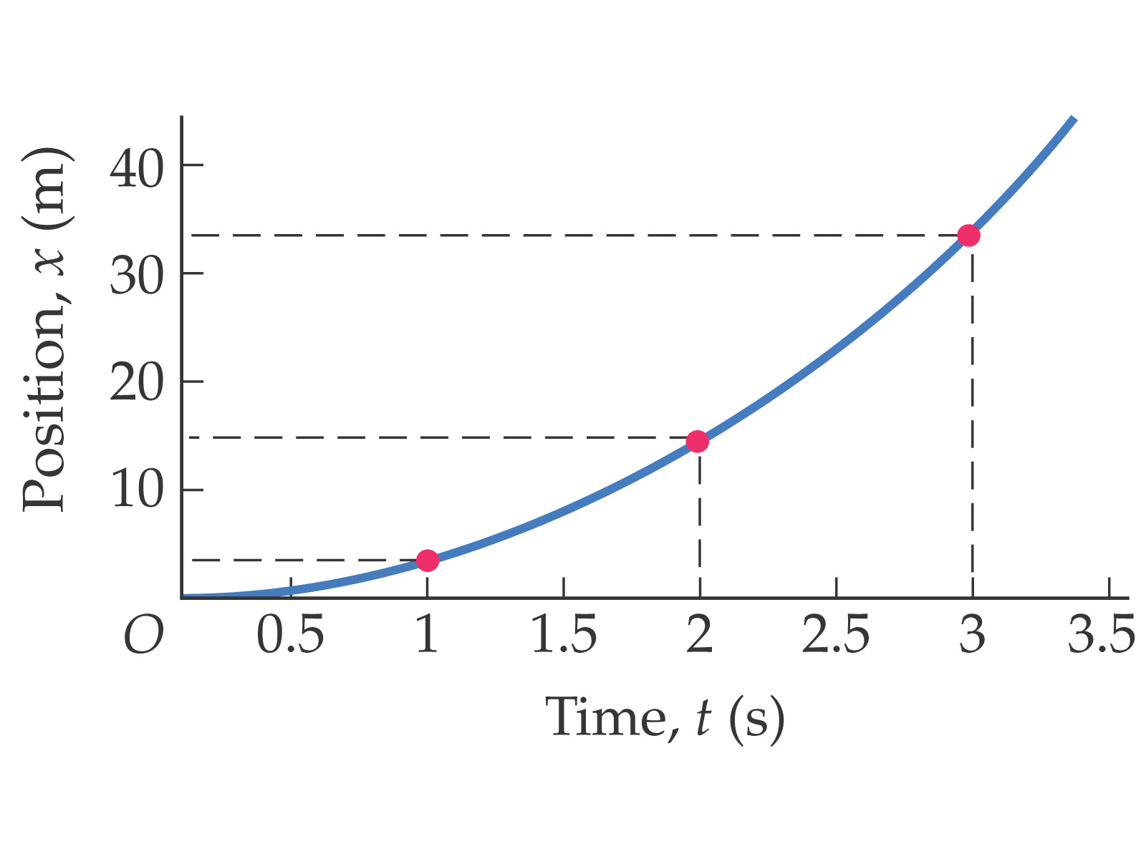 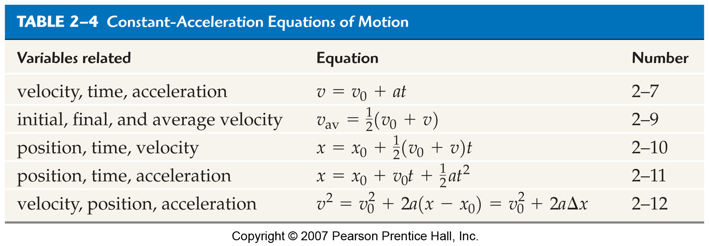

A car travels 25 m/s for time t1 and 34 m/s for time t2. Car

travels a total of 54 km in 28 minutes. Find t1 and t2.

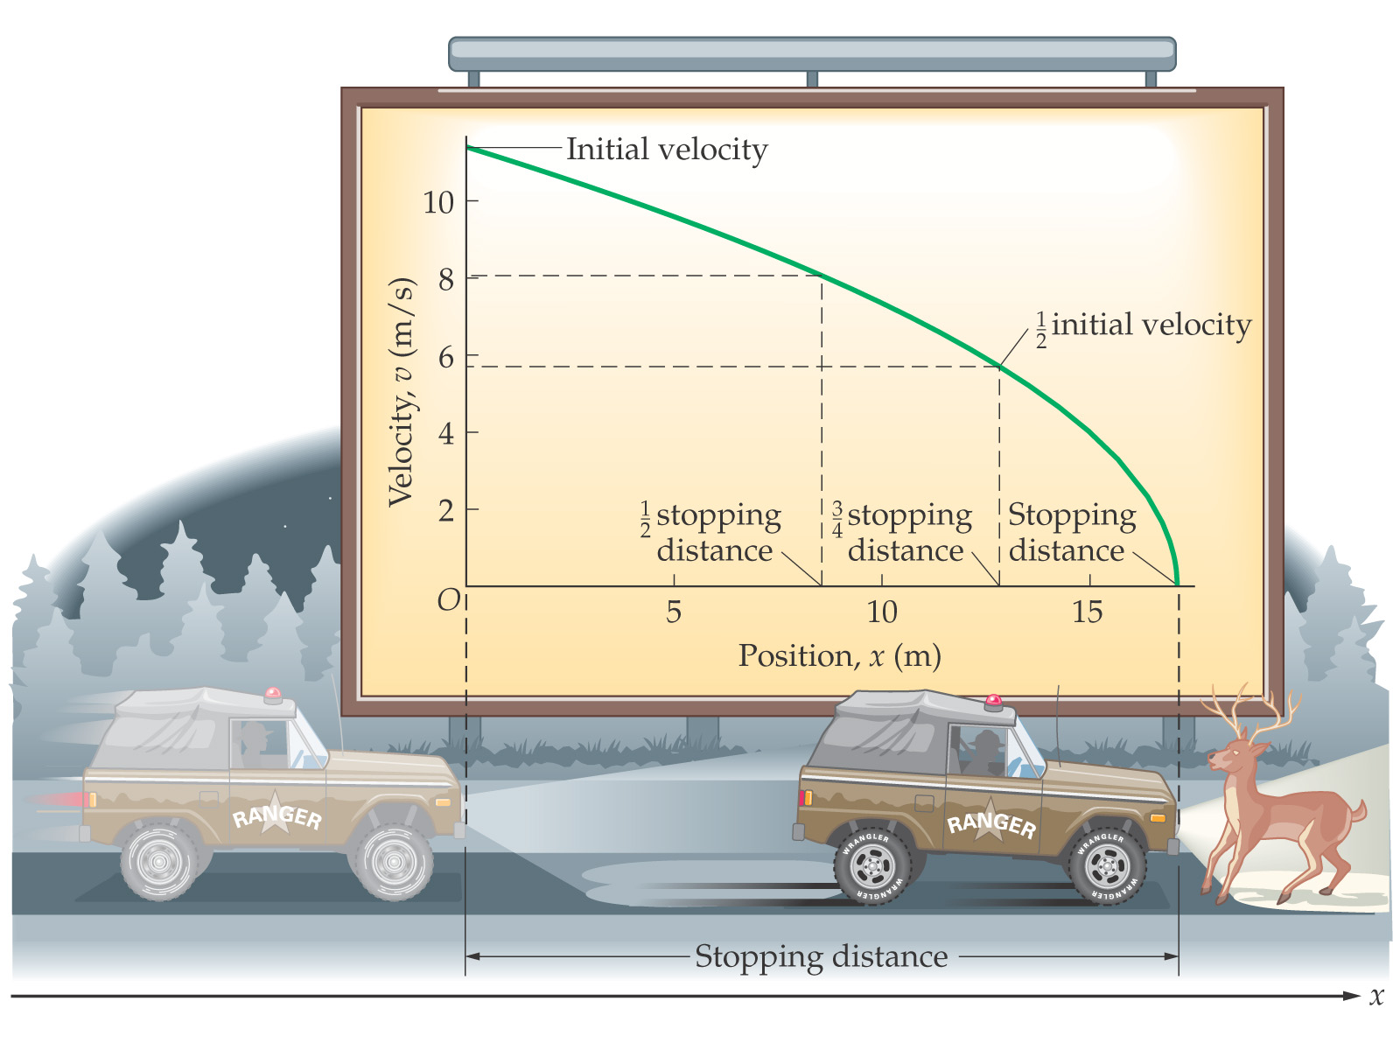

Hit the Brakes

y = **m** x + **b**

**.**

**.**

**.**

**.**

**.**

x

y



Linear Regression (Linear Least Squares Fit):

a mathematical procedure that gives the “best”

straight line through data points that don’t make

a straight line.

An object falling in air is subject to air resistance (and therefore is not freely falling).

**.**

**.**

**.**

**.**

**.**

t

P

**.**

**.**

**.**

**.**

**.**

t

v

**.**

**.**

**.**

**.**

**.**

t2

P

**Review: Acceleration**

|  |  |  |
| --- | --- | --- |
|  |  |  |
| positive acceleration | acceleration = zero | negative acceleration |

uniform acceleration: when an object’s rate of acceleration (*i.e.,* the rate at which its velocity changes) is constant.

### Variables Used to Describe Acceleration

|  |  |  |
| --- | --- | --- |
| **Variable** | **Quantity** | **MKS Units** |
|  | acceleration |  |
|  | acceleration due to gravity |  |

By convention, physicists use the variable  to mean acceleration due to gravity, and  to mean acceleration caused by something other than gravity.

Note that when an object’s velocity is changing, the final velocity, *v,* is not the same as the average velocity, . (This is a common mistake that first-year physics students make.)

Note also that  is the area under a graph of velocity (*v*) *vs.* time (*t*). Because , this means the *area under* a graph of velocity vs. time is the displacement. Note that this also works both for constant velocity (the graph on the left) and changing velocity (as shown in the graph on the right).

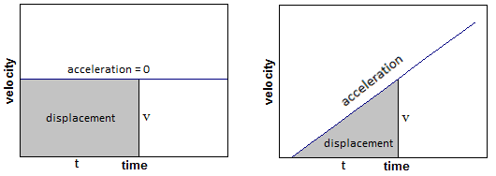

In calculus, the area under a curve is the integral. This means:



Where *v* can be any function of *t*. In the graphs below, between 0 s and 4 s the object is accelerating at a rate of .

Between 4 s and 6 s the object is moving at a constant velocity (of ), so the acceleration is zero.

The area under a velocity/time graph equals the total distance traveled.

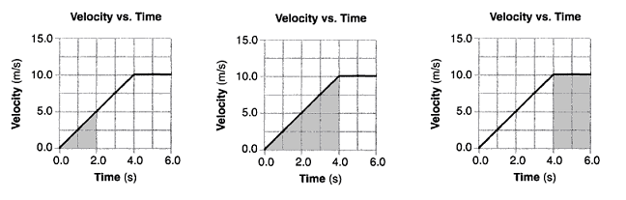

|  |  |  |
| --- | --- | --- |
| *a* = | *a* = | *a* = 0 |

To show the relationship between *v* and  we can combine the formula for average velocity with the formula for acceleration in order to get a formula for the position of an object that is accelerating.



However, the problem is that *v* in the formula  is the velocity at the *end*, which is not the same as the *average* velocity .

If the velocity of an object is changing (*i.e.,* the object is accelerating), the average velocity is given by the formula:



If the object starts at rest (not moving, which means ) and it accelerates at a constant rate, the average velocity is therefore



Combining all of these gives, for an object starting from rest:



If an object was moving before it started to accelerate, it had an initial velocity, or a velocity at time = 0. We will represent this initial velocity as [[1]](#footnote-1). Now, the formula becomes:

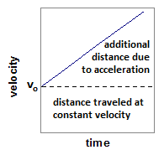



*additional* distance the object will travel because it is accelerating

distance the object would travel at its initial velocity

This equation can be combined with the equation for velocity to give the following equation, which relates initial and final velocity and distance:



Finally, when an object is accelerating because of gravity, we say that the object is in “free fall”.

On earth, the average acceleration due to gravity is approximately  at sea level (which we will usually round to , or sometimes just ). Any time gravity is involved (and the problem takes place on Earth), assume that .

1. pronounced “v-zero” or “v-naught” [↑](#footnote-ref-1)