8. A 2‑kilogram block rests at the edge of a platform that is 10 meters above level ground. The block is launched horizontally from the edge of the platform with an initial speed of 3 meters per second. Air resistance is negligible. The time it will take for the block to reach the ground is most nearly   
(A) 0.3 s (B) 1.0 s (C) 1.4 s (D) 2.0 s (E) 3.0 s

9. A diver initially moving horizontally with speed v dives off the edge of a vertical cliff and lands in the water a distance *d* from the base of the cliff. How far from the base of the cliff would the diver have landed if the diver initially had been moving horizontally with speed 2v?  
(A) *d* (B) (C) *2d* (D) *4d* (E) can’t be determined without knowing the height of the cliff

10. A truck traveled 400 meters north in 80 seconds, and then it traveled 300 meters east in 70 seconds. The magnitude of the average velocity of the truck was most nearly

(A) 1.2 m/s (B) 3.3 m/s (C) 4.6 m/s (D) 6.6 m/s (E) 9.3 m/s

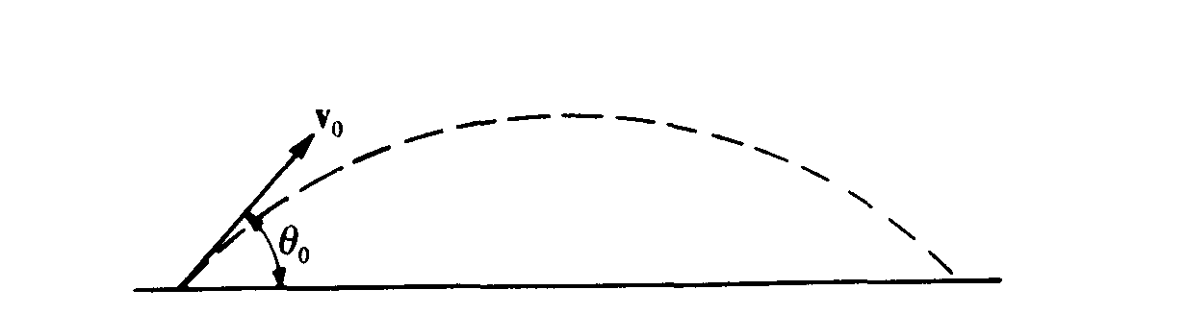

11. A projectile is fired with initial velocity *v*o at an angle θ0 with the horizontal and follows the trajectory shown above. Which of the following pairs of graphs best represents the vertical components of the velocity and acceleration, v and a, respectively, of the projectile as functions of time t?  
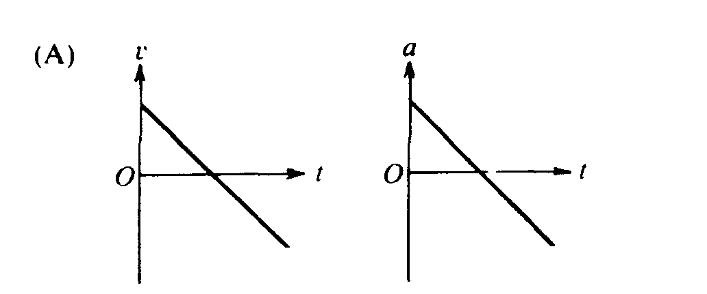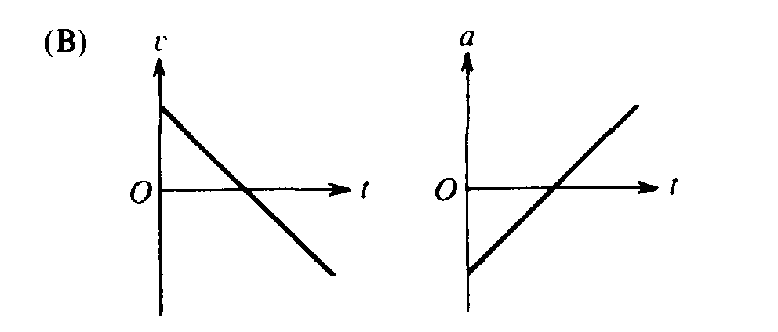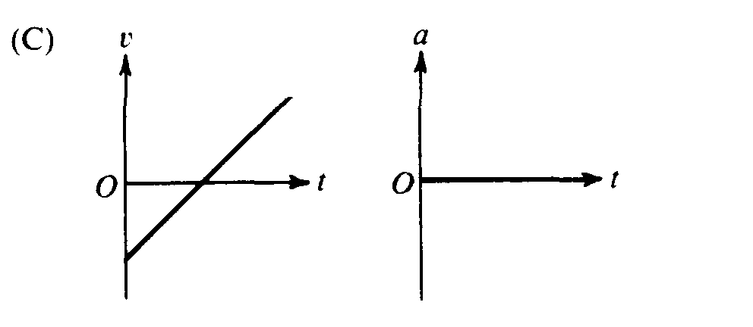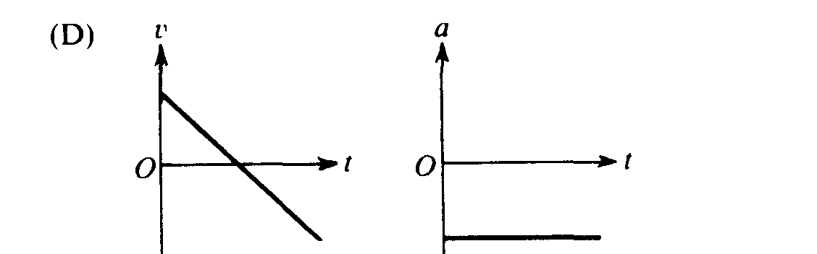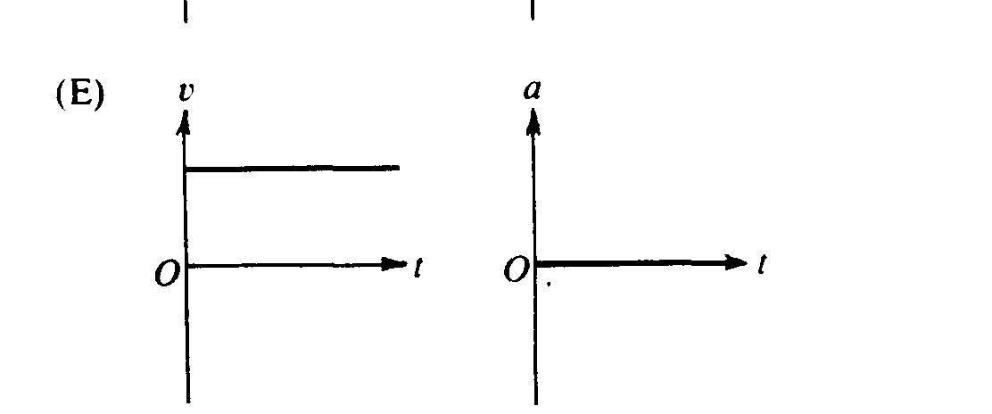

12. An object is released from rest on a planet that has no atmosphere. The object falls freely for 3.0 meters in the first second. What is the magnitude of the acceleration due to gravity on the planet?  
(A) 1.5 m/s2 (B) 3.0 m/s2 (C) 6.0 m/s2  (D) 10.0 m/s2 (E) 12.0 m/s2

Questions 13 – 14

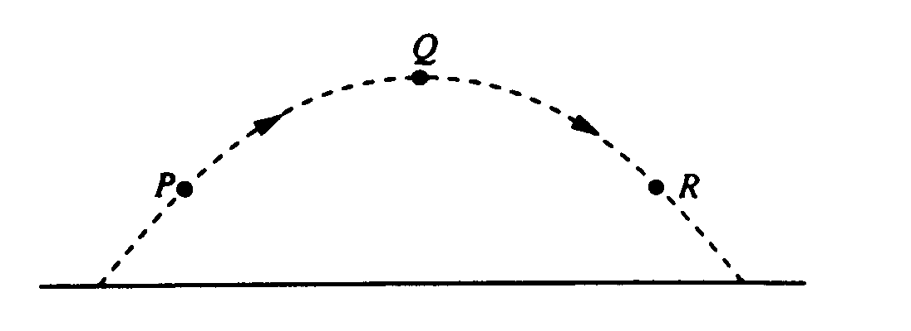

A ball is thrown and follows the parabolic path shown above. Air friction is negligible. Point Q is the highest point on the path. Points P and R are the same height above the ground.

13. How do the speeds of the ball at the three points compare?  
(A) vP < vQ < vR (B) vR < vQ < vP (C) vQ < vR < vP (D) vQ< vP = vR (E) vP = vR < vQ

14. Which of the following diagrams best shows the direction of the acceleration of the ball at point P?  
(A)  (B)  (C)  (D)  (E) 

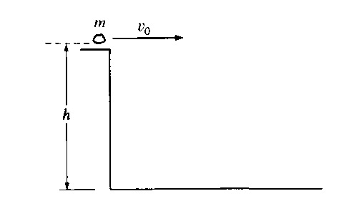

15. A rock of mass *m* is thrown horizontally off a building from a height *h*, as shown above. The speed of the rock as it leaves the thrower’s hand at the edge of the building is *v0*.How much time does it take the rock to travel from the edge of the building to the ground?

(A)  (B)  (C)  (D)  (E) 

16. A ball is thrown straight up in the air. When the ball reaches its highest point, which of the following is true?

(A) It is in equilibrium. (B) It has zero acceleration. (C)It has maximum momentum   
(D) It has maximum kinetic energy. (E) None of the above

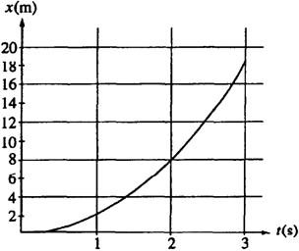

17. The graph above represents position x versus time t for an object being acted on by a constant force. The average speed during the interval between 1 s and 2 s is most nearly

(A) 2 m/s (B) 4 m/s (C) 5 m/s (D) 6 m/s (E) 8 m/s

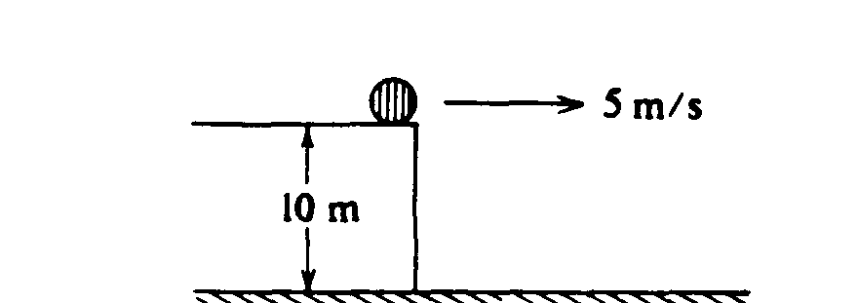

18. An object slides off a roof 10 meters above the ground with an initial horizontal speed of 5 meters per second as shown above. The time between the object's leaving the roof and hitting the ground is most nearly

(A)  s (B) s (C)  s (D) 2 s (E)  s

Questions 19 – 20

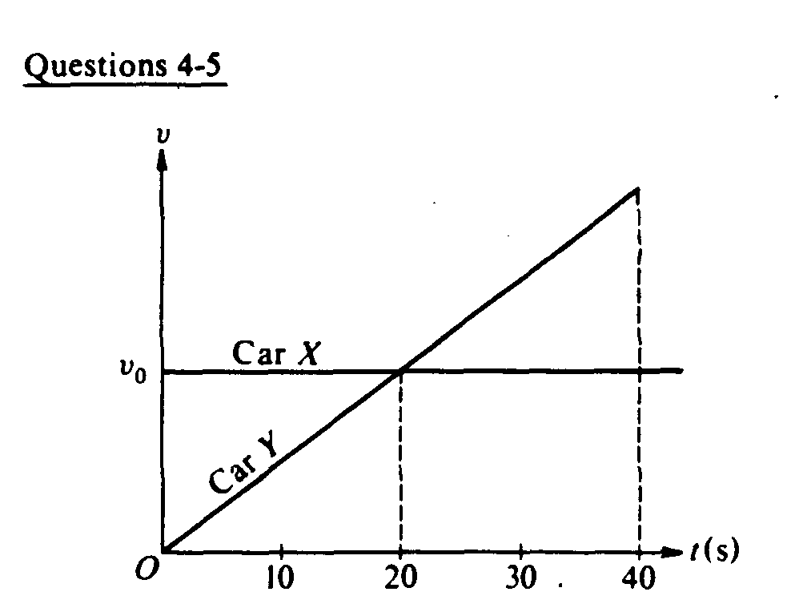

At time t = 0, car X traveling with speed *v*0 passes car Y which is just starting to move. Both cars then travel on two parallel lanes of the same straight road. The graphs of speed *v* versus time t for both cars are shown above.

19. Which of the following is true at time t = 20 seconds?

(A) Car Y is behind car X. (B) Car Y is passing car X. (C) Car Y is in front of car X.

(D) Both cars have the same acceleration. (E) Car X is accelerating faster than car Y.

20. From time t = 0 to time t = 40 seconds, the areas under both curves are equal. Therefore, which of the following is true at time t = 40 seconds?

(A) Car Y is behind car X. (B) Car Y is passing car X. (C) Car Y is in front of car X.

(D) Both cars have the same acceleration. (E) Car X is accelerating faster than car Y.

21. Which of the following pairs of graphs shows the distance traveled versus time and the speed versus time for an object uniformly accelerated from rest?

 

22. An object released from rest at time t = 0 slides down a frictionless incline a distance of 1 meter during the first second. The distance traveled by the object during the time interval from t = 1 second to t = 2 seconds is

(A) 1 m (B) 2 m (C) 3 m (D) 4 m (E) 5 m

23. Two people are in a boat that is capable of a maximum speed of 5 kilometers per hour in still water, and wish to cross a river 1 kilometer wide to a point directly across from their starting point. If the speed of the water in the river is 5 kilometers per hour, how much time is required for the crossing?

(A) 0.05 hr (B) 0.1 hr (C) 1 hr (D) 10 hr

(E) The point directly across from the starting point cannot be reached under these conditions.

24. A projectile is fired from the surface of the Earth with a speed of 200 meters per second at an angle of 30° above the horizontal. If the ground is level, what is the maximum height reached by the projectile?

(A) 5 m (B) 10 m (C) 500 m (D) 1,000 m (E) 2,000 m

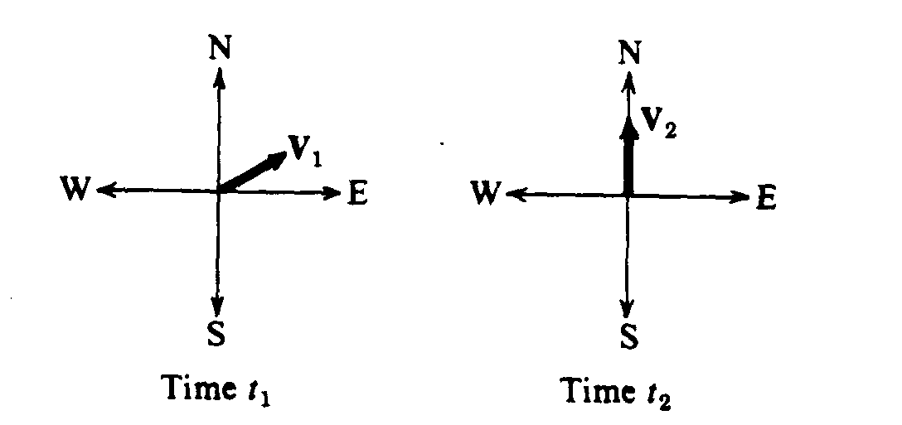

25. Vectors **V1** and**V2** shown above have equal magnitudes. The vectors represent the velocities of an object at times *t1*, and *t2*, respectively. The average acceleration of the object between time *t1* and *t2* was

(A) zero (B) directed north (C) directed west (D) directed north of east (E) directed north of west

26. A rock is dropped from the top of a 45‑meter tower, and at the same time a ball is thrown from the top of the tower in a horizontal direction. Air resistance is negligible. The ball and the rock hit the level ground a distance of 30 meters apart. The horizontal velocity of the ball thrown was most nearly

(A) 5 m/s (B) 10 m/s (C) 14.1 m/s (D) 20 m/s (E) 28.3 m/s

27. In the absence of air friction, an object dropped near the surface of the Earth experiences a constant acceleration of about 9.8 m/s2. This means that the

(A) speed of the object increases 9.8 m/s during each second   
(B) speed of the object as it falls is 9.8 m/s

(C) object falls 9.8 meters during each second   
(D) object falls 9.8 meters during the first second only

(E) rate of change of the displacement with respect to time for the object equals 9.8 m/s2

28. A 500‑kilogram sports car accelerates uniformly from rest, reaching a speed of 30 meters per second in 6 seconds. During the 6 seconds, the car has traveled a distance of

(A) 15 m (B) 30 m (C) 60 m (D) 90 m (E) 180 m

*29. At a particular instant, a stationary observer on the ground sees a package falling with speed v1 at an angle to the vertical. To a pilot flying horizontally at constant speed relative to the ground, the package appears to be falling vertically with a speed v2 at that instant. What is the speed of the pilot relative to the ground?

(A) v1 + v2 (B) v1 – v2 (C) v2 – v1 (D)  (E)

30. An object is shot vertically upward into the air with a positive initial velocity. Which of the following correctly describes the velocity and acceleration of the object at its maximum elevation?

Velocity Acceleration

(A) Positive Positive

(B) Zero Zero

(C) Negative Negative

(D) Zero Negative

(E) Positive Negative

*31. A spring‑loaded gun can fire a projectile to a height h if it is fired straight up. If the same gun is pointed at an angle of 45° from the vertical, what maximum height can now be reached by the projectile?

(A) h/4 (B)  (C) h/2 (D)  (E) h

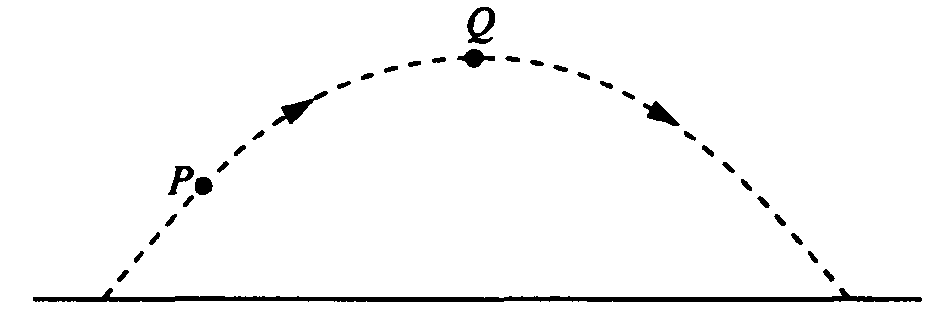

32. A ball is thrown and follows a parabolic path, as shown above. Air friction is negligible. Point Q is the highest point on the path. Which of the following best indicates the direction of the acceleration, if any, of the ball at point Q?

    (E) There is no acceleration of the ball at point Q.

33. The velocity of a projectile at launch has a hori­zontal component vh and a vertical component vv. Air resistance is negligible. When the projectile is at the highest point of its trajectory, which of the following shows the vertical and horizontal compo­nents of its velocity and the vertical component of its acceleration?

Vertical Horizontal Vertical

Velocity Velocity Acceleration

(A) vv  vh  0

(B) vv 0 0

(C) 0 vh 0

(D) 0 0 g

(E) 0 vh g

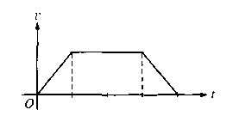

34. The graph above shows the velocity *v* as a function of time *t* for an object moving in a straight line. Which of the following graphs shows the corresponding displacement *x* as a function of time *t* for the same time interval?

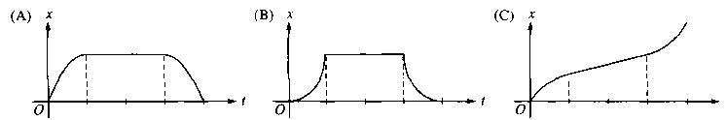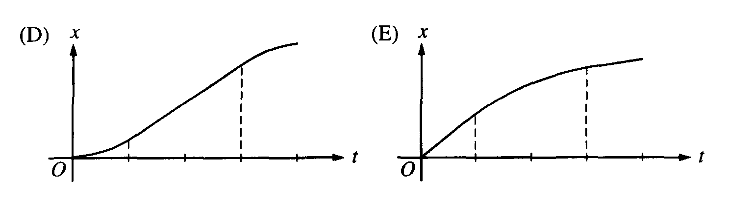

35. An object is dropped from rest from the top of a 400 m cliff on Earth. If air resistance is negligible, what is the distance the object travels during the first 6 s of its fall?

(A) 30 m (B) 60 m (C) 120 m (D) 180 m (E) 360 m

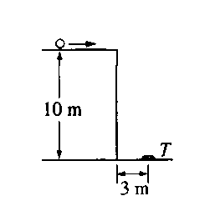

36. A target *T* lies flat on the ground 3 m from the side of a building that is 10 m tall, as shown above. A student rolls a ball off the horizontal roof of the building in the direction of the target. Air resistance is negligible. The horizontal speed with which the ball must leave the roof if it is to strike the target is most nearly

(A) 3/10 m/s (B)  m/s (C) m/s (D) 3 m/s (E) m/s



37. The graph above shows velocity v versus time t for an object in linear motion. Which of the following is a possible graph of position x versus time t for this object?



*38. A student is testing the kinematic equations for uniformly accelerated motion by measuring the time it takes for light‑weight plastic balls to fall to the floor from a height of 3 m in the lab. The student predicts the time to fall using *g* as 9.80 m/s2 but finds the measured time to be 35% greater. Which of the following is the most likely cause of the large percent error?

(A) The acceleration due to gravity is 70% greater than 9.80 m/s2 at this location.

(B) The acceleration due to gravity is 70% less than 9.80 m/s2 at this location.

(C) Air resistance increases the downward acceleration.

(D) The acceleration of the plastic balls is not uniform.

(E) The plastic balls are not truly spherical.



*39. An object is thrown with velocity **v** from the edge of a cliff above level ground. Neglect air resistance. In order for the object to travel a maximum horizontal distance from the cliff before hitting the ground, the throw should be at an angle *θ* with respect to the horizontal of

(A) greater than 60° above the horizontal (B) greater than 45° but less than 60° above the horizontal

(C) greater than zero but less than 45° above the horizontal (D) zero

(E) greater than zero but less than 45° below the horizontal

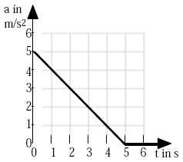

*40. Starting from rest at time t = 0, a car moves in a straight line with an acceleration given by the accompanying graph. What is the speed of the car at t = 3 s?

(A) 1.0 m/s (B) 2.0 m/s (C) 6.0 m/s (D) 10.5 m/s (E) 12.5 m/s

41. A flare is dropped from a plane flying over level ground at a velocity of 70 m/s in the horizontal direction. At the instant the flare is released, the plane begins to accelerate horizontally at 0.75 m/s2. The flare takes 4.0 s to reach the ground. Assume air resistance is negligible. Relative to a spot directly under the flare at release, the flare lands

(A) directly on the spot. (B) 6.0 m in front of the spot. (C) 274 m in front of the spot.   
(D) 280 m in front of the spot. (E) 286 m in front of the spot.

42. As seen by the pilot of the plane (in question #41) and measured relative to a spot directly under the plane when the flare lands, the flare lands

(A) 286 m behind the plane. (B) 6.0 m behind the plane. (C) directly under the plane.   
(D) 12 m in front of the plane. (E) 274 m in front of the plane

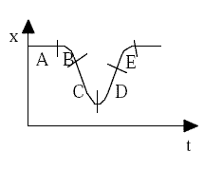

43. The graph above is a plot of position versus time. For which labeled region is the velocity positive and the acceleration negative?

(A) A (B) B (C) C (D) D (E) E

44. A child left her home and started walking at a constant velocity. After a time she stopped for a while and then continued on with a velocity greater than she originally had. All of a sudden she turned around and walked very quickly back home. Which of the following graphs best represents the distance versus time graph for her walk?

(A)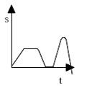(B)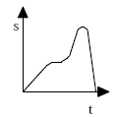(C)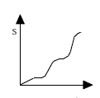(D)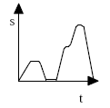(E)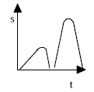

45. In a rescue attempt, a hovering helicopter drops a life preserver to a swimmer being swept downstream by a river current of constant velocity *v*. The helicopter is at a height of 9.8 m. The swimmer is 6.0 m upstream from a point directly under the helicopter when the life preserver is released. It lands 2.0 m in front of the swimmer. How fast is the current flowing? Neglect air resistance.

(A) 13.7 m/s (B) 9.8 m/s (C) 6.3 m/s (D) 2.8 m/s (E) 2.4 m/s

*46. A child tosses a ball directly upward. Its total time in the air is *T*. Its maximum height is *H*. What is its height after it has been in the air a time *T*/4? Neglect air resistance.

(A) H/4 (B) H/3 (C) H/2 (D) 2H/3 (E) 3H/4

47. A whiffle ball is tossed straight up, reaches a highest point, and falls back down. Air resistance is not negligible. Which of the following statements are true?

I. The ball’s speed is zero at the highest point.

II. The ball’s acceleration is zero at the highest point.

III. The ball takes a longer time to travel up to the highest point than to fall back down.

(A) I only (B) II only (C) I & II only (D) I & III only (E) I, II, & III

48. A truck driver travels three-fourths the distance of his run at one velocity (*v*) and then completes his run at one half his original velocity (½*v*). What was the trucker’s average speed for the trip?

(A) 0.85*v* (B) 0.80*v* (C) 0.75*v* (D) 0.70*v* (E) 0.65*v*

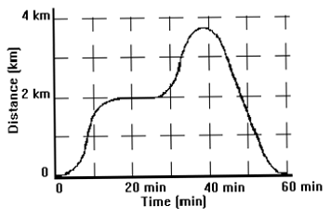

49. Above is a graph of the distance vs. time for car moving along a road. According the graph, at which of the following times would the automobile have been accelerating positively?

(A) 0, 20, 38, & 60 min. (B) 5, 12, 29, & 35 min. (C) 5, 29, & 57 min. (D) 12, 35, & 41 min.

(E) at all times from 0 to 60 min

50. A large beach ball is dropped from the ceiling of a school gymnasium to the floor about 10 meters below. Which of the following graphs would best represent its velocity as a function of time? (do not neglect air resistance)

(A)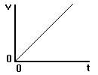 (B)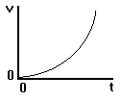 (C)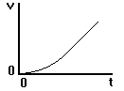 (D)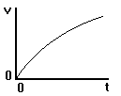 (E)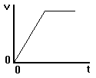

Questions 51 – 52

A car starts from rest and accelerates as shown in the graph below.

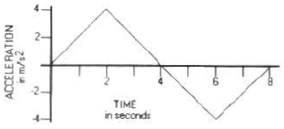

51. At what time would the car be moving with the greatest velocity?

(A) 0 seconds (B) 2 seconds (C) 4 seconds (D) 6 seconds (E) 8 seconds

*52. At what time would the car be farthest from its original starting position?

(A) 0 seconds (B) 2 seconds (C) 4 seconds (D) 6 seconds (E) 8 seconds