

1. (10 points)

A small block of mass 0.15 kg is placed at point *A* at a height 2.0 m above the bottom of a track, as shown in the figure above, and is released from rest. It slides with negligible friction down the track, around the inside of the loop of radius 0.60 m, and leaves the track at point *C* at a height 0.50 m above the bottom of the track.

1. Calculate the speed of the block when it leaves the track at point *C*.
2. On the figure below, draw and label the forces (not components) that act on the block when it is at the top of the loop at point *B*.
3. Calculate the minimum speed the block can have at point *B* without losing contact with the track.
4. Calculate the minimum height *h*min above the bottom of the track at which the block can be released and still go around the loop without losing contact with the track.

2. (15 points)



A 4700 kg truck carrying a 900 kg crate is traveling at 25 m/s to the right along a straight, level highway, as shown above. The truck driver then applies the brakes, and as it slows down, the truck travels 55 m in the next 3.0 s. The crate does not slide on the back of the truck.

1. Calculate the magnitude of the acceleration of the truck, assuming it is constant.
2. On the diagram below, draw and label all the forces acting on the crate during braking.



1. i. Calculate the minimum coefficient of friction between the crate and truck that prevents the crate from sliding.

ii. Indicate whether this friction is static or kinetic.

____ Static ____Kinetic

Now assume the bed of the truck is frictionless, but there is a spring of spring constant 9200 N m attaching the crate to the truck, as shown below. The truck is initially at rest.



(d) If the truck and crate have the same acceleration, calculate the extension of the spring as the truck

accelerates from rest to 25 m s in 10 s.

(e) At some later time, the truck is moving at a constant speed of 25 m s and the crate is in equilibrium. Indicate whether the extension of the spring is greater than, less than, or the same as in part (d) when the truck was accelerating.

___ Greater ___ Less ___ The same - Explain your reasoning

3. (15 Points)

The first meters of a 100‑meter dash are covered in 2 seconds by a sprinter who starts from rest and accelerates with a constant acceleration. The remaining 90 meters are run with the same velocity the sprinter had after 2 seconds.

1. Determine the sprinter's constant acceleration during the first 2 seconds.
2. Determine the sprinters velocity after 2 seconds have elapsed.
3. Determine the total time needed to run the full 100 meters.

d. On the axes provided below, draw the displacement vs time curve for the sprinter.

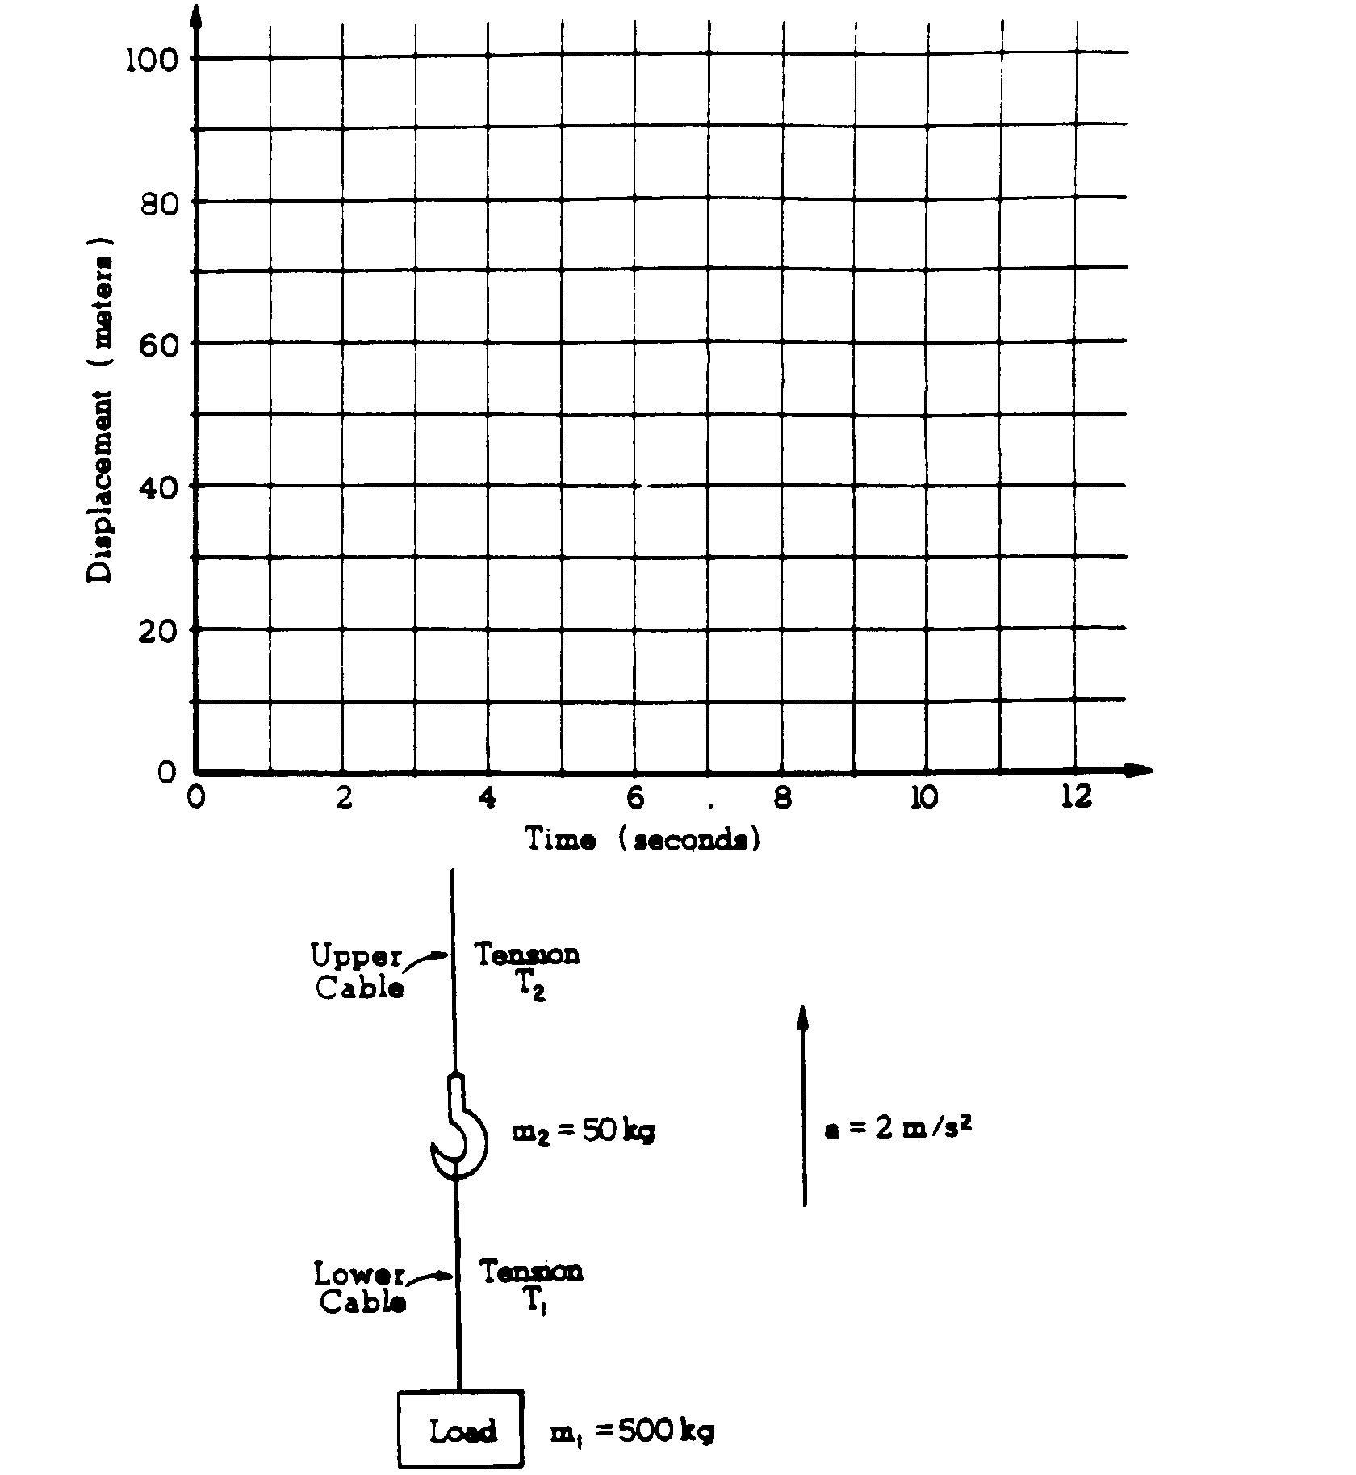

4. (15 Points)

A world-class runner can complete a 100 m dash in about 10 s. Past studies have shown that runners in such a race accelerate uniformly for a time *t* and then run at constant speed for the remainder of the race. A world‑class runner is visiting your physics class. You are to develop a procedure that will allow you to determine the uniform acceleration *a* and an approximate value of *t* for the runner in a 100 m dash. By necessity your experiment will be done on a straight track and include your whole class of eleven students.

1. By checking the line next to each appropriate item in the list below, select the equipment, other than the runner and the track, that your class will need to do the experiment.

____Stopwatches ____Tape measures ____ Rulers ____ Masking tape

____Metersticks ____ Starter's pistol ____ String ____ Chalk

1. Outline the procedure that you would use to determine *a* and *t*, including a labeled diagram of the experimental setup. Use symbols to identify carefully what measurements you would make and include in your procedure how you would use each piece of the equipment you checked in part (a).

1. Outline the process of data analysis, including how you will identify the portion of the race that has uniform acceleration, and how you would calculate the uniform acceleration.

5.

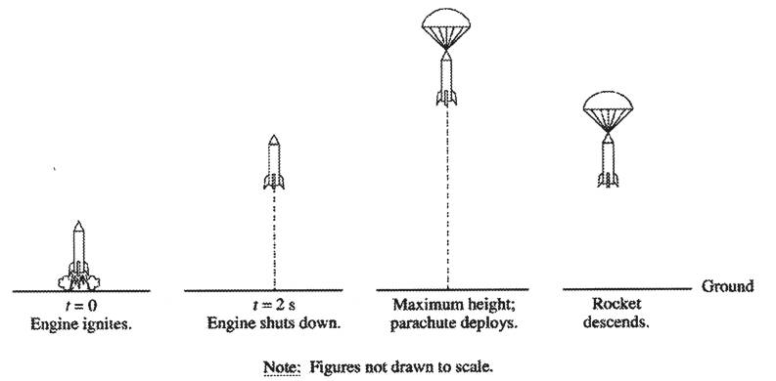

A model rocket is launched vertically with an engine that is ignited at time t = 0, as shown above. The engine provides an upward acceleration of 30 m/s2 for 2.0 s. Upon reaching its maximum height, the rocket deploys a parachute, and then descends vertically to the ground.

1. Determine the speed of the rocket after the 2 s firing of the engine.
2. What maximum height will the rocket reach?
3. At what time after t = 0 will the maximum height be reached?

6.

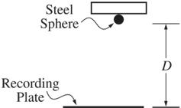

A student wishing to determine experimentally the acceleration *g* due to gravity has an apparatus that holds a small steel sphere above a recording plate, as shown above. When the sphere is released, a timer automatically begins recording the time of fall. The timer automatically stops when the sphere strikes the recording plate.

The student measures the time of fall for different values of the distance *D* shown above and records the data in the table below. These data points are also plotted on the graph.

|  |  |  |  |  |  |
| --- | --- | --- | --- | --- | --- |
| Distance of Fall (m) | 0.10 | 0.50 | 1.00 | 1.70 | 2.00 |
| Time of Fall (s) | 0.14 | 0.32 | 0.46 | 0.59 | 0.63 |

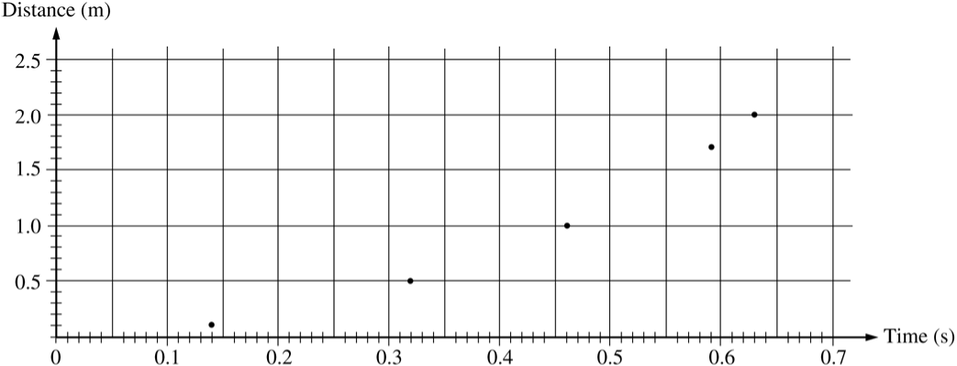

1. On the grid above, sketch the smooth curve that best represents the student's data

The student can use these data for distance D and time t to produce a second graph from which the acceleration g due to gravity can be determined.

1. If only the variables D and t are used, what quantities should the student graph in order to produce a linear relationship between the two quantities?
2. On the grid below, plot the data points for the quantities you have identified in part (b), and sketch the best straight-line fit to the points. Label your axes and show the scale that you have chosen for the graph.



1. Using the slope of your graph in part (c), calculate the acceleration g due to gravity in this experiment.
2. State one way in which the student could improve the accuracy of the results if the experiment were to be performed again. Explain why this would improve the accuracy.