Name:__________________________________________Date:___________Period:______________
Problems - Section 6.3-6-4
- A 5.0 kg object (m₁) is connected to a 10.0 kg object (m₂) by a string. If a pulling force F of 20 N is applied to the 5.0 kg object as shown. What is the acceleration of the system? What is the tension in the string connecting the objects? assume a frictionless surface .
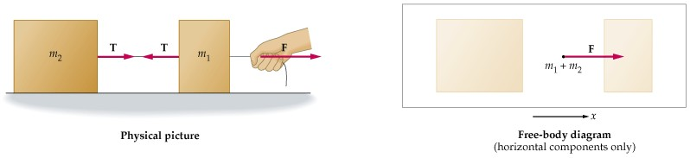

- Mass 1 (10 kg) rests on a table connected by a string to Mass 2 (5 kg). Find the minimum coefficient of static friction for which the blocks remain stationary.

- From the figure above, Mass 1 (10 kg) rests on a table connected by a string to Mass 2 (5 kg). If m_{s} = 0.30 and m_{k} = 0.20, what is the acceleration of each block? What is the tension in the connecting string?

Pulley’s on the ramp
- Two blocks are connected by a string as shown in the figure. What is the acceleration, assuming there is no friction? At an angle of 45 degrees . Mass 1 weighs 10 kg and mass 2 weighs 5 kg

M₂
M₁

