INTRODUCTION

Almost all of us are familiar with static electricity because we can see and feel
it in the winter. On dry winter days, static electricity can build up in our bodies
and cause a spark to jump from our bodies to pieces of metal or other people's bodies. We can see, feel and hear the sound of the spark when it jumps.

In this PhysicsQuest you will investigate some applications of electrostatics.

PhysicsQuest

ELECTROSTATICS
TASK

You will read each section by clicking on the links provided and answer the questions given.
PROCESS AND RESOURCES

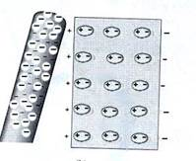
Part I. TRIBOELECTRICITY

Rubbing silk on a glass rod makes the glass positive and the silk negative. Rubbing fur on a hard rubber rod makes the hard rubber negative and the fur positive. Whenever two different materials rub against each other it is likely that one will leave with more electrons than it started with and the other will leave with less. This effect is known as "triboelectricity," from the Greek "tribein," or "to rub".

1. What is a triboelectric series?

2. Give two examples of materials that are more likely to give up electrons, and two examples of materials that are more likely attract electrons.

3. Which material is neutral in the triboelectric series?

Part II. ELECTROSTATIC GENERATORS

A variety of electrostatic generators are available for
producing large amounts of electric charge.

4. Name two electrostatic generators.

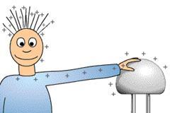
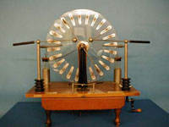
Van de Graaf Generator
5. Briefly describe how the Van de Graaf
generator works.

6. What is wrong with the cartoon on the right?

Part III. LIGHTNING

A spark is a stream of electrons jumping across an air gap, heating the air until it glows and expands. Certain conditions can cause enough static electricity buildup to cause a spark or lightning.

7. Describe the creation of a ground strike of lightning.

LIGHTNING AND THUNDER

A single stroke of lightning can heat the air around it to 30,000 degrees Celsius (54,000 F)! This extreme heating causes the air to expand at an explosive rate creating a shock wave that turns into a booming sound wave, the thunder.

8. Explain why there is a time difference between the sight of lightning and the sound of thunder?
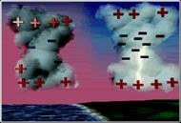
LIGHTNING TYPES AND FORMS

9. Name three types of lightning and explain how they are
different from each other.
10. Lightning can take many forms as it appears on the sky.
Briefly describe six forms of lightning.

SAFETY

11. Give three safety guidelines to follow during a lightning
storm.

LIGHTNING MYTHS

12. Discuss in detail four lightning myths.
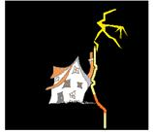
PART IV. DETERMINATION OF THE CHARGE OF THE ELECTRON

In 1909 R. Millikan performed an experiment to determine the
charge of the electron. He received the Nobel Prize for his work.

13. Describe Millikan's experiment in detail using your own words.
14. Draw a labeled sketch of the experiment.
15. Draw a neat-labeled free body diagram of the forces on the
oil drop.
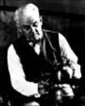
Millikan's Oil Drop Experiment Links:

Millikan's Experiment

Movie of the Oil-Drop Experiment

Physics of Millikan's Experiment
