18.2 Elecromagnetic Spectrum

Unit: 5 - Energy

Learning Objectives:
- Rank and classify electromagnetic waves based on their frequencies and wavelengths.
- Describe the uses for different waves of the electromagnetic spectrum.

Language Objectives:
- Understand and correctly use the terms “Electromagnetic Spectrum”, “Amplitude Modulation “Frequency Modulation”, “Thermographs”

Notes:
The Electromagnetic Spectrum Includes:
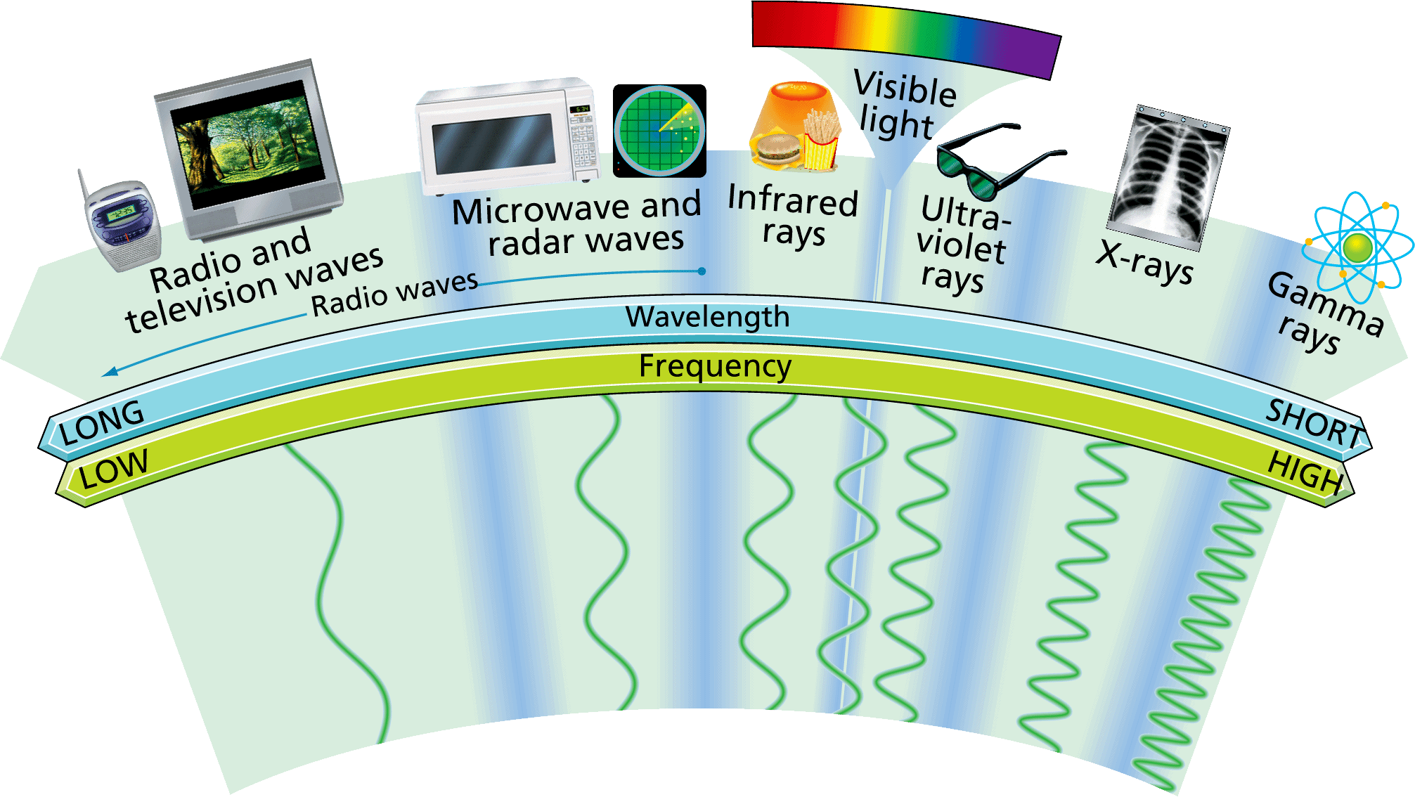
1.
2.
3.
4.
5.
6.
7.

Radio waves are used in _______________________ technologies, as well as in microwave ovens and radar.
Radio waves have the ______________ wavelengths in the electromagnetic spectrum. Wavelengths range from 1 millimeter to as much as thousands of kilometers or longer.
Radio waves also have the _________________ frequencies in the spectrum—300,000 megahertz (MHz) or less.
In a vacuum (absent of anything) – the speed ___________________
There are two ways that signals are encoded for radio.
In amplitude modulation, the amplitude of the wave is varied. The frequency remains the ____________ AM radio stations broadcast by _____________modulation.
In frequency modulation, the _____________ of the wave is varied. The __________________ remains the same. FM stations broadcast by frequency modulation
The announcer’s voice and the music on CD leave the radio studio as electronic signals. Those signals are used to produce a wave with either a varying amplitude or a varying frequency.
- AM waves have a varying amplitude.
B. FM waves have a varying frequency.
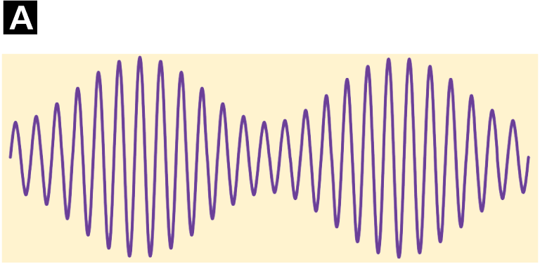
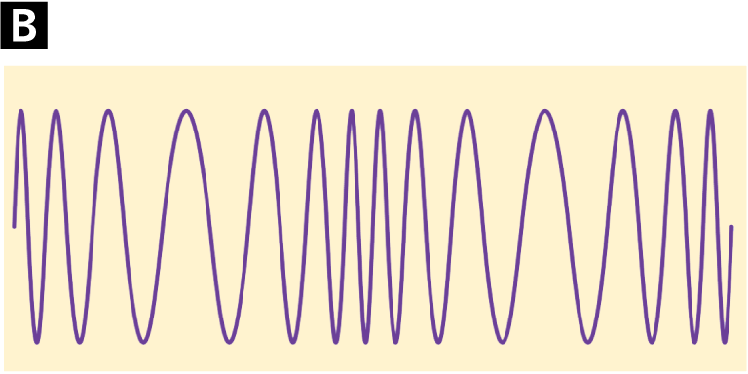
The shortest-wavelength radio waves are called __________ Microwave wavelengths are from about 1 m to about 1 mm.
Frequencies vary from about 300 MHz to about 300,000 MHz.
Microwaves _______________ food. Microwaves also carry _______________ conversations. The process works much like a radio broadcast.
Infrared rays are used as a _______________ and to discover areas of heat differences
Infrared rays have ___________ frequencies than radio waves and ____________frequencies than red light. Infrared wavelengths vary from about 1 millimeter to about 750 nanometers (10^{–9} meter).
Your skin senses infrared radiation as warmth. Restaurants use infrared lamps to keep foods warm
Warmer objects ________________ infrared radiation than cooler objects.
A device called a thermograph uses infrared sensors to create ___________________ color-coded pictures that show variations in temperature.
Search-and-rescue teams use infrared cameras to locate people who are trapped during disasters.
A thermogram can be used to diagnose problems in a utility line.
  - When viewed in visible light, the wires all look the same.
  - The colors in the thermogram image show that the electric current in the center wire is not flowing as it should.
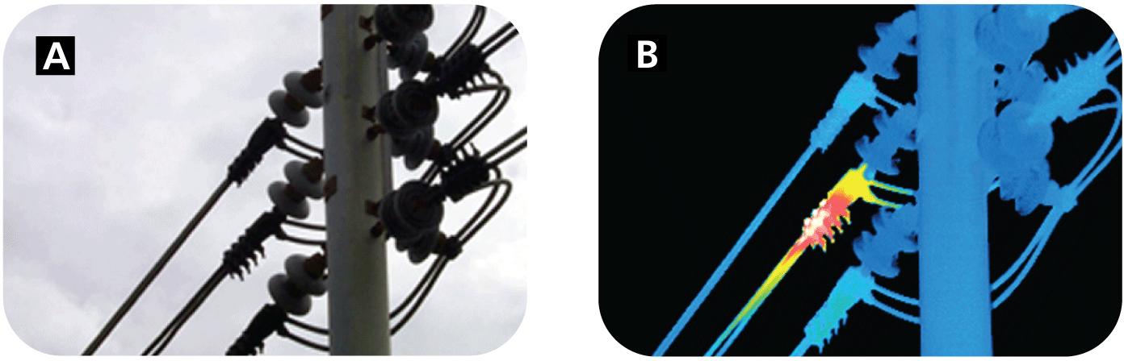
People use visible light to see, to help keep them ______, and to communicate with one another.
The visible part of the electromagnetic spectrum is light that the _____________ can see.
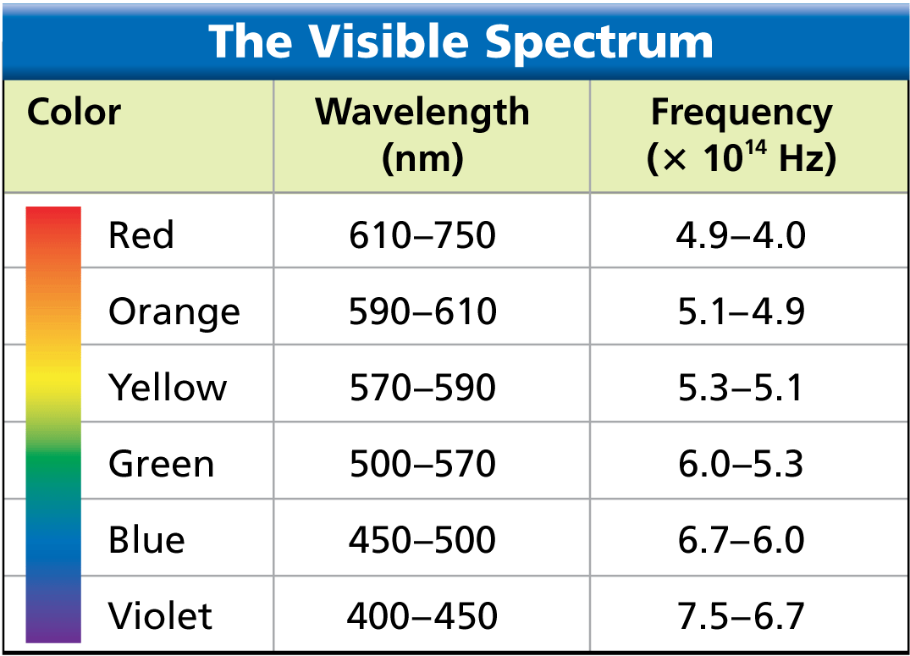
Each wavelength in the visible spectrum corresponds to a specific frequency and has a particular color.
Each color of light corresponds to a _________________ of wavelengths. The wavelengths of visible light are quite small. Wavelengths of red light, for example, are about one hundredth the thickness of a human hair
Ultraviolet rays have applications in __________________ and in ____________
Ultraviolet rays vary from about 400 nm to about 4 nm.
Some exposure to ultraviolet rays helps your skin produce ____________, which helps the body absorb calcium from foods.
Excessive exposure can cause sunburn, wrinkles, skin cancer, and eye damage.
Ultraviolet rays are used to kill microorganisms. In winter, plant nurseries use ultraviolet lights to help plants grow.
X-rays are used in medicine, industry, and transportation to make pictures of the inside of solid objects.
X-rays have very ______________ from about 12 nm to about 0.005 nm.
X-rays have high energy and can penetrate matter that light cannot.
Too much exposure to X-rays can _______________ living tissue.
Your teeth and bones ____________ X-rays. X-ray photographs show softer tissue as dark, highly exposed areas. Bones and teeth appear white.
The lids on aluminum cans are sometimes inspected with X-rays to make sure they are sealed properly.
X-rays can be used to identify the contents of entire truck trailers.
Gamma rays are used in the medical field to _______________ and make pictures of the brain, and in industrial situations as an inspection tool.
Gamma rays have the ____________wavelengths in the electromagnetic spectrum, about 0.005 nm or less.
They have the ___________ frequencies, the most energy, and the greatest penetrating ability of all the electromagnetic waves.
Exposure to tiny amounts of gamma rays is tolerable, but overexposure can be ______________.
Gamma rays are used in radiation therapy to kill cancer cells without harming nearby healthy cells.
Gamma rays are also used to make pictures of the human brain, with different levels of brain activity represented by different colors.
Pipelines are checked with machines that travel on the inside of a pipe, taking gamma ray pictures along the entire length.

