17.4 Sound and Hearing

**Unit:** 5 - Waves

### Learning Objectives:

### Describe the properties of sound waves and explain how sound is produced and reproduced

### Describe how sound waves behave in application such as ultrasound and music.

### Explain how relative motion determines the frequency of sound an observer hears

### Analyze the function of the main regions of the human ear.

### Language Objectives:

* Understand and correctly use the terms “Sound Wave, “Intensity”, “Decibel”, “Loudess”, “Pitch”, “Sonar”, “Doppler Effect”, “Resonance”

### Notes: What are the main properties of sound?

Many behaviors of sound can be explained using a few properties—_______, ___________________ and ___________________.

**Speed in Sound Wave**

It takes time for sound to travel from place to place.

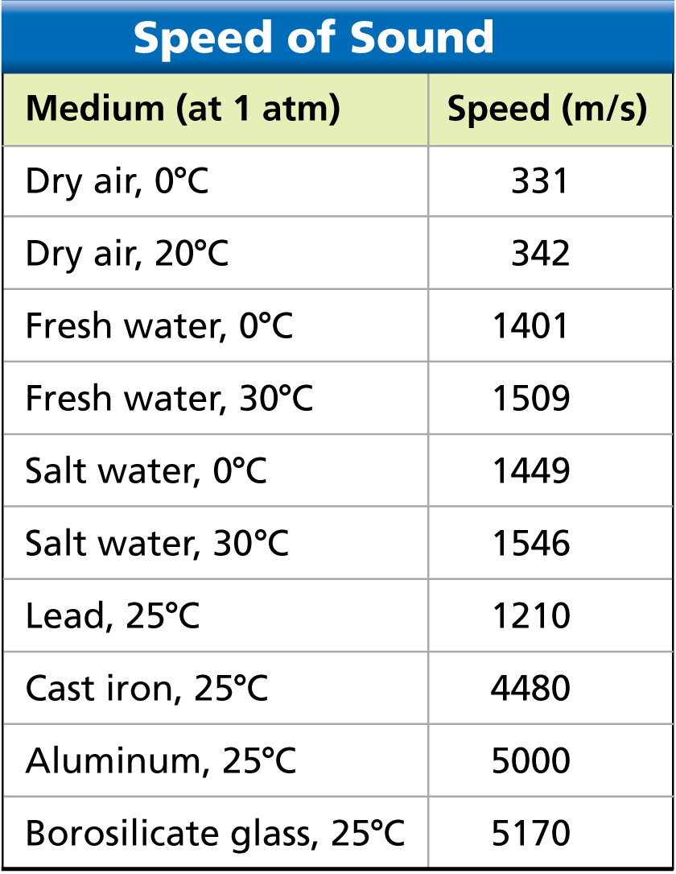The speed of sound varies in different media. In dry air at 20°C, the speed of sound is _______________________.

**Properties of Sound Waves**

In general, sound waves travel ___________ in solids, slower in liquids, and slowest in gases.

Particles in a solid tend to be closer together than particles in a liquid or a gas.

**Intensity and Loudness**

Intensity is the ________ at which a wave’s energy flows through a given area.

Sound intensity depends on both the wave’s _____________ and the distance from the sound source.

The _______________ is a unit that compares the intensity of different sounds

For every 10-decibel increase, the sound intensity increases tenfold.

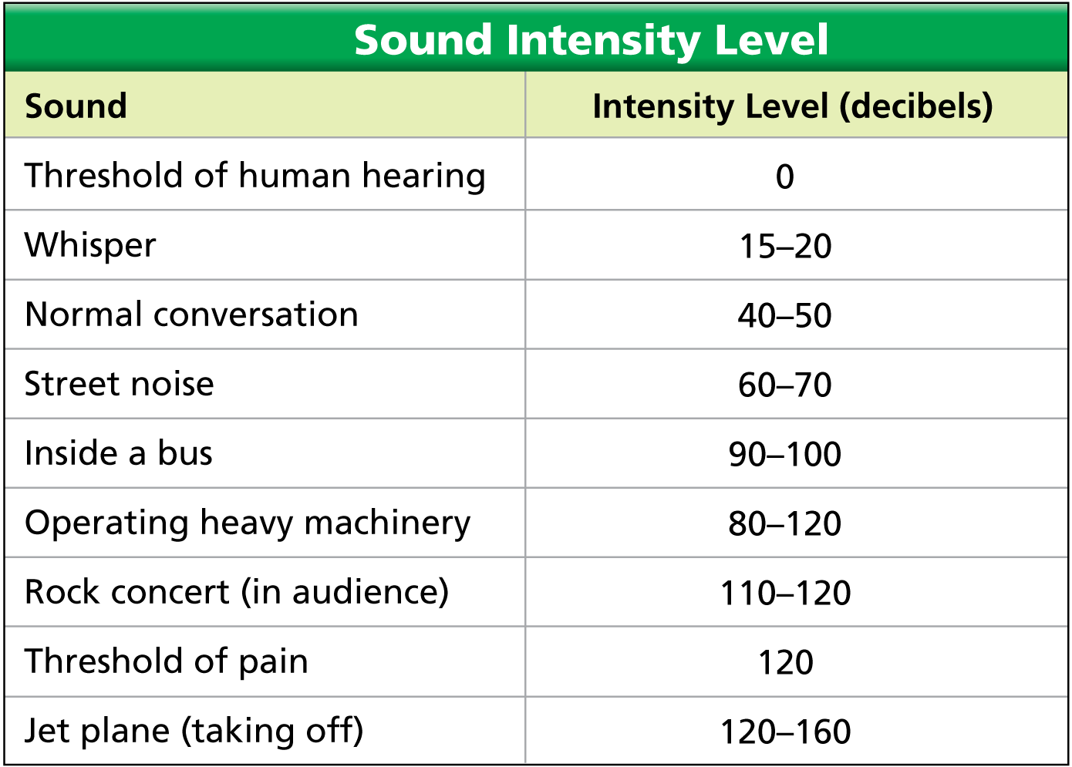A 0-decibel sound can just __________ be heard.

A 20-decibel sound has __________ more energy per second than a 0-decibel sound.

A 30-decibel sound delivers _______________ more energy per second than a 0-decibel sound.

Lengthy exposure to sounds more intense than 90 decibels can cause hearing damage.

**Just Loudness**

Loudness is a _______________ response to the intensity of sound, modified by physical factors.

The loudness depends on ___________________.

Loudness also depends on factors such as the health of your ears and how your brain interprets sound waves.

**Frequency & Pitch**

The frequency of a sound wave depends on how __________ the source of the sound is vibrating.

The air in the tubing of brass instruments forms a standing wave. ____________ tubing makes a standing wave with a __________ wavelength and a lower frequency.

**What is pitch?**

Pitch is the frequency of a sound as you __________________.

High-frequency sounds have a ______________pitch, and low-frequency sounds have a low pitch.

Pitch also depends on other factors such as your age and the health of your ears.

**What is an ultrasound?**

Ultrasound is used in a variety of applications, including sonar and ultrasound imaging.

Most people hear sounds between ______ hertz and _____________ hertz.

_________ is sound at frequencies lower than most people can hear.

__________is sound at frequencies higher than most people hear.

**What is the Doppler Effect?**

The Doppler Effect is when a source of sound approaches, an observer hears a ____________frequency. When the sound source moves away, the observer hears a _____________ frequency.

The Doppler effect is a change in sound frequency caused by motion of the sound source, motion of the listener, or both.

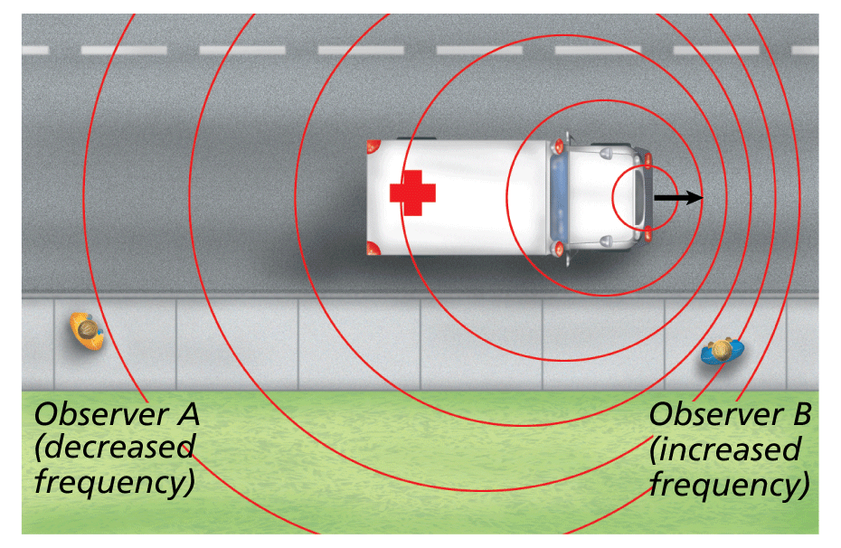



**Outer Ear**

The part of the ear you can see funnels sound waves down the ear canal, a tunnel about _____________ long.

Sound waves strike the eardrum, a tightly stretched membrane between the ____________________ ear.

The eardrum vibrates at the ____________ frequency as the sound waves striking it.

**Middle Ear**

The middle ear contains three tiny bones—the _____________, the _______, and the ____________. The three bones act as a lever system to amplify the motion of the eardrum.

When the eardrum vibrates, the hammer vibrates at the same frequency.

The hammer strikes the anvil.

The anvil moves the stirrup back and forth

Ear Inner

Vibrations from the stirrup travel into the ____________, a spiral-shaped canal filled with fluid.

The inside of the cochlea is lined with thousands of nerve cells with tiny hair-like projections.

As the fluid in the cochlea vibrates, the projections sway back and forth and send electrical impulses to the brain.

**How do musical instruments vary pitch?**

Most musical instruments vary pitch by changing the ______________ of standing waves.

Musical instruments can produce a wide variety of sounds.

In a wind instrument, holes are closed using fingers or valves to change the length of the standing sound wave.

For some stringed instruments, musicians change the length of the strings by pressing down with their fingers.

Other instruments use a fixed set of strings of different lengths.

**More on Music**

Musical instruments can produce a wide variety of sounds.

In a wind instrument, holes are closed using fingers or valves to change the length of the standing sound wave.

For some stringed instruments, musicians change the length of the strings by pressing down with their fingers.

Other instruments use a fixed set of strings of different lengths.

**Resonance**

Resonance is the response of a standing wave to another wave of the same frequency. Musical instruments often use ________________ to amplify sound.

One wave can “push” another wave to a _________ amplitude.

Resonance can produce a dramatic ____________ in amplitude.

**Reverberations**

Sound-absorbing tiles in this auditorium ___________unwanted reflections. Thecurved reflecting panels above the stage help gather and direct sound waves toward the audience.