17.3 Behavior of Waves

Unit: 5 - Waves

Learning Objectives:

Describe how reflection, refraction, diffraction and interference affect waves.

State a rule that explains refraction of waves as it passes from one medium into another.

Identify factors that affect the amount of refraction, diffraction or interference.

Distinguish between constructive and destructive interference and explain how standing wave forms Language Objectives:
- Understand and correctly use the terms “Reflection”, “Refraction”, “Diffraction”, “Interference”, “Constructive Interference”, “Destructive Interference”, “Standing Wave”, “Node”, “Antinode”

Notes: What is reflection?
Reflection occurs when a wave ___________ a surface that it _________cannot pass through.
Reflection _________ change the _________________ of a wave, but the wave can be flipped upside down.
What is Refraction?
Refraction is the__________ of a wave as it enters a new medium at an angle
What causes the refraction of a wave when it enters a new medium?
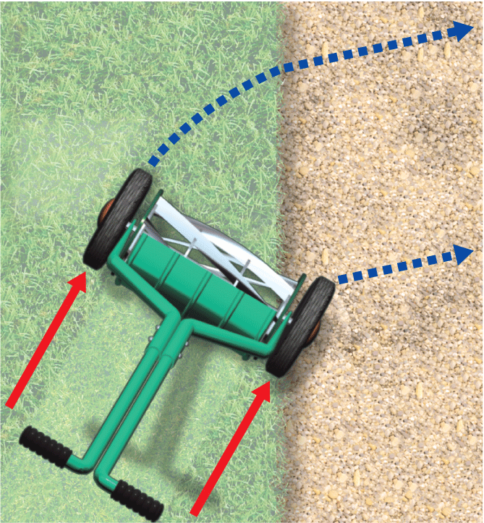
When a wave enters a medium at an angle, refraction occurs because one side of the wave moves more ___________ than the other side
A lawnmower turns when it is pushed at an angle from the grass onto the gravel.
The wheel on the gravel slows down, but the other wheel is still moving at a faster speed on the grass
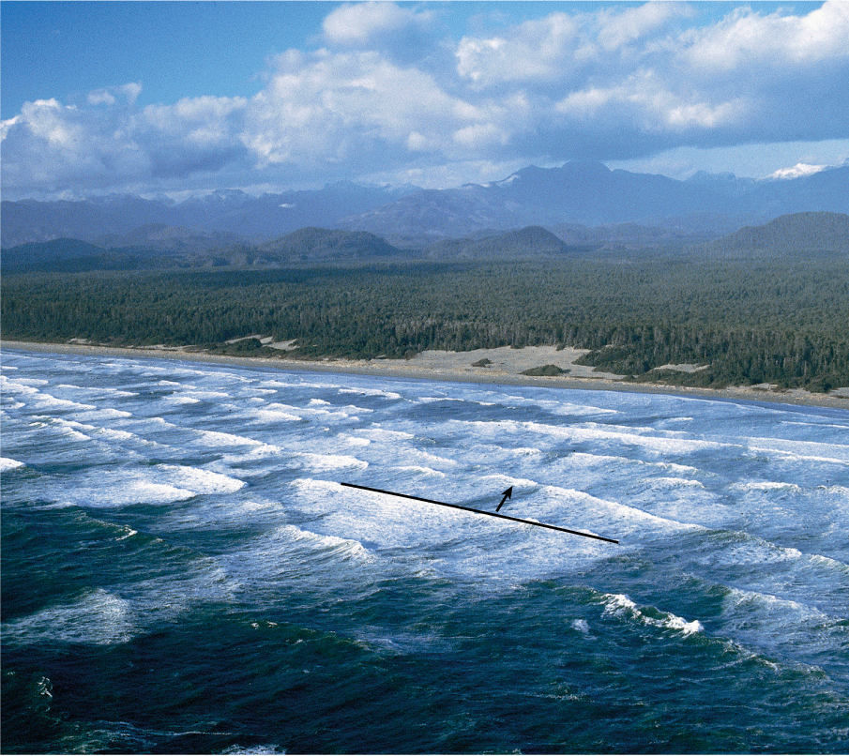
As an ocean wave approaches the shore at an angle, the wave bends, or refracts, because one side of each wave front slows down before the other side does.
An ocean wave refracts as it flows into a shallow area.
The shallower water can be considered a new medium.
As one side of each wave enters shallower water before the other, that side slows down and the wave bends.
If a wave front is parallel to the shoreline, the wave enters the shallower water all at once, and there is no refraction.
What is diffraction?
Diffraction is the bending of a wave as it _______________ an obstacle or passes through a ____________opening.
A wave diffracts more if its wavelength is_______________ compared to the size of an opening or obstacle.
Water waves spread out as they pass through a narrow opening.
The pattern produced is very similar to the circular ____________ you see when a pebble is tossed into a pond.
Diffraction also occurs when ____________ around an obstacle.
The larger the wavelength is compared to the size of the opening or obstacle, _________________ the wave diffracts

- This wave diffracts, or spreads out, after it passes through a narrow opening.
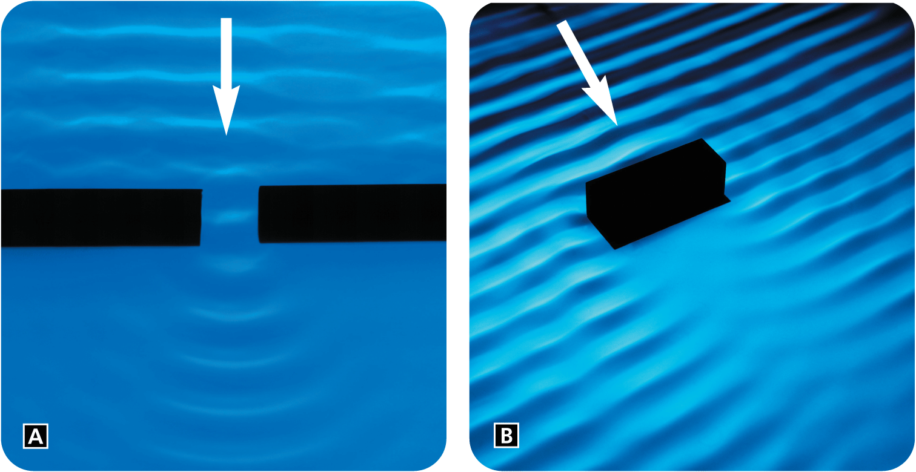
- Diffraction also occurs when a wave encounters an obstacle.

What is interference?
Interference occurs when two or more waves ___________ and combine together.
There are two types of interference:
__________________
__________________
More on Interference
When waves collide, they can occupy the ______________ of space and then continue on.
  - Constructive interference occurs when two or more waves combine to produce a wave with a __________ displacement.
  - Destructive interference occurs when two or more waves combine to produce a wave with a ___________displacement.

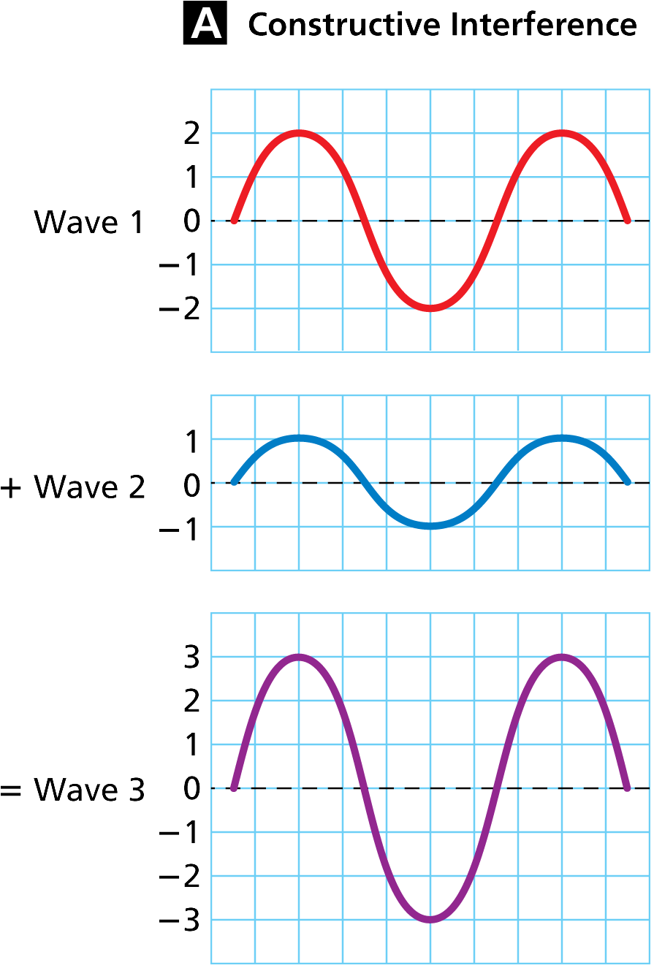
Constructive Interference
Two waves with equal frequencies travel in opposite directions.
When a ________________________ the result is a wave with _____________ amplitude.

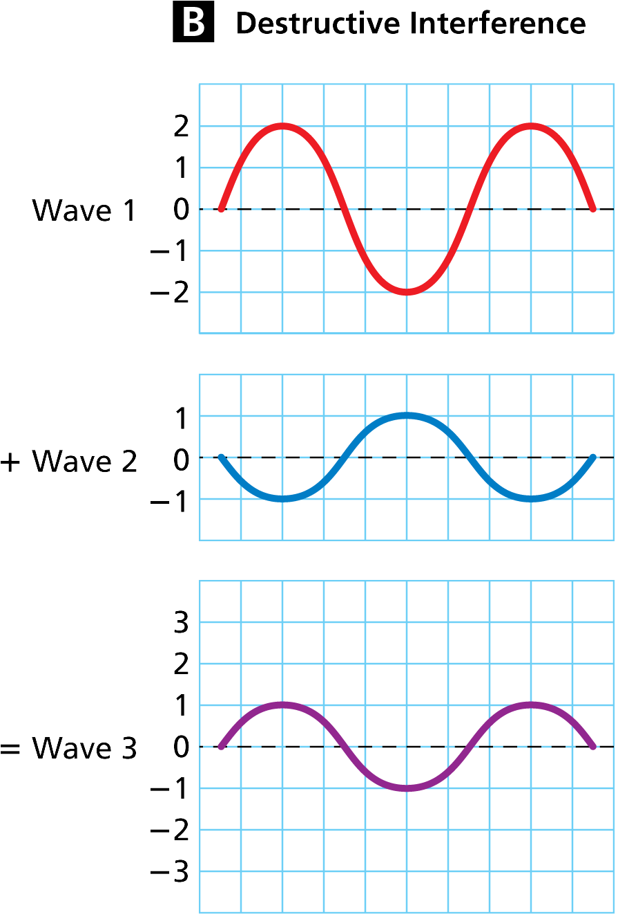
Destructive Interference
Two waves with equal frequencies travel in opposite directions.
When a ______________ the result is a wave with a ______________ amplitude.

What is a standing wave?
A standing wave is a wave that appears to ________________it does not seem to move through the medium.
A standing wave forms only if __________a wavelength or a ____________ of half a wavelength fits exactly into the length of a vibrating cord.
Interference occurs as the incoming waves pass through the ____________waves.
At certain frequencies, interference between a wave and its reflection can produce a standing wave.

Node vs Antinode on a Standing Wave
A node is a point on a standing wave that has ______________ from the rest position. At the nodes, there is ________________ interference between the incoming and reflected waves.
An antinode is a point where a _________________ occurs midway between two nodes.
These photos show standing waves for two different frequencies.
  - One wavelength equals the length of the cord.
  - Two wavelengths equal the length of the cord.
